UNITED STATES
SECURITIES AND EXCHANGE COMMISSION
Washington, D.C. 20549

FORM 10-Q

(Mark One)

☒ QUARTERLY REPORT PURSUANT TO SECTION 13 OR 15(d) OF THE SECURITIES EXCHANGE ACT OF 1934

For the quarterly period ended March 31, 2026

OR

☐ TRANSITION REPORT PURSUANT TO SECTION 13 OR 15(d) OF THE SECURITIES EXCHANGE ACT OF 1934

For the transition period from _______________ to _________________

Commission File Number: 001-38508

Sports Entertainment Gaming Global Corporation
(Exact name of registrant as specified in its charter)

Delaware |  | 81-1996183
(State or other jurisdiction of |  | (I.R.S. Employer
incorporation or organization) |  | Identification No.)
5049 Edwards Ranch Rd., 4th Floor, Fort Worth, TX |  | 76109
(Address of principal executive offices) |  | (zip code)

(737) 787-3798
(Registrant’s telephone number, including area code)

N/A
(Former name, former address and former fiscal year, if changed since last report)

Securities registered pursuant to Section 12(b) of the Act:

Title of each class |  | Trading Symbol(s) |  | Name of each exchange on which registered
Common stock, $0.001 par value |  | SEGG |  | The Nasdaq Stock Market LLC
Warrants to purchase one share of common stock, each at an exercise price of $16,100.00 |  | LTRYW |  | The Nasdaq Stock Market LLC

Indicate by check mark whether the registrant (1) has filed all reports required to be filed by Section 13 or 15(d) of the Securities Exchange Act of 1934 during the preceding 12 months (or for such shorter period that the registrant was required to file such reports), and (2) has been subject to such filing requirements for the past 90 days. ☐ Yes ☒ No

Indicate by check mark whether the registrant has submitted electronically every Interactive Data File required to be submitted pursuant to Rule 405 of Regulation S-T (§232.405 of this chapter) during the preceding 12 months (or for such shorter period that the registrant was required to submit such files). ☒ Yes ☐ No

Indicate by check mark whether the registrant is a large accelerated filer, an accelerated filer, a non-accelerated filer, smaller reporting company, or an emerging growth company. See the definitions of “large accelerated filer,” “accelerated filer,” “smaller reporting company,” and “emerging growth company” in Rule 12b-2 of the Exchange Act.

Large accelerated filer ☐ | Accelerated filer ☐
Non-accelerated filer ☒ | Smaller reporting company ☒
 | Emerging growth company ☒

If an emerging growth company, indicate by check mark if the registrant has elected not to use the extended transition period for complying with any new or revised financial accounting standards provided pursuant to Section 13(a) of the Exchange Act. ☐

Indicate by check mark whether the registrant is a shell company (as defined in Rule 12b-2 of the Exchange Act). ☐ Yes ☒ No

As of September 30, 2026, 3,413,024 shares of common stock, par value $0.001 per share were issued and outstanding.

TABLE OF CONTENTS

 |  | Page
Part I. Financial Information
Item 1. Consolidated Financial Statements |  | 1
Condensed Consolidated Balance Sheets as of March 31, 2026 (unaudited) and December 31, 2025 |  | F-1
Condensed Consolidated Statements of Operations and Comprehensive Loss for the three months ended March 31, 2026 and 2025 (unaudited) |  | F-2
Condensed Consolidated Statements of Equity for the three months ended March 31, 2026 and 2025 (unaudited) |  | F-3
Condensed Consolidated Statements of Cash Flows for the three months ended March 31, 2026 and 2025 (unaudited) |  | F-4
Notes to Condensed Consolidated Financial Statements (unaudited) |  | F-5
Item 2. Management’s Discussion and Analysis of Financial Condition and Results of Operations |  | 2
Item 3. Quantitative and Qualitative Disclosures about Market Risk |  | 14
Item 4. Controls and Procedures |  | 14
Part II. Other Information
Item 1. Legal Proceedings |  | 16
Item 1A. Risk Factors |  | 20
Item 2. Unregistered Sales of Equity Securities and Use of Proceeds |  | 23
Item 3. Defaults Upon Senior Securities |  | 23
Item 4. Mine Safety Disclosures |  | 23
Item 5. Other Information |  | 23
Item 6. Exhibits |  | 24

i

CAUTIONARY NOTE REGARDING FORWARD-LOOKING STATEMENTS

This Report on Form 10-Q (this “Report”) contains forward-looking statements within the meaning of Section 27A of the Securities Act of 1933, as amended (the “Securities Act”), and Section 21E of the Securities Exchange Act of 1934, as amended (the “Exchange Act”), including statements regarding the financial condition, results of operations, future operating performance, liquidity, business strategy, and prospects of Sports Entertainment Gaming Global Corporation (doing business as “SEGG,” “SEGG Media,” the “Company,” “we,” “our,” or “us”). Forward-looking statements appear in a number of places in this Report, including, without limitation, under the heading in Part I, “Item 2. Management’s Discussion and Analysis of Financial Condition and Results of Operations.” In addition, any statements that refer to projections, forecasts or other characterizations of future events or circumstances, including any underlying assumptions, are forward-looking statements. Forward-looking statements are typically identified by words such as “plan,” “believe,” “expect,” “anticipate,” “intend,” “outlook,” “estimate,” “forecast,” “project,” “continue,” “could,” “may,” “might,” “possible,” “potential,” “predict,” “should,” “would” and other similar words and expressions, but the absence of these words does not mean that a statement is not forward-looking.

Forward-looking statements are based on the current expectations of the management of SEGG Media and are inherently subject to uncertainties and changes in circumstances and their potential effects and speak only as of the date of such statement. There can be no assurance that future developments will be those that have been anticipated. These forward-looking statements involve a number of risks, uncertainties, or other assumptions that may cause actual results or performance to be materially different from those expressed or implied by these forward-looking statements. These risks and uncertainties include, but are not limited to, those factors discussed and identified in the section entitled “Risk Factors” in our Annual Report on Form 10-K for the year ended December 31, 2025 (the “Annual Report”) which was filed on July 10, 2026 and in this Report, as such factors may be updated in our periodic reports filed with the Securities and Exchange Commission (the “SEC”), as well as the following:

 | ● | our ability to continue implementing our strategic business plan;
 | ● | our ability to successfully operate and grow our digital media, sports, entertainment and gaming businesses;
 | ● | our ability to monetize our digital media audience through advertising, sponsorships, commercial partnerships, platform monetization and other revenue-generating activities;
 | ● | our dependence on third-party digital platforms and technology providers;
 | ● | our ability to complete, support and realize the anticipated benefits of strategic acquisitions;
 | ● | our ability to remediate material weaknesses in our internal control over financial reporting;
 | ● | our ability to regain compliance with Nasdaq listing standards and our SEC reporting obligations;
 | ● | our ability to maintain sufficient liquidity and obtain additional financing;
 | ● | ongoing litigation, governmental inquiries and regulatory matters;
 | ● | general economic, geopolitical and capital market conditions; and
 | ● | the other risks described in Item 1A. Risk Factors in our Annual Report on Form 10-K for the year ended December 31, 2025 and in this Report.

The risks described herein or in the “Risk Factors” sections of our other public filings referenced above are not exhaustive. Other sections of this Report describe additional factors that could adversely affect our business, financial condition or results of operations. New risk factors emerge from time to time and it is not possible to predict all such risk factors, nor can we assess the impact of all such risk factors on our business, or the extent to which any factor or combination of factors may cause actual results to differ materially from those contained in any forward-looking statements. Forward-looking statements are not guarantees of future performance. You should not put undue reliance on these statements, which speak only as of the date hereof. All forward-looking statements attributable to us or persons acting on our behalf are expressly qualified in their entirety by the foregoing cautionary statements. We undertake no obligations to update or revise publicly any forward-looking statements, whether as a result of new information, future events or otherwise, except as required by law.

ii

Explanatory Note

As disclosed in the Company’s Current Report on Form 8-K filed on October 8, 2026, SEGG Media (formerly Lottery.com/AutoLotto) reported that new testimony and an internal inquiry uncovered details about two connected transactions from 2020–2021. The Company alleges that former Trident CEO Vadim Komissarov (“Komissarov”), with assistance from three former Lottery executives, arranged a circular scheme involving $9 million held in a restricted Massachusetts law-firm escrow account.

Although AutoLotto allegedly could not access or control the money, it recorded the $9 million as revenue and cash from a purported sale of customer data to Datassure in 2020. The same funds were then presented as part of AutoLotto’s acquisition of Global Gaming from a Czech company created by Komissarov, returning the money to its original source in 2021. The transactions allegedly caused improper recognition of revenue, deferred revenue, and cash, as well as an overstated acquisition cost of $10.57 million (the “Legacy Transactions”).

Komissarov was sentenced to three years in prison in June 2026. Two former Lottery executives pleaded guilty in May 2025 and await sentencing. SEGG Media states that its current officers and directors were not involved in any manner in the Legacy Transactions and that none of the participants involved remain associated with the Company.

Accordingly, and as further described in Note 3 to the condensed consolidated financial statements included in this Report, the Company’s Audit Committee, in consultation with Company’s management and its independent registered public accounting firm, has concluded that the Company’s previously issued financial statements require certain corrections to address the Legacy Transactions. As such, the Annual Report on Form 10-K/A for the year ended December 31, 2021, its Annual Report on Form 10-K for the year ended December 31, 2022, and its Quarterly Reports on Form 10-Q for the quarters ended March 31, 2022, June 30, 2022, and September 30, 2022 (collectively, the “Affected Reports”) should no longer be relied upon and require restatement, and that its financial statements for the years ended December 31, 2023, December 31, 2024, and December 31, 2025, and the interim periods within those years (collectively, the “Correction Periods”), require correction but were not rendered unreliable despite the corrections needed. The Company’s Audit Committee and management do not believe the error corrections to Correction Period financial statements would alter a reasonable investor’s assessment of the Company’s financial condition or results of operations for those periods. The Company has yet to file the amended Annual or Quarterly Reports reflecting the Legacy Transaction corrections. This Report presents the Company’s financial statements for the period covered hereby, including comparative prior-period amounts on a corrected basis properly accounting for the Legacy Transactions in advance of filing amendments to the Company’s previously issued financial statements.

Additionally, this Report is the first quarterly report filed by the Company that includes the results of Veloce Media Group (Veloce Esports Limited, Quadrant, and Veloce Racing or collectively “Veloce”), in which the Company acquired a controlling interest on February 17, 2026, as described in Note 4. Veloce’s results are included in the Company’s consolidated financial statements only from the acquisition date forward. The acquisition had a significant effect on revenue and expenses, and many components of the balance sheet such that the Company’s results of operations for the three months ended March 31, 2026 are not directly comparable to the corresponding prior-year period.

iii

PART I – FINANCIAL INFORMATION

Item 1. Financial Statements

 |  | Page
Condensed Consolidated Balance Sheets as of March 31, 2026 (unaudited) and December 31, 2025 |  | F-1
Condensed Consolidated Statements of Operations and Comprehensive Loss for the three months ended March 31, 2026 and 2025 (unaudited) |  | F-2
Condensed Consolidated Statements of Equity for the three months ended March 31, 2026 and 2025 (unaudited) |  | F-3
Condensed Consolidated Statements of Cash Flows for the three months ended March 31, 2026 and 2025 (unaudited) |  | F-4
Notes to Condensed Consolidated Financial Statements (unaudited) |  | F-5

1

SPORTS ENTERTAINMENT GAMING GLOBAL CORPORATION
CONDENSED CONSOLIDATED BALANCE SHEETS

 |  | March 31, 2026 |  |  |  | December 31, 2025
ASSETS
Current assets:
Cash |  | $ | 785,905 |  |  | $ | 171,524
Restricted Cash |  |  | - |  |  |  | -
Accounts receivable, net |  |  | 1,288,309 |  |  |  | 231,259
Inventory |  |  | 260,653 |  |  |  | -
Prepaid expenses |  |  | 8,958,148 |  |  |  | 8,634,275
Other current assets |  |  | 3,237,237 |  |  |  | 3,843,228
Total current assets |  |  | 14,530,252 |  |  |  | 12,880,286
Notes receivable |  |  | 2,000,000 |  |  |  | 2,000,000
Investments |  |  | 260,139 |  |  |  | 250,000
Goodwill |  |  | 59,257,140 |  |  |  | 7,087,232
Intangible assets, net |  |  | 29,118,522 |  |  |  | 13,859,528
Property and equipment, net |  |  | 75,150 |  |  |  | 1,095
Other long-term assets |  |  | 17,091,958 |  |  |  | 16,818,711
Total assets |  | $ | 122,333,161 |  |  | $ | 52,896,852
LIABILITIES AND STOCKHOLDERS’ EQUITY
Current liabilities:
Trade payables |  | $ | 11,074,256 |  |  | $ | 8,557,915
Deferred revenue |  |  | 59,662 |  |  |  | 21,990
Notes payable - current |  |  | 12,912,966 |  |  |  | 6,186,163
Accrued interest |  |  | 1,586,347 |  |  |  | 1,557,032
Accrued and other expenses |  |  | 9,349,554 |  |  |  | 13,510,721
Other liabilities |  |  | 19,080,459 |  |  |  | 2,065,537
Total current liabilities |  |  | 54,063,244 |  |  |  | 31,899,358
Long-term liabilities:
Other long-term liabilities |  |  | - |  |  |  | -
Total long-term liabilities |  |  | - |  |  |  | -
Commitments and contingencies (Note 14) |  |  | - |  |  |  | -
Total liabilities |  |  | 54,063,244 |  |  |  | 31,899,358
Stockholders’ Equity
Equity Controlling Interest
Preferred Stock, par value $0.001, 1,000,000 shares authorized, none issued and outstanding |  |  | - |  |  |  | -
Common stock, par value $0.001, 500,000,000 shares authorized, 2,734,697 and 982,898 issued and outstanding March 31, 2026 and December 31, 2025, respectively |  |  | 2,783 |  |  |  | 983
Common stock, treasury at par; 48,337 shares and 0, outstanding March 31, 2026 and December 31, 2025, respectively |  |  | (48 | ) |  |  | -
Additional paid-in capital |  |  | 335,503,295 |  |  |  | 307,018,667
Accumulated other comprehensive loss |  |  | (1,817,325 | ) |  |  | 311,932
Accumulated deficit |  |  | (290,341,308 | ) |  |  | (286,556,363 | )
Total SEGG Media stockholders’ equity |  |  | 43,347,397 |  |  |  | 20,775,219
Noncontrolling interest |  |  | 24,922,520 |  |  |  | 222,275
Total Stockholders’ Equity |  |  | 68,269,917 |  |  |  | 20,997,494
Total liabilities and stockholders’ equity |  | $ | 122,333,161 |  |  | $ | 52,896,852

The accompanying notes are an integral part of these condensed consolidated financial statements.

F-1

SPORTS ENTERTAINMENT GAMING GLOBAL CORPORATION
CONDENSED CONSOLIDATED STATEMENTS OF OPERATIONS AND COMPREHENSIVE LOSS
(UNAUDITED)

 |  | 2026 |  |  |  | 2025
 |  | Three Months Ended March 31,
 |  | 2026 |  |  |  | 2025
Revenue |  | $ | 1,200,983 |  |  | $ | 223,849
Cost of revenue |  |  | 869,464 |  |  |  | 162,468
Gross profit |  |  | 331,519 |  |  |  | 61,381
Operating expenses:
Personnel costs |  |  | 1,023,032 |  |  |  | 686,637
Professional fees |  |  | 2,316,572 |  |  |  | 1,089,208
General and administrative |  |  | 1,061,652 |  |  |  | 738,693
Depreciation and amortization |  |  | 1,102,936 |  |  |  | 895,337
Total operating expenses |  |  | 5,504,192 |  |  |  | 3,409,875
Loss from operations |  |  | (5,172,673 | ) |  |  | (3,348,494 | )
Other expenses
Interest expense |  |  | 396,819 |  |  |  | 71,807
Interest income |  |  | - |  |  |  | (196,347 | )
Other expense |  |  | 1,012,484 |  |  |  | -
Other income |  |  | (3,042,309 | ) |  |  | (64,572 | )
Total other expenses (income), net |  |  | (1,633,006 | ) |  |  | (189,112 | )
Net loss before income tax |  |  | (3,539,667 | ) |  |  | (3,159,382 | )
Income tax expense (benefit) |  |  | - |  |  |  | 4,150
Net loss |  |  | (3,539,667 | ) |  |  | (3,163,532 | )
Other comprehensive loss
Foreign currency translation adjustment, net |  |  | (1,576,357 | ) |  |  | (28,720 | )
Comprehensive loss |  |  | (5,116,024 | ) |  |  | (3,192,252 | )
Net (Income) Loss attributable to noncontrolling interest |  |  | 394,756 |  |  |  | 17,272
Net loss attributable to SEGG Media |  | $ | (4,721,268 | ) |  | $ | (3,174,980 | )
Net loss per common share
Basic and diluted |  | $ | (2.49 | ) |  | $ | (9.42 | )
Weighted average common shares outstanding
Basic and diluted |  |  | 1,894,261 |  |  |  | 337,134

The accompanying notes are an integral part of these condensed consolidated financial statements.

F-2

SPORTS ENTERTAINMENT GAMING GLOBAL CORPORATION
CONDENSED CONSOLIDATED STATEMENTS OF EQUITY (UNAUDITED)
For the Three Months Ended March 31, 2026 and 2025

 |  | Shares |  |  |  | Amount |  |  |  |  |  |  |  |  |  |  | Capital |  |  |  | Deficit |  |  |  | Income |  |  |  | Equity |  |  |  | Interest |  |  |  | Equity
 |  |  |  |  |  |  |  |  |  |  |  |  |  |  |  |  |  |  |  |  |  |  |  |  | Accumulated |  |  |  | Total
 |  |  |  |  |  |  |  |  |  |  |  |  |  |  |  |  | Additional |  |  |  |  |  |  |  | Other |  |  |  | SEGG |  |  |  |  |  |  |  | Total
 |  | Common Stock |  |  |  |  |  |  |  | Treasury Stock |  |  |  |  |  |  | Paid-In |  |  |  | Accumulated |  |  |  | Comprehensive |  |  |  | Stockholders’ |  |  |  | Noncontrolling |  |  |  | Stockholders’
 |  | Shares |  |  |  | Amount |  |  |  | Shares |  |  | Amount |  |  |  | Capital |  |  |  | Deficit |  |  |  | Income |  |  |  | Equity |  |  |  | Interest |  |  |  | Equity
Balance as of December 31, 2024 |  |  | 261,812 |  |  |  | 262 |  |  | - |  |  |  | - |  |  | $ | 283,931,498 |  |  | $ | (263,468,728 | ) |  |  | 16,880 |  |  |  | 20,479,912 |  |  |  | 2,064,916 |  |  |  | 22,544,828
Conversion of debt to equity |  |  | 8,751 |  |  |  | 9 |  |  |  |  |  |  |  |  |  |  | 211,011 |  |  |  |  |  |  |  |  |  |  |  | 211,020 |  |  |  |  |  |  |  | 211,020
Stock issued in lieu of cash |  |  | 110,866 |  |  |  | 111 |  |  |  |  |  |  |  |  |  |  | 2,673,297 |  |  |  |  |  |  |  |  |  |  |  | 2,673,408 |  |  |  |  |  |  |  | 2,673,408
Other comprehensive loss |  |  |  |  |  |  |  |  |  |  |  |  |  |  |  |  |  |  |  |  |  |  |  |  |  | (199,163 | ) |  |  | (199,163 | ) |  |  |  |  |  |  | (199,163 | )
Net loss |  |  | - |  |  |  | - |  |  | - |  |  |  | - |  |  |  | - |  |  |  | (3,306,468 | ) |  |  | - |  |  |  | (3,306,468 | ) |  |  | (17,272 | ) |  |  | (3,323,740 | )
Balance as of March 31, 2025 |  |  | 381,430 |  |  | $ | 381 |  |  | - |  |  |  | - |  |  |  | 286,815,806 |  |  |  | (266,775,196 | ) |  |  | (182,283 | ) |  | $ | 19,858,709 |  |  | $ | 2,047,644 |  |  | $ | 21,906,352
Balance as of December 31, 2025 |  |  | 982,975 |  |  | $ | 983 |  |  | - |  |  |  | - |  |  | $ | 307,018,667 |  |  |  | (286,556,363 | ) |  |  | 311,932 |  |  | $ | 20,775,219 |  |  | $ | 222,275 |  |  | $ | 20,997,494
Balance |  |  | 982,975 |  |  | $ | 983 |  |  | - |  |  |  | - |  |  | $ | 307,018,667 |  |  |  | (286,556,363 | ) |  |  | 311,932 |  |  | $ | 20,775,219 |  |  | $ | 222,275 |  |  | $ | 20,997,494
Conversion of debt to Equity |  |  | 62,586 |  |  |  | 63 |  |  |  |  |  |  |  |  |  |  | 183,615 |  |  |  |  |  |  |  |  |  |  |  | 183,678 |  |  |  |  |  |  |  | 183,678
Stock issued in lieu of cash |  |  | 504,592 |  |  |  | 505 |  |  |  |  |  |  |  |  |  |  | 2,482,567 |  |  |  |  |  |  |  |  |  |  |  | 2,483,072 |  |  |  |  |  |  |  | 2,483,072
Proceeds from direct placement of common stock |  |  | 349,980 |  |  |  | 350 |  |  |  |  |  |  |  |  |  |  | 1,714,550 |  |  |  | - |  |  |  | - |  |  |  | 1,714,900 |  |  |  |  |  |  |  | 1,714,900
Sales of common stock to public shareholders |  |  | 230,014 |  |  |  | 230 |  |  |  |  |  |  |  |  |  |  | 1,196,614 |  |  |  |  |  |  |  |  |  |  |  | 1,196,844 |  |  |  |  |  |  |  | 1,196,844
Shares issued for acquisition |  |  | 352,207 |  |  |  | 352 |  |  | (48,337 | ) |  |  | (48 | ) |  |  | 21,270,866 |  |  |  |  |  |  |  |  |  |  |  | 21,271,170 |  |  |  |  |  |  |  | 21,271,170
Shares issued under stock purchase agreement |  |  | 300,680 |  |  |  | 300 |  |  |  |  |  |  |  |  |  |  | 1,636,416 |  |  |  |  |  |  |  |  |  |  |  | 1,636,716 |  |  |  |  |  |  |  | 1,636,716
Prior period adjustment |  |  |  |  |  |  |  |  |  |  |  |  |  |  |  |  |  |  |  |  |  | (245,278 | ) |  |  |  |  |  |  | (245,278 | ) |  |  |  |  |  |  | (245,278 | )
Other comprehensive loss |  |  | - |  |  |  | - |  |  |  |  |  |  |  |  |  |  | - |  |  |  |  |  |  |  | (2,129,257 | ) |  |  | (2,129,257 | ) |  |  |  |  |  |  | (2,129,257 | )
Net loss |  |  | - |  |  |  | - |  |  | - |  |  |  | - |  |  |  | - |  |  |  | (3,539,667 | ) |  |  | - |  |  |  | (3,539,667 | ) |  |  | 24,700,245 |  |  |  | 21,160,578
Balance as of March 31, 2026 |  |  | 2,783,034 |  |  |  | 2,783 |  |  | (48,337 | ) |  |  | (48 | ) |  |  | 335,503,295 |  |  |  | (290,341,308 | ) |  |  | (1,817,325 | ) |  |  | 43,347,397 |  |  |  | 24,922,520 |  |  |  | 68,269,917
Balance |  |  | 2,783,034 |  |  |  | 2,783 |  |  | (48,337 | ) |  |  | (48 | ) |  |  | 335,503,295 |  |  |  | (290,341,308 | ) |  |  | (1,817,325 | ) |  |  | 43,347,397 |  |  |  | 24,922,520 |  |  |  | 68,269,917

The accompanying notes are an integral part of these condensed consolidated financial statements.

F-3

SPORTS ENTERTAINMENT GAMING GLOBAL CORPORATION
CONDENSED CONSOLIDATED STATEMENTS OF CASH FLOWS (UNAUDITED)
For the Three Months Ended March 31, 2026 and 2025

 |  | 2026 |  |  |  | 2025
 |  | Three Months Ended March 31,
 |  | 2026 |  |  |  | 2025
CASH FLOWS FROM OPERATING ACTIVITIES
Net loss attributable to SEGG Media |  | $ | (4,721,268 | ) |  | $ | (3,174,980 | )
Adjustments to reconcile net income to net cash used in operating activities:
Income (loss) attributable to noncontrolling interest |  |  | (394,756 | ) |  |  | 17,272
Depreciation and amortization |  |  | 1,067,192 |  |  |  | 895,337
Changes in assets and liabilities:
Accounts receivable |  |  | (614,392 | ) |  |  | 6,996
Prepaid expenses |  |  | (104,781 | ) |  |  | 78,666
Inventory |  |  | (36,711 | ) |  |  | -
Other current assets |  |  | 570,006 |  |  |  | (251,874 | )
Other long-term assets |  |  | (273,247 | ) |  |  | 22,163
Trade payables |  |  | 2,516,341 |  |  |  | 255,403
Accrued and other expenses, net of acquisitions |  |  | (3,257,726 | ) |  |  | 1,832,001
Write-off of time barred accounts payable & accrued liabilities |  |  | (2,678,303 | ) |  |  | -
Deferred revenue |  |  | 37,672 |  |  |  | (26,786 | )
Other liabilities |  |  | (375,500 | ) |  |  | (229,299 | )
Net cash provided by (used in) operating activities |  |  | (8,265,473 | ) |  |  | (575,101 | )
CASH FLOWS FROM INVESTING ACTIVITIES
Purchases of property and equipment |  |  | 8,381 |  |  |  | -
Payments made as deposits made for acquisitions |  |  | - |  |  |  | -
Proceeds from collection of note receivable |  |  | - |  |  |  | 250,000
Net cash provided by (used in) investing activities |  |  | 8,381 |  |  |  | 250,000
CASH FLOWS FROM FINANCING ACTIVITIES
Proceeds from short-term loans |  |  | - |  |  |  | 18,221
Proceeds from stock purchase agreement |  |  | 1,636,717 |  |  |  | -
Proceeds from issuance of convertible notes |  |  | 2,746,655 |  |  |  | 678,802
Proceeds from direct placement |  |  | 1,714,900 |  |  |  | -
Proceeds from sale of common shares to public investors |  |  | 1,196,844 |  |  |  | -
Net cash provided by (used in) financing activities |  |  | 7,295,116 |  |  |  | 697,023
Net effect of exchange rate changes on Cash |  |  | 1,576,357 |  |  |  | 28,720
NET CHANGE IN NET CASH AND RESTRICTED CASH |  |  | 614,381 |  |  |  | 400,642
CASH AND RESTRICTED CASH - BEGINNING OF YEAR |  |  | 171,524 |  |  |  | 68,035
CASH AND RESTRICTED CASH - END OF PERIOD |  | $ | 785,905 |  |  | $ | 468,677
Supplemental Disclosure of Cash Flow Information:
Interest paid in cash |  | $ | - |  |  | $ | -
Taxes paid in cash |  | $ | - |  |  | $ | -
Supplemental non-cash investing and financing activities:
Conversion of convertible debt to equity |  |  | 183,677 |  |  |  | -
Payment of liabilities through issuance of notes payable |  |  | 2,003,830
Future consideration payable for acquisition |  |  | 15,107,412 |  |  |  | -
Common stock issued as part of acquisition consideration |  |  | 21,271,218 |  |  |  | -
Noncontrolling interest in subsidiaries acquired during period |  |  | 25,084,555 |  |  |  | -

The accompanying notes are an integral part of these condensed consolidated financial statements.

F-4

SPORTS ENTERTAINMENT GAMING GLOBAL CORPORATION
NOTES TO CONDENSED CONSOLIDATED FINANCIAL STATEMENTS (UNAUDITED)
THREE MONTHS ENDED MARCH 31, 2026

Note 1. Nature of Operations

Sports Entertainment Gaming Global Corporation (“SEGG” or the “Company”), doing business as SEGG Media, is a Delaware corporation originally incorporated on March 17, 2016 as Trident Acquisitions Corp (“Trident”). On October 29, 2021, the Trident completed a business combination with AutoLotto, Inc. (“AutoLotto”), which became its primary operating subsidiary and the Company was renamed Lottery.com Inc. In July 2022, the Company substantially curtailed its operations due to liquidity constraints and subsequently undertook a restructuring of its business. While operations of the lottery business in the United States were halted, respective subsidiaries, providing data services, and lottery activities in Mexico continued to operate. Since that time, the Company has reestablished certain operations, completed strategic acquisitions, expanded its portfolio of operating businesses, and continued implementing initiatives designed to strengthen its financial reporting processes and corporate governance framework.

Effective January 27, 2026, the Company changed its corporate name from Lottery.com Inc. to Sports Entertainment Gaming Global Corporation to reflect the Company’s expanded business activities across sports, entertainment, media, gaming, and technology. Following the acquisition of Veloce Esports Limited, a company organized under the laws of England and Wales and doing business as Veloce Media Group, as reported in an 8-K dated February 17, 2026, the Company currently operates a diversified portfolio of businesses spanning digital media, sports, entertainment, gaming and technology.

Veloce Media Group, which consists of Veloce eSports, Quadrant, and Veloce Racing, is a digital media business focused on sports, motorsports, gaming, and entertainment that generates revenue through digital advertising, sponsorships, commercial partnerships, platform monetization, content production and licensing, as well as sales of branded merchandise, talent management, and related media activities (“Veloce”). While benefiting from the Company’s broader strategic, commercial and capital allocation initiatives Veloce continues to operate as a standalone business within the Company’s portfolio.

As previously noted, this Report and the accompanying condensed consolidated financial statements include, for the first time, the results of Veloce, but only from the acquisition date.

Following the Veloce acquisition, the Company conducts its operations through the following principal business activities:

 | ● | Digital Media and Consumer Brands. The Company owns and operates digital media businesses and consumer brands and related digital properties that generate revenue from digital advertising, sponsorships, content production and licensing, branded merchandise, and other-related media activities. These operations include Veloce’s and the Company’s portfolio of consumer brands, including Sports.com, Concerts.com, and Lottery.com’s consumer brands.

 | ● | Gaming Operations. The Company operates lottery, gaming and related interactive entertainment businesses, including business-to-consumer lottery operations in Mexico and related gaming initiatives in jurisdictions where permitted by applicable law.

 | ● | Data Services and Technology. The Company develops and licenses proprietary technology, data products, application programming interfaces (“APIs”), analytics, and related digital services that support both the Company’s internal operations and third-party customers.

Regulatory Environment

The Company operates in industries that are subject to a variety of federal, state, local, and international laws and regulations. Certain of the Company’s operations, including its lottery and gaming activities, are subject to licensing, regulatory oversight, and other legal requirements in the jurisdictions in which they operate. In addition, the Company’s businesses are subject to laws and regulations relating to advertising, consumer protection, data privacy, intellectual property, artificial intelligence, information security, e-commerce, employment, and other matters applicable to digital media and technology businesses.

The Company’s operations span multiple jurisdictions, and changes in applicable laws, regulations, licensing requirements, or governmental policies may affect the manner in which certain of its businesses are conducted. Management monitors applicable legal and regulatory developments and modifies the Company’s operations as appropriate to maintain compliance with applicable requirements.

F-5

Note 2. Significant Accounting Policies

Basis of Presentation

The accompanying unaudited condensed consolidated financial statements have been prepared in accordance with U.S. generally accepted accounting principles (“GAAP”) for interim financial information and with the instructions to Form 10-Q and Article 10 of Regulation S-X. Accordingly, they do not include all of the information and footnotes required by GAAP for complete annual financial statements. In the opinion of management, all adjustments (consisting of normal recurring adjustments) considered necessary for a fair presentation have been included. Operating results for the three months ended March 31, 2026 are not necessarily indicative of the results that may be expected for the year ending December 31, 2026 or any other period. These condensed consolidated financial statements should be read in conjunction with the Company’s audited consolidated financial statements and related notes for the year ended December 31, 2025 included in the Company’s Annual Report on Form 10-K, as such statements will be amended as described in Note 3, Restatement of Previously Issued Financial Statements. As described in Note 3, the comparative prior-period amounts presented in these condensed consolidated financial statements reflect the correction of the errors described in Note 3 and may differ from amounts previously reported for the same periods.

Going Concern

The accompanying consolidated financial statements have been prepared on a going concern basis of accounting, which contemplates continuity of operations, realization of assets and classification of liabilities and commitments in the normal course of business. The accompanying consolidated financial statements do not reflect any adjustments relating to the recoverability and classification of recorded asset amounts or the amounts and classifications of liabilities that might result if the Company is unable to continue as a going concern.

Pursuant to the requirements of the Financial Accounting Standards Board’s ASC Topic 205-40, Disclosure of Uncertainties about an Entity’s Ability to Continue as a Going Concern, management must evaluate whether there are conditions or events, considered in the aggregate, that raise substantial doubt about the Company’s ability to continue as a going concern for one year from the date these financial statements are issued. This evaluation does not take into consideration the potential mitigating effect of management’s plans that have not been fully implemented or are not within control of the Company as of the date the financial statements are issued. When substantial doubt exists under this methodology, management evaluates whether the mitigating effect of its plans sufficiently alleviates substantial doubt about the Company’s ability to continue as a going concern. The mitigating effect of management’s plans, however, is only considered if both (1) it is probable that the plans will be effectively implemented within one year after the date that the financial statements are issued, and (2) it is probable that the plans, when implemented, will mitigate the relevant conditions or events that raise substantial doubt about the entity’s ability to continue as a going concern within one year after the date that the financial statements are issued.

In July 2022, the Company substantially curtailed its operations. Subsequently, the Company has reestablished operations, completed strategic acquisitions, expanded its portfolio of operating businesses. The Company has experienced recurring net losses and negative cash flows from operations and has an accumulated deficit of approximately $290. million on March 31, 2026. For the quarter ended March 31, 2026, which included results of operations for Veloce from the acquisition on February 17 through March 31, the Company incurred a loss of $3.5 million. For the year ending December 31, 2025, the Company reported a net loss of $19.7 million. Subsequently, the Company sustained additional operating losses and anticipates additional operating losses for the next twelve months.

The Company has historically funded its activities almost exclusively from debt and equity financing. Management’s plans in order to meet its operating cash flow requirements include financing activities such as private placements of its common stock, preferred stock offerings, and issuances of debt and convertible debt. Management believes that it will be able to continue to raise funds by sale of its securities or by issuing convertible debt obligations to provide the additional cash needed to meet the Company’s obligations as they become due. Despite the Company’s historical record for funding activities from debt and equity financing and Management’s belief that it will be able to continue to raise funds from similar activities, in accordance with ASC 205-40, management must evaluate whether conditions and events, considered in the aggregate, raise substantial doubt about the Company’s ability to continue as a going concern within one year after the date the financial statements are issued. As such, Management concluded that substantial doubt exists.

F-6

Impact of Trident Acquisition Corp. Business Combination

We accounted for the October 29, 2021 Business Combination as a reverse recapitalization whereby AutoLotto was determined as the accounting acquirer and Trident Acquisition Corp. (“TDAC”) as the accounting acquiree. This determination was primarily based on:

 | ● | former AutoLotto stockholders having the largest voting interest in Sports Entertainment Gaming Global Corporation f/k/a Lottery.com. Inc. (“SEGG Media”);

 | ● | the board of directors of SEGG Media having seven members, and AutoLotto’s former stockholders having the ability to nominate the majority of the members of the board of directors;

 | ● | AutoLotto management continuing to hold executive management roles for the post-combination company and being responsible for the day-to-day operations;

 | ● | the post-combination company assuming the Lottery.com name (now SEGG Media);

 | ● | the post-combination business maintaining the pre-existing AutoLotto headquarters; and the intended strategy of the Company being a continuation of AutoLotto’s strategy.

Accordingly, the Business Combination was treated as the equivalent of AutoLotto issuing stock for the net assets of TDAC, accompanied by a recapitalization. The net assets of TDAC are stated at historical cost, with no goodwill or other intangible assets recorded.

While TDAC was the legal acquirer in the Business Combination, because AutoLotto was determined as the accounting acquirer, the historical financial statements of AutoLotto became the historical financial statements of the combined company, upon the consummation of the Business Combination. As a result, the financial statements included in the accompanying consolidated financial statements reflect (i) the historical operating results of AutoLotto prior to the Business Combination; (ii) the combined results of the Company and AutoLotto following the closing of the Business Combination; (iii) the assets and liabilities of AutoLotto at their historical cost; and (iv) the Company’s equity structure for all periods presented.

In connection with the Business Combination transaction, we have converted the equity structure for the periods prior to the Business Combination to reflect the number of shares of the Company’s common stock issued to AutoLotto’s stockholders in connection with the recapitalization transaction. As such, the shares, corresponding capital amounts and earnings per share, as applicable, related to AutoLotto convertible preferred stock and common stock prior to the Business Combination have been retroactively converted by applying the exchange ratio established in the Business Combination.

Non-controlling Interest

Non-controlling interest represents the proportionate minority ownership of Aganar and JuegaLotto, Dotcom Ventures, and Veloce, held by minority members and reflects their capital investments as well as their proportionate interest in subsidiary income or losses and other changes in members’ equity, including translation adjustments.

F-7

Segment Reporting

Operating segments are defined as components of an enterprise for which discrete financial information is available and is regularly reviewed by the Company’s chief operating decision maker (“CODM”) to allocate resources and assess performance in accordance with ASC 280 – Segment Reporting. We determined that our Chief Financial Officer is the Chief Operating Decision Maker (“CODM”).

Historically, the Company has operated as a single-reporting unit focused on its lottery and gaming platform, and its organizational structure, internal reporting systems, and resource allocation processes were aligned accordingly. As a result, the Company previously operated as one operating and reportable segment.

Following the Company’s strategic transformation and expansion into a broader sports, entertainment, and gaming ecosystem, including the development and monetization of Sports.com and related media, technology, and experiential assets, the Company is in the process of evolving its internal reporting structure to reflect these distinct business activities.

As of the reporting date, the CODM continues to evaluate financial performance and allocate resources on a consolidated basis; however, management is actively assessing whether the Company’s emerging business lines—principally gaming, sports media, and entertainment—meet the criteria for separate operating and reportable segments under ASC 280.

The Company expects that, as these business verticals continue to scale and discrete financial information becomes more routinely reviewed by the CODM, it may present disaggregated segment information in future filings.

Concentration of Credit Risks

Financial instruments that are potentially subject to concentrations of credit risk are primarily cash. Cash holdings are placed with major financial institutions deemed to be of high-credit-quality in order to limit credit exposure. The Company maintains deposits and certificates of deposit with banks which may exceed the Federal Deposit Insurance Corporation (“FDIC”) insured limit and may from time to time have money in money market or other accounts which are not FDIC insured. In addition, deposits aggregating approximately $69,376 on September 25, 2026 were held in foreign banks. Management believes the risk of loss in connection with these accounts is minimal.

Use of Estimates

The preparation of the financial statements requires management to make estimates and assumptions to determine the reported amounts of assets, liabilities, revenue and expenses. Although management believes these estimates are reasonable, actual results could differ from these estimates. The Company evaluates its estimates on an ongoing basis and prepares its estimates on historical experience and other assumptions the Company believes to be reasonable under the circumstances.

Reclassifications

Certain balances have been reclassified in the accompanying consolidated financial statements to conform to the current year presentation. These reclassifications had no effect on the balances of current or total assets or liabilities and prior year’s net loss or accumulated deficit.

Foreign currency translation

Assets and liabilities of subsidiaries operating outside the United States with a functional currency other than U.S. Dollars are translated into U.S. Dollars using end of period exchange rates. Sales, costs and expenses are translated at the average exchange rates in effect during the respective accounting period. For Global Gaming, translations are from Mexican Pesos [MXN] to U.S. Dollars. For Sports.com Media and Veloce translations are from British Pounds [GBP] to U.S. Dollars. Foreign currency translation gains and losses are included as a component of accumulated other comprehensive income (loss).

Solely for the convenience of the reader, U.S. dollar equivalents of British pound–denominated transactions are translated from British Pounds (£) to U.S. Dollars ($) at the rate of exchange as quoted by OFX on March 31, 2026 (£1=$0.7569) for balance sheet amounts and at the average rate of exchange during the period for income and expense amounts (£1=$0.7472), Examples, see related party loans and notes disclosed in Note 10, Notes Payable and Convertible Debt, and Note 15, Related Party Transactions.

Cash and Restricted Cash

As of March 31, 2026 and December 31, 2025, cash was comprised of cash deposits. From time-to-time cash deposits with some banks may exceed federally insured limits with the majority of cash held in one financial institution. Management believes all financial institutions holding its cash are of high credit quality and does not believe the Company is subject to unusual credit risk beyond the normal credit risk associated with commercial banking relationships.

The Company had no marketable securities as of March 31, 2026 and December 31, 2025.

F-8

Accounts Receivable

Historically, the Company through its various merchant providers pre-authorized forms of payment prior to the sale of digital representation of lottery games to minimize exposure to losses related to uncollected payments and did not extend credit to the user of the B2C Platform or the commercial partner of the B2B API, which are its customers, in the normal course of business. The Company estimates its bad debt exposure each period and records a bad debt provision for accounts receivable it believes it may not collect in full. In the fall of 2024, the Company completed a project whereby certain older items in accounts receivable for the TinBu subsidiary were offset against the allowance for uncollectible receivables, resulting in a reduction in the number of individual items in accounts receivable which were aged greater than 90 days and the total amount for those items. At the completion of this project, the balance in the allowance for uncollectible receivables on December 31, 2024 was $33,000.

In the Fall of 2025, the Company completed a similar project and offset older items in accounts receivable for the TinBu subsidiary against the allowance for uncollectible receivables. Approximately $55,000 representing individual items aged greater than 90 days was written off against the allowance leaving approximately $8,000 aged greater than 90 days in accounts receivable and reducing the allowance for uncollectable receivables to $0 at December 31, 2025. The Company increased its allowance for uncollectible receivables to $5,000 as of March 31, 2026.

Credit Losses on Accounts Receivable and Contract Assets

The Company measures expected credit losses on its current accounts receivable and current contract assets in accordance with ASC Topic 326, Financial Instruments—Credit Losses. Effective January 1, 2026, the Company adopted ASU 2025-05, Measurement of Credit Losses for Accounts Receivable and Contract Assets, on a prospective basis. In connection with the adoption of this standard, the Company elected to apply the current-conditions practical expedient to all eligible short-term trade receivables and contract assets. Under this expedient, the Company measures the allowance for credit losses by assuming that economic conditions existing at the balance sheet date will remain constant over the remaining brief life of these assets. Accordingly, the Company is not required to develop or incorporate forward-looking macroeconomic forecasts into its credit loss model for these current assets. The adoption of this standard did not have a material impact on the Company’s consolidated financial statements or opening retained earnings.

Inventory

In connection with the Company’s acquisition of Veloce on February 17, 2026 (see Note 4, Business Combination and Acquisitions), the Company’s consolidated balance sheet includes inventory for the first time, held by Quadrant, a Veloce business that sells motorsports- and esports-related branded merchandise. Quadrant Esports Limited continues to operate as a standalone business following the acquisition; inventory has been incorporated into the Company’s consolidated financial reporting for GAAP consolidation purposes.

Inventory consists primarily of finished merchandise held for sale and is stated at the lower of cost or net realizable value, with cost determined using the FIFO accounting method. The Company reviews inventory for excess, slow-moving, or obsolete items and records a reserve when the carrying value exceeds estimated net realizable value.

As of March 31, 2026, inventory consisted of $261,000 in finished goods.

Prepaid Expenses [primarily] for Advertising Credits

Prepaid expenses consist primarily of payments made on contractual obligations for services to be consumed in future periods. The Company entered into an agreement with two third parties to provide advertising services and issued equity instruments as compensation for the advertising services (“Prepaid advertising credits”). The Company expenses the service as it is performed by the third parties. The value of the services provided have been used to value these contracts. For the year ended December 31, 2021 the Company reserved for potential inability to realize $2,000,000 of prepaid advertising credits in future periods. For the period ending December 31, 2024, the Company determined that an estimated $4,745,000 of prepaid advertising credits purchased during 2017 and 2018 might not be able to be fully utilized. As a result, the Company decreased prepaid expenses by $4,745,000 and increased its reserve for loss of prepaid advertising credits by $4,745,000 for the year ended December 31, 2024. Similarly, for the period ending December 31, 2025, the Company determined that an estimated $5,688,000 of prepaid advertising credits purchased during 2017 and 2018 might not be able to be fully utilized. As a result, the Company decreased prepaid expenses by $5,688,000 and increased its reserve for loss of prepaid advertising credits by $5,688,000 for the year ended December 31, 2025. Prepaid expenses are included in current assets on the consolidated balance sheets. The Company had total remaining prepaid expenses of $9,061,628 and $8,634,275 as of March 31, 2026 and December 31, 2025, respectively.

Investments

On August 2, 2018, AutoLotto purchased 186,666 shares of Class A-1 common stock of a third-party business development partner representing 4% of the total outstanding shares of the company. As this investment resulted in less than 20% ownership, it was accounted for using the cost basis method.

Veloce eSports Ltd. owns an entity in RAK which is registered in Ras Al Khaimah. The entity, which is expected to be utilized for Veloce’s Web3 initiatives, and has had no operating activity to date, is also accounted for on the cost basis method.

Property and equipment, net

Property and equipment are stated at cost. Depreciation and amortization are generally computed using the straight-line method over estimated useful lives ranging from three3 to five years. Leasehold improvements are amortized over the shorter of the lease term or the estimated useful life of the asset. Routine maintenance and repair costs are expensed as incurred. The costs of major additions, replacements and improvements are capitalized. Gains and losses realized on the sale or disposal of property and equipment are recognized or charged to other expense in the consolidated statement of operations.

Depreciation of property and equipment is computed using the straight-line method over the following estimated useful lives:

Schedule of Depreciation of Property and Equipment
Computers and equipment |  | 3-4 years
Furniture and fixtures |  | 4-5 years
Software |  | 3-4 years

Leases

Right-of-use assets (“ROU assets”) represent the Company’s right to use an underlying asset for the lease term and lease liabilities represent the obligation to make lease payments arising from the lease. Operating lease ROU assets and liabilities are recognized at commencement date based on the present value of lease payments over the lease term. Variable lease payments are not included in the calculation of the right-of-use asset and lease liability due to uncertainty of the payment amount and are recorded as lease expense in the period incurred. As most of the leases do not provide an implicit rate, the Company used its incremental borrowing rate based on the information available at commencement date in determining the present value of lease payments. Otherwise, the implicit rate was used when readily determinable. The lease terms may include options to extend or terminate the lease when it is reasonably certain that the Company will exercise that option. Lease expense for lease payments is recognized on a straight-line basis over the lease term.

Under the available practical expedient, the Company accounts for the lease and non-lease components as a single lease component for all classes of underlying assets as both a lessee and lessor. Further, management elected a short-term lease exception policy on all classes of underlying assets, permitting the Company to not apply the recognition requirements of this standard to short-term leases (i.e. leases with terms of 12 months or less).

F-9

Internal Use Software Development and Digital Assets

Software development costs incurred internally to develop software programs and digital assets to be used solely to meet our internal needs and applications are capitalized once the preliminary project stage is complete and it is probable that the project will be completed and the software or digital asset will be used to perform the intended function. Additionally, we capitalize qualifying costs incurred for upgrades and enhancements to existing software and digital assets that result in additional functionality. Costs related to preliminary project planning activities, post-implementation activities, maintenance and minor modifications are expensed as incurred. Internal-use software and digital asset development costs are amortized on a straight-line basis over the estimated useful life of the software.

Goodwill and Other Intangible Assets

Goodwill represents the excess of the cost of assets acquired over the fair value of the net assets at the date of acquisition. Intangible assets represent the fair value of separately recognizable intangible assets acquired in connection with the Company’s business combinations. The Company evaluates its goodwill and other intangibles for impairment on an annual basis or whenever events or circumstances indicate that an impairment may have occurred in accordance with the provisions of ASC 350, “Goodwill and Other Intangible Assets”.

Revenue Recognition

The Company recognizes revenue in accordance with Accounting Standards Codification (“ASC”) Topic 606, Revenue from Contracts with Customers. Revenue is recognized when control of the promised goods or services is transferred to the customer in an amount that reflects the consideration the Company expects to receive in exchange for those goods or services.

The Company identifies the contract with the customer and the performance obligations contained in the contract, determines the transaction price, allocates the transaction price to the performance obligations based on their relative standalone selling prices, and recognizes revenue when, or as, each performance obligation is satisfied.

The Company’s principal sources of revenue include digital media and advertising services, sponsorships and commercial partnerships, content production and licensing, merchandise sales, lottery and gaming operations, and data services.

Digital Media, Advertising, Sponsorship and Platform Monetization Revenue

Digital media revenue is generated through advertising placements, sponsorship agreements, branded content, commercial partnerships, platform monetization, and other media-related services across the Company’s owned and operated digital platforms.

Advertising, sponsorship, and branded content revenues are generally recognized over time as advertising impressions are delivered, sponsorship rights are fulfilled, or contractual performance obligations are satisfied. Where performance obligations are satisfied at a point in time, revenue is recognized when control of the promised service transfers to the customer.

The Company also earns revenue from third-party digital platforms that monetize content based on audience engagement and other performance-based metrics, including advertising views, impressions, watch time, and similar measures. These arrangements generally include variable consideration. The Company estimates variable consideration using the expected amount or most likely amount method, as appropriate under the circumstances, and includes such amounts in the transaction price only to the extent it is probable that a significant reversal of cumulative revenue recognized will not occur when the uncertainty associated with the variable consideration is subsequently resolved. Estimates are updated each reporting period as additional information becomes available.

Contracts containing multiple performance obligations are evaluated individually, and the transaction price is allocated to each performance obligation based on their relative standalone selling prices.

Content Production and Licensing

The Company generates revenue from the production, distribution, licensing, and commercialization of original digital content and other intellectual property.

Revenue from content production services is generally recognized over time as services are performed or at the point in time when the contracted deliverable has been completed and accepted by the customer, depending upon the terms of the underlying agreement.

Revenue from licensing intellectual property is recognized based on the nature of the license granted. Functional licenses are generally recognized at the point in time control transfers to the customer, while symbolic licenses that require the Company to support or maintain the underlying intellectual property throughout the license term are recognized over the contractual term.

Merchandise and Consumer Products

The Company generates revenue from the sale of branded merchandise, apparel, consumer products, and related products through owned and third-party sales channels.

Revenue is recognized at the point in time control of the product transfers to the customer, which generally occurs upon shipment or delivery, depending upon the applicable contractual terms. The Company records estimates for product returns, discounts, and other variable consideration, where applicable, based on historical experience and expected future activity.

F-10

Lottery and Gaming Revenue

Lottery and gaming revenue primarily consists of lottery game sales and related gaming services.

The Company’s performance obligation is satisfied when the lottery game or other gaming product is delivered to the customer. Revenue is recognized at the point in time control transfers to the customer.

Management evaluates each revenue stream to determine whether the Company acts as principal or agent in accordance with ASC 606. In making this determination, the Company considers, among other factors, whether it controls the specified good or service before transfer to the customer, is primarily responsible for fulfilling the promise to provide the good or service, bears inventory or fulfillment risk, and has discretion in establishing pricing. Where the Company concludes it acts as principal; revenue is presented on a gross basis. Where the Company acts as an agent, revenue is presented on a net basis.

Data Services

Data services revenue is generated through subscription-based access to proprietary data, data licensing arrangements, and the sale of certain data products.

Subscription revenue is recognized ratably over the contractual subscription period as customers receive and consume the benefits of the service. Revenue associated with data delivered at a specific point in time is recognized upon delivery of the contracted data set to the customer.

Arrangements with Multiple Performance Obligations

Certain customer contracts contain multiple performance obligations. In these arrangements, the Company allocates the transaction price to each performance obligation based on its relative standalone selling price. Standalone selling prices are generally determined based on observable prices charged to customers for similar goods or services.

Deferred Revenue

Deferred revenue represents amounts billed or collected from customers in advance of the Company’s satisfaction of the related performance obligations and is recognized as revenue as those obligations are satisfied.

Payment terms vary depending upon the nature of the products or services provided and the terms negotiated with individual customers. The period between invoicing and payment is less than one year.

Contract Assets

The Company generally does not recognize contract assets because its rights to consideration are typically unconditional upon satisfying its performance obligations.

Taxes

Taxes assessed by governmental authorities that are both imposed on and concurrent with specific revenue-producing transactions, and that are collected from customers, are excluded from revenue.

Cost of Revenue

Cost of revenue consists primarily of the direct costs incurred in generating the Company’s digital media, advertising, sponsorship, platform monetization, content production, merchandise, data services, and gaming revenues. These costs include content creation and media production expenses, talent and rights-related costs, advertising fulfilment costs, revenue-sharing arrangements, merchandise costs, data acquisition costs, platform hosting and technology expenses, payment processing fees, affiliate commissions, and payments to gaming partners and lottery providers, as applicable. Cost of revenue is recognized in the period in which the related revenue is recognized or expected to be recognized, which may result in recording Deferred Costs in order to match them with recognition of related revenue. Variable costs, including revenue-sharing arrangements, platform monetization fees, commissions, and other direct costs, are recognized concurrently with the related revenue.

Stock-based Compensation

Effective October 1, 2019, the Company adopted ASU 2018-07, Compensation - “Stock Compensation (Topic 718): Improvements to Nonemployee Share-based Payment Accounting” (“ASC 718”), which addresses aspects of the accounting for nonemployee share-based payment transactions and accounts for share-based awards to employees in accordance with ASC 718, Stock Compensation. Under this guidance, stock compensation expense is measured at the grant date, based on the fair value of the award, and is recognized as an expense over the estimated service period (generally the vesting period) on the straight-line attribute method.

F-11

Income Taxes

For both financial accounting and tax reporting purposes, the Company reports income and expenses based on the accrual method of accounting.

For federal and state income tax purposes, the Company reports income or loss from their investments in limited liability companies on the consolidated income tax returns. As such, all taxable income and available tax credits are passed from the limited liability companies to the individual members. It is the responsibility of the individual members to report the taxable income and tax credits, and to pay any resulting income taxes. Therefore, the income and losses incurred by the limited liability companies have been consolidated in the Company’s tax return and provision based upon its relative ownership.

Income taxes are accounted for in accordance with ASC 740, “Income Taxes” (“ASC 740”), using the asset and liability method. Under this method, deferred income tax assets and liabilities are recognized for the future tax consequences attributable to temporary differences between the financial statement carrying amounts of existing assets and liabilities and their respective tax bases. Deferred income tax assets and liabilities are measured using enacted tax rates expected to apply to taxable income in the years in which these temporary differences are expected to be recovered or settled. The effect on deferred tax assets and liabilities of a change in tax rates is recognized in income in the period that includes the enactment date. A valuation allowance is provided for those deferred tax assets for which it is more likely than not that the related benefit will not be realized.

The Company records uncertain tax positions in accordance with ASC 740 on the basis of a two-step process in which (i) the Company determines whether it is more likely than not that the tax positions will be sustained on the basis of the technical merits of the position; and (ii) for those tax positions that meet the more likely than not recognition threshold, the Company recognizes the largest amount of tax benefit that is more than 50 percent likely to be realized upon ultimate settlement with the related tax authority. The Company’s policy is to recognize interest and penalties related to the underpayment of income taxes as a component of income tax expense or benefit. To date, there have been no interest or penalties charged in relation to the unrecognized tax benefits.

Generally, the taxing authorities can audit the previous three years of tax returns and in certain situations audit additional years. For federal tax purposes, based on filing dates, the Company’s 2020 through 2025 tax years generally remain open for examination by the tax authorities under the normal three-year statute of limitations. Similarly for state tax purposes, based on filing dates, the Company’s 2020 through 2025 tax years remain open for examination by the tax authorities under the normal four-year statute of limitations.

Fair Value of Financial Instruments

The Company determines the fair value of its financial instruments in accordance with the provisions of ASC 820, Fair Value Measurements and Disclosures (“ASC 820”), which establishes a fair value hierarchy that prioritizes the inputs to valuation techniques used to measure fair value. The hierarchy gives the highest priority to unadjusted quoted prices in active markets for identical assets or liabilities (Level 1 measurements) and the lowest priority to unobservable inputs (Level 3 measurements). The three levels of the fair value hierarchy under ASC 820 are described below:

 | ● | Level 1 - Unadjusted quoted prices in active markets that are accessible at the measurement date for identical, unrestricted assets or liabilities

 | ● | Level 2 - Quoted prices in markets that are not active, or inputs that are observable, either directly or indirectly, for substantially the full term of the asset or liability

 | ● | Level 3 - Valuation is generated from model-based techniques that use significant assumptions not observable in the market. These unobservable assumptions reflect our own estimates of assumptions that market participants would use in pricing the asset or liability.

Determination of fair value and the resulting hierarchy requires the use of observable market data whenever available.

F-12

The classification of an asset or liability in the hierarchy is based upon the lowest level of input that is significant to the measurement of fair value.

Fair value of stock options and warrants

Management uses the customary Black-Scholes option-pricing model to calculate the fair value of stock options and warrants. Use of this method requires management to make assumptions and estimates about the expected life of options and warrants, anticipated forfeitures, the risk-free rate, and the volatility of the Company’s share price. In making these assumptions and estimates, management relies on historical market data.

Recent Accounting Pronouncements

In November 2023, the FASB issued ASU 2023-07, Segment Reporting (Topic 280): Improvements to Reportable Segment Disclosures, which requires enhanced disclosures regarding significant segment expenses and other segment items for entities that report segment information under ASC 280. The amendments do not change the definition of a segment, the method for determining reportable segments, or the criteria for aggregating operating segments. The Company adopted the annual disclosure requirements of ASU 2023-07 effective January 1, 2024, and adopted the interim disclosure requirements effective January 1, 2026. The adoption did not have a material impact on the Company’s consolidated financial statements, but required expanded segment disclosures, including in the interim periods covered by this Report.

Historically, the Company has operated as a single-reporting unit focused on its lottery and gaming platform, and its organizational structure, internal reporting systems, and resource allocation processes were aligned accordingly. As a result, the Company previously operated as one operating and reportable segment.

Following the Company’s strategic transformation and expansion into a broader sports, entertainment, and gaming ecosystem, including the development and monetization of Sports.com and related media, technology, and experiential assets, the Company is in the process of evolving its internal reporting structure to reflect these distinct business activities.

As of the reporting date, the CODM continues to evaluate financial performance and allocate resources on a consolidated basis; however, management is actively assessing whether the Company’s emerging business lines—principally gaming, sports media, and entertainment—meet the criteria for separate operating and reportable segments under ASC 280.

In June 2016, the FASB issued ASU 2016-13, Financial Instruments—Credit Losses (Topic 326): Measurement of Credit Losses on Financial Instruments, which requires expected credit losses on financial assets held at the reporting date to be measured based on historical experience, current conditions, and reasonable and supportable forecasts. The Company adopted ASU 2016-13 effective January 1, 2023. The adoption did not have a material impact on the Company’s consolidated financial statements or related disclosures.

In December 2023, the FASB issued ASU 2023-09, Income Taxes (Topic 740): Improvements to Income Tax Disclosures, which requires enhanced income tax disclosures, including additional information in the effective tax rate reconciliation and expanded disclosures of income taxes paid. ASU 2023-09 was effective for the Company’s annual reporting period beginning January 1, 2025. The adoption did not have a material impact on the Company’s consolidated financial statements or related disclosures for 2025. The Veloce acquisition may result in additional future disclosures regarding taxes paid [federal, state, and foreign] and breakdown of pretax income and tax expense [domestic and foreign].

The FASB issued ASU 2024-04, Debt—Debt with Conversion and Other Options (Subtopic 470-20): Induced Conversions of Convertible Debt Instruments, which clarifies, and broadens, the circumstances under which a settlement of convertible debt should be accounted for as an induced conversion rather than an extinguishment. ASU 2024-04 is effective for the Company’s annual and interim reporting periods beginning January 1, 2026. The initial adoption did not have a material impact on the Company’s consolidated financial statements.

The FASB issued ASU 2025-05, Financial Instruments—Credit Losses (Topic 326): Measurement of Credit Losses for Accounts Receivable and Contract Assets, which is effective for the Company’s annual and interim reporting periods beginning January 1, 2026.

Recent Accounting Pronouncements Not Yet Adopted

None

Restatement of Previously Issued Financial Statements

As referenced in the Explanatory Note (supra) and further described in Note 3 (infra) of this Report, the Company has identified errors in previously issued financial statements relating to certain historical transactions (referred to herein as Legacy Transactions) that predate the Company’s October 2021 business combination. The Company accounts for the correction of these errors in accordance with FASB Accounting Standards Codification Topic 250, Accounting Changes and Error Corrections, which requires that identified errors be evaluated to determine whether they are material to any previously issued financial statements. Errors determined to be material to previously issued financial statements are corrected through a restatement of those financial statements; errors determined not to be material to previously issued financial statements are corrected in the financial statements for the period in which they are identified or, as applicable here, through amendment as described in Note 3.

F-13

Note 3 - Restatement of Previously Issued Financial Statements

Background

Sports Entertainment Gaming Global Corporation (“SEGG” or the “Company”), formerly known as Lottery.com Inc. (“Lottery”), and prior to its business combination with the special purpose acquisition company Trident Acquisition Corp. (“Trident”) in October 2021, known as AutoLotto, Inc. (“AutoLotto”), has identified two related historical, connected transactions from 2020 and 2021 (the “Legacy Transactions”) that predate the Company’s business combination and the tenure of its current executive management team and Board of Directors, which resulted in material errors in the financial statements for 2020, 2021 and 2022. The Legacy Transactions were planned and executed by Vadim Komissarov, Trident’s former Chief Executive Officer (“Komissarov”), with the assistance of Lawrence Anthony DiMatteo, Lottery’s co-founder and former Chief Executive Officer, Matthew Clemenson, Lottery’s co-founder and former Chief Revenue Officer, and Ryan Dickinson, Lottery’s former President and Chief Financial Officer (collectively, the “Lottery Former Executives”). On June 24, 2026, Komissarov was sentenced to three years in prison for, among other things, his involvement in the Legacy Transactions. Clemenson and Dickinson pleaded guilty on May 22, 2025, for, among other things, their involvement in the Legacy Transactions, and currently await sentencing. The internal inquiry concluded that none of the Company’s current officers or directors had any involvement in the Legacy Transactions, and no individual who participated in the Legacy Transactions is currently employed by or engaged with the Company in any capacity.

Between July 15, 2026 and August 7, 2026, the Company obtained sworn testimony given in depositions of Dickinson and of Datassure’s former Chief Executive Officer, Jeffery Sparrow, taken in a matter unrelated to the Legacy Transactions (the “Depositions”). Based on the testimony given in the Depositions, together with additional information obtained through a subsequent inquiry conducted by the Company’s current Chief Financial Officer and Chief Operating Officer (collectively, the “New Information”), the Company’s current management determined that, in December 2020, Komissarov instructed the Lottery Former Executives to record a $9,000,000 transaction with Datassure as revenue and cash, notwithstanding that AutoLotto was unable to possess, access, or transfer those funds, which were instead held in a restricted escrow account at Boston Law Group P.C., a Massachusetts law firm. The New Information indicates that the restricted funds held in escrow belonged to an acquaintance of Komissarov and that, pursuant to a series of escrow reports provided by Boston Law Group, AutoLotto purportedly received $9,000,000 for selling customer data to Datassure and then used that $9,000,000, together with other consideration, to fund AutoLotto’s acquisition of Global Gaming Enterprises, Inc. (“Global Gaming”) from Pan European Associates, S.R.O., a Czech company created by Komissarov (“Pan Euro”), thereby returning the $9,000,000 to its original source, an acquaintance of Komissarov’s. At Komissarov’s direction and with his participation, the Lottery Former Executives recorded the revenue and cash transaction in December 2020, recorded related revenue transactions in the first and second quarters of 2021, and overstated the price paid for the June 30, 2021 acquisition of Global Gaming as $10,572,674, creating supporting books and records that caused both transactions to appear bona fide.

Consequences of the Errors

As a result of the Legacy Transactions, the Company has determined that its previously issued financial statements contain the following errors: (i) an overstatement of revenue, deferred revenue and cash in the fourth quarter of 2020 arising from the improper recognition of the $9,000,000 Datassure transaction, notwithstanding that the underlying funds were never available to the Company; (ii) an overstatement of revenue recognized in the first and second quarters of 2021 arising from related transactions; and (iii) an overstatement of the purchase price recorded for the Company’s June 30, 2021 acquisition of Global Gaming, with resulting overstatements of goodwill and identifiable intangible assets recognized in that acquisition and of the amortization and impairment expense recognized on those assets in subsequent periods.

Restatement Determination and Affected Periods

In consultation with management and the Company’s independent registered public accounting firm, on October 5, 2026, the Company’s Audit Committee determined that:

● | the effects of correcting these errors are most significant for the years in which they occurred; as a result the Company’s Annual Report on Form 10-K/A for the year ended December 31, 2021, its Annual Report on Form 10-K for the year ended December 31, 2022, and its Quarterly Reports on Form 10-Q for the quarters ended March 31, 2022, June 30, 2022, and September 30, 2022 (collectively, the “Affected Reports”) should no longer be relied upon and require restatement; and
● | the Company’s financial statements for the years ended December 31, 2023, December 31, 2024, and December 31, 2025, and the interim periods within those years (collectively, the “Correction Periods”), require correction to reflect the effects of the Legacy Transactions, but do not have the same reliability concerns because effects of correcting the errors are much less significant in subsequent accounting periods, will result in lower restated amounts for losses and accumulated deficit, and would not significantly alter a reasonable investor’s assessment of the Company’s financial condition or results of operations for those periods.

The Company intends to restate the Affected Reports by amendment. It also intends to amend its filings for the Correction Periods, so that every previously filed report affected by the Legacy Transactions is refiled to reflect the corrections.

Effect of the Restatement and Correction on the Company’s Financial Statements

The Company expects the restatement of the Affected Reports to: decrease previously reported revenue, deferred revenue, and cash at December 31, 2020; decrease revenue reported for the quarters ended March 31, 2021 and June 30, 2021; increase accumulated deficit reported at December 31, 2020 and 2021; decrease goodwill, intangible assets, and total assets at December 31, 2021 and in all subsequent reporting periods; and decrease amortization expense associated with the Global Gaming intangible assets for all reporting periods after December 31, 2021. The Company expects these corrections to increase previously reported net loss for the years ended December 31, 2020 and December 31, 2021, with the most significant effects on the Company’s balance sheet and results of operations occurring in those two years.

For the Correction Periods, the Company expects to remove impairment expense associated with Global Gaming that was previously recorded but is no longer required due to the lower carrying values of the Global Gaming assets resulting from the correction. This is expected to decrease previously reported operating losses and result in lower accumulated deficit for each of the years and interim periods after December 31, 2021 through and including December 31, 2025.

Based on the Company’s evaluation, the errors underlying the Legacy Transactions relate to historical, accounting entries and are not expected to affect the Company’s cash position or liquidity for any period presented in this Report.

Quantitative Impact

The following table presents the estimated effect of the restatement and correction on the Company’s previously reported consolidated balance sheets and statements of operations for the periods indicated. The Company believes these amounts are final but cautions that if additional information is discovered or received, either from third parties or during completion of the Company’s restatement work and the related audit and review procedures, amounts presented could potentially change:

Schedule of Error Corrections and Previously Issued Financial Statements

Balance Sheet (as of Dec. 31, 2025) |  | As Previously Reported |  |  |  | Adjustment |  |  |  | As Restated
Goodwill |  | $ | 9,061,675 |  |  | $ | (1,974,443 | ) |  | $ | 7,087,232
Intangible assets, net |  | $ | 14,648,458 |  |  | $ | (788,930 | ) |  | $ | 13,859,528
Total assets |  | $ | 55,660,225 |  |  | $ | (2,763,373 | ) |  | $ | 52,896,852
Accumulated other comprehensive Income (Loss) |  |  | 264,768 |  |  |  | 47,164 |  |  |  | 311,932
Accumulated deficit |  | $ | (284,007,361 | ) |  | $ | (2,549,002 | ) |  | $ | (286,556,363 | )
Total SEGG stockholder’s equity |  |  | 23,277,057 |  |  |  | (2,501,838 | ) |  |  | 20,775,219
Noncontrolling Interest |  |  | 483,810 |  |  |  | (261,535 | ) |  |  | 222,275
Total equity |  | $ | 23,760,867 |  |  | $ | (2,763,373 | ) |  | $ | 20,997,494
Total liabilities and stockholder’ equity |  |  | 55,660,225 |  |  |  | (2,763,373 | ) |  |  | 52,896,852

Statement of Operations (Three Months Ended March 31, 2025) |  | As Previously Reported |  |  |  | Adjustment |  |  |  | As Restated
Amortization expense |  | $ | 1,026,826 |  |  | $ | (131,488 | ) |  | $ | 895,338
Total operating expenses |  |  | 3,541,363 |  |  |  | (131,488 | ) |  |  | 3,409,875
Income (Loss) from operations |  |  | (3,479,982 | ) |  |  | 131,488 |  |  |  | (3,348,494 | )
Net Income (Loss) before income tax |  | $ | (3,290,870 | ) |  | $ | 131,488 |  |  | $ | (3,159,382 | )
Net income (loss) |  |  | (3,295,020 | ) |  |  | 131,488 |  |  |  | (3,163,532 | )
Net Income (loss) attributable to SEGG |  |  | (3,306,468 | ) |  |  | 131,488 |  |  |  | (3,174,980 | )
Net loss per share, basic and diluted* |  | $ | (0.14 | ) |  | $ | (9.28 | ) |  | $ | (9.42 | )
Weighted average common shares outstanding |  |  | 23,990,699 |  |  |  | 23,653,565 |  |  |  | 337,134

* |  | Loss per share in the adjustment column and “As Restated” column reflect a 7 for 1 reverse split executed July 26, 2026

F-14

Internal Control Considerations

The Company alleges that the Legacy Transactions (and original financial reporting thereof) were directly caused by intentional and unlawful acts committed by Komissarov, and reflected either a continuation of the material weaknesses in internal control over financial reporting previously disclosed by the Company or represented evidence of additional material weakness specific to the pre-and early post-business-combination period. Management and the Audit Committee will evaluate the efficacy of the Company’s internal controls to determine if additional improvements are recommended in light of the Legacy Transactions. As of the date of this Report, the Company has not reached any conclusions beyond the material weaknesses previously disclosed. See Part I, Item 4, Controls and Procedures.

Completion of Inquiry and Other Matters

The Company has completed its internal inquiry into the matters described in this Note. The amounts and comparisons described above reflect the results of that inquiry but could potentially change as the Company finalizes its restatement work and completes the related audit and interim review procedures. The disclosures in this Note, together with the Company’s Current Report on Form 8-K regarding these matters, are intended to constitute the full extent of the Company’s public disclosure regarding the Legacy Transactions as of the date of this Report. Except as may otherwise be required by applicable law, it should not be inferred that the Company intends to release additional findings beyond what is described in this Note, the amended financial statements for the Correction Periods, or the restated financial statements for the Affected Reports.

Beginning with this Report on Form 10-Q for the fiscal quarter ended March 31, 2026, and for all Quarterly Reports on Form 10-Q and Annual Reports on Form 10-K filed thereafter, the Company presents its financial statements and other financial information as if all amended and restated financial statements for the Correction Periods and the Affected Reports had already been filed, including by presenting corrected historical and comparative financial information for prior periods, rather than presenting such prior periods on an as-previously-reported (and since-superseded) basis and separately filing the corresponding amended reports for the Correction Periods and the Affected Reports at a later date. The Company has yet to file the amended Annual Reports on Form 10-K or Quarterly Reports on Form 10-Q reflecting the restatement and correction described in this Note.

Note 4. Business Combination and Acquisitions

TDAC Combination

On October 29, 2021, the Company and AutoLotto consummated the transactions contemplated by the Merger Agreement. At the Closing, each share of common stock and preferred stock of AutoLotto that was issued and outstanding immediately prior to the effective time of the Merger (other than excluded shares as contemplated by the Merger Agreement) was cancelled and converted into the right to receive approximately 3.0058 shares (the “Exchange Ratio”) of Lottery.com. common stock.

The Merger closing was a triggering event for the Series B convertible notes, of which $63.8 million was converted into 2,320 shares of AutoLotto that were then converted into 6,975 shares of Lottery.com common stock using the Exchange Ratio and applying subsequent reverse stock splits.

At the Closing, each option to purchase AutoLotto’s common stock, whether vested or unvested, was assumed and converted into an option to purchase a number of shares of Lottery.com common stock in the manner set forth in the Merger Agreement.

The Company accounted for the Business Combination as a reverse recapitalization whereby AutoLotto was determined as the accounting acquirer and TDAC as the accounting acquiree. Refer to Note 2, Significant Accounting Policies, for further details. Accordingly, the Business Combination was treated as the equivalent of AutoLotto issuing stock for the net assets of TDAC, accompanied by a recapitalization. The net assets of TDAC are stated at historical cost, with no goodwill or other intangible assets recorded.

The accompanying consolidated financial statements and related notes reflect the historical results of AutoLotto prior to the merger and do not include the historical results of TDAC prior to the consummation of Business Combination.

Upon the closing of the transaction, AutoLotto received total gross proceeds of approximately $42,794,000, from TDAC’s trust and operating accounts. Total transaction costs were approximately $9,460,000, which principally consisted of advisory, legal and other professional fees and were recorded in additional paid in capital. Cumulative debt repayments of approximately $11,068,000, inclusive of accrued but unpaid interest, were paid in conjunction with the close, which included approximately $5,475,000 repayment of notes payable to related parties, and approximately $5,593,000 payment of accrued underwriter fees.

Pursuant to the terms of the Business Combination Agreement, the holders of issued and outstanding shares of AutoLotto immediately prior to the Closing (the “Sellers”) were entitled to receive up to 4,286 additional shares of Common Stock (the “Seller Earnout Shares”) and Vadim Komissarov, Ilya Ponomarev and Marat Rosenberg (collectively the “TDAC Founders”) were also entitled to receive up to 2,857 additional shares of Common Stock (the “TDAC Founder Earnout Shares” and, together with the Seller Earnout Shares, the “Earnout Shares”). One of the earnout criteria had not been met by the December 31, 2021 deadline thus no earnout shares were granted specific to that criteria. 2,143 of the Seller Earnout Shares and 1,429 TDAC Founder Earnout Shares were still eligible Earnout Shares until December 31, 2022. Conditions for the earnout were not met and the potential earnout shares were forfeited on December 31, 2022. [Share counts reflect the effect of subsequent reverse stock splits]

Global Gaming Acquisition

On June 30, 2021, the Company completed its acquisition of 100 percent of the equity of Global Gaming Enterprises, Inc., a Delaware corporation (“Global Gaming”), which holds 80% of the equity of each of Medios Electronicos y de Comunicacion, S.A.P.I de C.V. (“Aganar”) and JuegaLotto, S.A. de C.V. (“JuegaLotto”). JuegaLotto is federally licensed by the Mexico regulatory authorities with jurisdiction over the ability to sell international lottery games in Mexico through an authorized federal gaming portal and is licensed for games of chance in other countries throughout Latin America. Aganar has been operating in the licensed Lottery market in Mexico since 2007 and is licensed to sell Mexican National Lottery draw games, instant win tickets, and other games of chance online with access to a federally approved online casino and sportsbook gaming license and additionally issues a proprietary scratch lottery game in Mexico under the brand name Capalli. The opening balance of the acquirees have been included in our consolidated balance sheet since the date of the acquisition. Since the acquirees’ financial statements were denominated in Mexican pesos, the exchange rate of 22.0848 pesos per dollar was used to translate the balances.

The net purchase price was allocated to the assets and liabilities acquired as per the table below. Goodwill would represent the future economic benefits arising from other assets acquired that could not be individually identified and separately recognized. As part of correcting the errors and restating financial statements as described elsewhere in this report, no Goodwill has been recognized on the Global Gaming acquisition. The fair values of the acquired identifiable intangible assets were determined using Level 3 inputs which were not observable in the market.

F-15

The total purchase price of $2,039,691, consisted of cash of $1,530,000 and 98,205 shares of common stock of AutoLotto at $4.69 per share (after accounting for subsequent reverse stock splits). The total consideration transferred was approximately $1,055,214, reflecting the purchase price, net of cash on hand at Global Gaming and the principal amount of certain loans acquired. The purchase price is for an 80% ownership interest and is therefore grossed up to $1,965,843 to reflect the 20% minority interest in the acquirees. The purchase price was allocated to the identified tangible and intangible assets acquired based on their estimated fair values at the acquisition date as follows:

Schedule of Identified Tangible and Intangible Asset Acquired
Cash |  | $ | 517,460
Accounts receivable, net |  |  | 34,134
Accounts receivable - Other
VAT (net)
Prepaids |  |  | 5,024
Property and equipment, net |  |  | 2,440
Other assets, net |  |  | 65,350
Intangible assets |  |  | 2,280,644
Total assets |  | $ | 2,905,051
Accounts payable and other liabilities |  | $ | (387,484 | )
Director’s Loan
Customer deposits |  |  | (134,707 | )
Related party loan |  |  | (417,017 | )
Total liabilities |  | $ | (939,208 | )
Total net assets of acquirees |  | $ | 1,965,843

Following are details of the purchase price allocated to the intangible assets acquired.

Schedule of Intangible Assets Acquired
Category |  | Fair Value (Restated)
Customer relationships |  | $ | 114,000
Gaming licensees |  |  | 1,071,900
Trade names and trademarks |  |  | 684,200
Technology |  |  | 410,544
Total Intangibles |  |  | 2,280,644

S&MI Ltd. Acquisition (September 1, 2024)

On September 1, 2024, the Company finalized an agreement for the acquisition of S&MI, Ltd. which was renamed Sports.com Media Services Ltd. on September 12, 2024 and subsequently renamed Sports.com Media Group Ltd. on February 17, 2025 (“Sports.com Media”). In the agreement with Sports.com Media shareholders (the “Share Purchase and Sale Agreement”), the Purchase Price was the total equivalent One Million Dollars USD ($1,000,000.00) in restricted stock units of common shares in the Company. (the “Payment-In-Kind”) fixed at Two Hundred Ten Dollars USD ($210.00) per share (the “Fixed Price”) after accounting for reverse stock splits that occurred after the acquisition. The Purchase Price was to be paid out over five payments on the following schedule: The first payment of $150,000 in restricted common stock (714 shares) of the Company was due and payable on September 1, 2024 (the “Completion Date” and the “First Issuance Date”.). The remaining payments in restricted common stock to the shareholders of Sports.com Media by the Company were to be made as follows: (i) a second payment of $212,500 (1,012 shares) due on or before the 31st day following ninety days after the Completion Date (the Second Issuance Date”); (ii) a third payment, of $212,500 (1,012 shares) due on or before the 31st day following ninety days after the Second Issuance Date (the Third Issuance Date”); (iii) a fourth payment of $212,500 (1,012 shares) due on or before the 31st day following ninety days after the Third Issuance Date (the “Fourth Issuance Date”); and (vi) a final and fifth payment of $212,500 (1,012 shares) due on or before the 31st day following ninety days after the Fourth Issuance Date.

In the event that the closing price of the restricted stock units of common shares of the Company to be issued to the shareholders of Sports.com Media is lower than the Fixed Purchase Price on the six (6) month anniversary of any issuance date of said shares (collectively the “Anniversary Issuance Price”), then the Fixed Purchase Price shall be adjusted downward to the volume-weighted average price (“VWAP”) of the common stock for the five (5) consecutive trading days immediately preceding the six (6) month anniversary date of said issuance date. Accordingly, the Company shall be obligated to tender to the shareholders of Sports.com Media additional restricted stock units of common shares of the Company to make up the difference between the Fixed Purchase Price and the Anniversary Issuance Price.

The opening balances of Sports.com Media have been included in our consolidated balance sheet since the date of the acquisition. Since the Sports.com Media’s financial statements were denominated in British Pounds, the exchange rate of 1.3141 pounds per dollar was used to translate the balances.

The net purchase price was allocated to the assets and liabilities acquired as per the table below. Goodwill represents the future economic benefits arising from other assets acquired that could not be individually identified and separately recognized. The fair values of the acquired intangible assets were determined using the valuation analysis performed by a third-party valuation firm.

F-16

The total purchase price of $1,000,000 consists of 4,762 shares of common stock at $210.00 per share after accounting for reverse stock splits that occurred after the acquisition. The total consideration transferred after net assets and assumption of long-term debt was approximately $440,000, reflecting the purchase price, net of cash on hand at Sports.com Media and the principal amount of certain loans assumed by the Company. The purchase price was for a 100% ownership interest. The purchase price was allocated to the identified tangible and intangible assets acquired based on their estimated fair values at the acquisition date as follows:

Schedule of Identified Tangible and Intangible Asset Acquired
Accounts receivable, net |  |  | 124,928
Other Receivables |  |  | 50,817
Intangible assets |  |  | 234,000
Goodwill |  |  | 1,315,000
Total assets |  | $ | 1,724,745
Accounts payable and other liabilities |  | $ | (175,543 | )
Director’s Loan |  |  | (558,632 | )
Total liabilities |  | $ | (734,175 | )
Total net assets of acquiree |  | $ | 990,570

PlusEVO Ltd. Acquisition and Formation of Spektrum Ltd. (March 2025)

On March 6, 2025, the Company entered into a Stock Purchase and Sale Agreement to acquire certain assets from PlusEVO Ltd. and to form a new entity, Spektrum Ltd., which is intended to become a provider of technology supporting international lottery and gaming operations.

The purchase price for the asset acquisition was $1.5 million, payable in 7,143 shares of the Company’s restricted common stock at a fixed price of $210.00 per share after accounting for reverse stock splits that occurred after the acquisition. The shares were to be issued in five installments over a 30-month period following closing, subject to specified vesting and restriction terms. The agreement includes a price protection feature under which additional shares may be issued if the Company’s stock price is below the fixed price at certain measurement dates.

DotCom Ventures Inc. Asset Acquisition (July 2025) and Converted to Acquisition of Controlling Interest (February 2026)

On July 23, 2025, the Company acquired a 51% interest in the assets of DotCom Ventures Inc., consisting primarily of the Concerts.com and TicketStub.com domain names and certain related technology assets. The Company’s auditors evaluated the transaction under the applicable accounting guidance and concluded that the acquired set of assets did not meet the definition of a business under US GAAP because there was no substantive process where a set of inputs could be converted into specific outputs and there was no workforce consisting of employees or organized contractors in place for converting acquired inputs into outputs as of December 31, 2025. Accordingly, the transaction was initially accounted for as an asset acquisition, with the purchase price allocated to the acquired assets based on their relative fair values. The acquired assets are included within intangible assets on the consolidated balance sheet for the year ended December 31, 2025. In February of 2026, the Company added resources to operate and manage this business, and systems had been developed to enable inputs to be converted into specific outputs. Accordingly, the Asset Acquisition was converted into an acquisition of controlling interest applying guidance for Purchase Accounting effective February 1, 2026. Subsequently, the Company exercised call options provided in the Purchase Agreement and increased its Controlling interest from 51% on February 1 to 61% as of March 31, 2026.

Schedule of transaction to change to controlling interest
Intangible assets |  |  | 10,000,000
Goodwill |  |  | 3,000,000
Total assets |  | $ | 13,000,000
Notes Payable |  | $ | 3,000,000
Total liabilities |  | $ | 3,000,000
Total net assets of acquiree |  | $ | 10,000,000

Veloce Esports Limited Acquisition (February 17, 2026)

On February 17, 2026, the Company acquired a controlling interest in Veloce Esports Limited, an England and Wales company operating in digital media, esports, motorsports, and content, including its Quadrant Esports Limited subsidiary, through two linked transactions: (i) a Subscription Agreement under which the Company subscribed for 4,634 newly issued A1 ordinary Veloce shares and (ii) seven Share Purchase Agreements under which the Company acquired 20,008 existing Veloce ordinary shares from Daniel Bailey, James MacLaurin, Jack Clarke, Darryl Eales, Andrew Webb, MPA Creative Limited (“MPA”), and Crimson Swordblade Limited (“Crimson”). Following the closing, the Company owned approximately 67.9% of Veloce’s outstanding shares, with the remaining interest held by Veloce’s other existing shareholders as a noncontrolling interest.

Consideration under the Subscription Agreement totaled £5,675,444 (approximately $7.7 million), consisting of £3,187,500 in cash and 48,337 shares of common stock valued at $70.00 per share. Consideration under the Share Purchase Agreements totaled £25,135,262 (approximately $34.2 million), consisting of 303,869 shares of the Company’s common stock valued at $70.00 per share, a pre-funded warrant to purchase 227,500 shares issued to Crimson, and cash payable in installments through February 15, 2027. In total, the Company issued 352,207 shares of common stock valued at $70 per share in connection with the acquisition. Share counts and share values referenced here reflect the August reverse stock split.

The opening balances of Veloce have been included in the Company’s consolidated balance sheet since the Acquisition Date. Because Veloce’s financial statements are denominated in British pounds, the exchange rate in effect on February 17, 2026 ($1.36 per £1) was used to translate Veloce’s assets and liabilities to U.S. dollars for purposes of the purchase price allocation below.

The purchase price allocation below is preliminary. Consistent with the treatment applied to the Global Gaming and Sports.com Media acquisitions described above, the Company is in the process of obtaining a third-party valuation of Veloce’s identifiable intangible assets and expects to finalize the categories and useful lives of those assets, and the resulting purchase price allocation, in connection with the Form 10-Q for the quarter ending September 30, 2026, or the Form 10-K for the year ending December 31, 2026.

Schedule of Veloce Acquisition
Cash |  |  | 221,905
Accounts Receivables |  |  | 722,445
Prepaids |  |  | 454,420
Inventory |  |  | 223,942
Other current assets |  |  | 7,576,847
Intangible assets |  |  | 15,387,255
Goodwill related to SEGG acquisition |  |  | 46,161,758
Total assets |  | $ | 70,748,573
Accounts payable and other liabilities |  | $ | 3,218,094
Accrued expenses |  |  | 703,470
Other current liabilities |  |  | 5,489,669
Total liabilities |  | $ | 9,390,513
Total net assets of acquiree |  | $ | 61,358,058

F-17

Note 5. Property and Equipment, net

Property and equipment, net as of March 31, 2026 and December 31, 2025, consisted of the following:

Schedule of Property and Equipment
 |  | March 31, 2026 |  |  |  | December 31, 2025
Computers and equipment |  | $ | 475,021 |  |  | $ | 115,162
Furniture and fixtures |  |  | 59,221 |  |  |  | 18,612
Software |  |  | 2,026,200 |  |  |  | 2,026,200
Property and equipment |  |  | 2,560,442 |  |  |  | 2,159,974
Accumulated depreciation |  |  | (2,485,292 | ) |  |  | (2,158,879 | )
Property and equipment, net |  | $ | 75,150 |  |  | $ | 1,095

Depreciation expense for the three months ended March 31, 2026 was $5,897 and was $1,718 for the three months ended March 31, 2025.

Note 6. Prepaid Expenses [primarily] for Advertising Credits

Prepaid expenses consist of payments made on contractual obligations for services to be consumed in future periods. Prepaid expenses consist primarily of advertising credits from two top tier media organizations that operate in the United States. The advertising credits were obtained in return for warrants, shares of common stock, and shares of preferred stock. The agreements do not specify a time period for utilizing these credits, and there is no requirement to provide cash or other consideration in connection with utilizing them. The balance can be utilized at any time at the mutual consent of the parties. The Company expects to resume utilizing these credits in the fourth quarter of 2026. Accordingly, they are presented as current assets.

The Company expenses the service as it is performed by the third parties. The value of the services provided have been used to value these contracts. For the year ended December 31, 2021 the Company reserved for potential inability to realize $2,000,000 of prepaid advertising credits in future periods. For the period ending December 31, 2024, the Company determined that an estimated $4,745,000 of prepaid advertising credits purchased during 2017 and 2018 might not be able to be fully utilized. As a result, the Company decreased prepaid expenses by $4,745,000 and increased its reserve for loss of prepaid advertising credits by $4,745,000 for the year ended December 31, 2024. Similarly, for the period ending December 31, 2025, the Company determined that an estimated $5,688,000 of prepaid advertising credits purchased during 2017 and 2018 might not be able to be fully utilized. As a result, the Company decreased prepaid expenses by $5,688,000 and increased its reserve for loss of prepaid advertising credits by $5,688,000 for the year ended December 31, 2025. Prepaid expenses are included in current assets on the consolidated balance sheets. The Company had total remaining prepaid expenses of $9,061,628 and $8,634,275 as of March 31, 2026 and December 31, 2025, respectively.

Note 7. Notes Receivable

Secured Note Receivable

On March 22, 2022, the Company entered into a 3three year secured promissory note with an original carrying amount of $2,000,000. The note bears simple interest at approximately 3.1% per annum, with principal and accrued interest due upon maturity. The note is secured by substantially all assets, accounts, and tangible and intangible property of the borrower and is further supported by a personal guarantee from the borrower’s principal. The borrower may prepay the note at any time without penalty.

The note was received in consideration for cash advanced by the Company to the borrower, including a previously funded bridge loan, and in connection with a broader technology development and licensing relationship under which the Company agreed to develop technology for use by the borrower in connection with the launch of an online gaming platform in a jurisdiction outside the United States. As of December 31, 2025, the outstanding principal balance of the note was $2,000,000.

The note matured during 2025 and remained outstanding as of December 31, 2025. Management evaluated the collectability of the note in accordance with ASC 326, including consideration of the Company’s security interests, the personal guarantee, and the contractual enforcement rights available under the related agreements. Based on this evaluation, management concluded that the recorded carrying amount of the note remains recoverable as of December 31, 2025.

SP Global Holdings

On October 5, 2021, the Company provided $250,000 to SP Global Holdings in exchange for a 3-year promissory note with interest at 8%. Principal and accrued interest were due in a balloon payment at maturity. The note was repaid in March 2025.

Note 8. Write-Off of Goodwill and Intangibles

As required by ASC 350 Intangibles – Goodwill and Other Impairment and ASC 360 – Impairment Testing: Long-Lived Assets, in connection with preparing the consolidated financial statements management conducts a review as to whether there are any circumstances that might indicate the impairment of its long-lived assets, goodwill and other indefinite-lived intangible assets.

The Company reviews the goodwill and intangibles acquired in the acquisitions of TinBu, LLC and Global Gaming Enterprises, Inc., Sports.com Media Ltd, Spektrum Ltd, DotCom Ventures, Veloce, the domain names and software purchased from third parties, and software developed in-house. Each of TinBu, Global Gaming, Sports.com Media Ltd, Spektrum Ltd, DotCom Ventures, Veloce Esports, Quadrant, and Lottery.com may be considered a reporting unit for application of the annual review for potential impairment.

For the year ended December 31, 2023, the Company performed a valuation of each of the then present reporting units described above, using discounted cash flow methodologies and estimates of fair market value. Based on the results of the quantitative assessment, the Company determined that the goodwill for the TinBu reporting units was impaired. Accordingly, the Company recognized goodwill impairment charges of $5.65 million for the TinBu reporting unit.

Similarly, the Company performed an impairment analysis for the three months ended September 30, 2024. As a result of that analysis, it was determined that impairment charges were necessary, and an impairment of goodwill for $1.6 million was recorded for the TinBu’s reporting unit. Based on results of qualitative analyses, there were no impairments identified or recorded for the years ended December 31, 2024 or 2025.

F-18

Note 9. Intangible assets, net

Gross carrying values and accumulated amortization of intangible assets:
Schedule of Finite Lived Intangible Assets and Amortization Expenses
 |  | March 31, 2026 |  |  |  |  |  |  |  |  |  |  |  |  |  | December 31, 2025
 |  |  |  | Gross |  |  |  |  |  |  |  |  |  |  |  | Gross
 |  | Useful |  | Carrying |  |  |  | Accumulated |  |  |  |  |  |  |  | Carrying |  |  |  | Accumulated
 |  | Life |  | Amount |  |  |  | Amortization |  |  |  | Net |  |  |  | Amount |  |  |  | Amortization |  |  |  | Net
Amortizable intangible assets
Customer relationships |  | 6 years |  | $ | 1,056,200 |  |  | $ | (1,032,450 | ) |  | $ | 23,750 |  |  | $ | 1,056,200 |  |  | $ | (1,027,700 | ) |  | $ | 28,500
Trade name |  | 6 years |  |  | 773,926 |  |  |  | (591,534 | ) |  |  | 181,992 |  |  |  | 721,200 |  |  |  | (535,150 | ) |  |  | 186,050
Technology |  | 6 years |  |  | 15,562,734 |  |  |  | (2,688,364 | ) |  |  | 12,874,370 |  |  |  | 3,545,344 |  |  |  | (1,806,175 | ) |  |  | 1,739,169
Software agreements |  | 6 years |  |  | 14,450,000 |  |  |  | (14,450,000 | ) |  |  | - |  |  |  | 14,450,000 |  |  |  | (14,035,000 | ) |  |  | 415,000
Gaming license |  | 6 years |  |  | 1,071,900 |  |  |  | (848,588 | ) |  |  | 223,312 |  |  |  | 1,071,900 |  |  |  | (803,925 | ) |  |  | 267,975
Internally developed software & digital assets |  | 2 - 10 years |  |  | 3,316,923 |  |  |  | (1,893,466 | ) |  |  | 1,423,457 |  |  |  | 3,316,923 |  |  |  | (1,804,924 | ) |  |  | 1,511,999
Domain names |  | 15 years |  |  | 16,935,000 |  |  |  | (2,543,359 | ) |  |  | 14,391,642 |  |  |  | 12,035,000 |  |  |  | (2,316,665 | ) |  |  | 9,710,335
 |  |  |  | $ | 53,166,683 |  |  | $ | (24,048,161 | ) |  | $ | 29,118,522 |  |  | $ | 36,196,567 |  |  | $ | (22,329,539 | ) |  | $ | 13,859,528

Balances presented for the three months ended March 31, 2026 include amounts resulting from the acquisition of controlling interest in Veloce (on February 17, 2026) and amortization from the closing date through March 31, 2026 in addition to the Company’s pre-acquisition intangible assets. Amortization expense for intangible assets for the three months ended March 31, 2026 and 2025 totaled $1,095,916 and $1,025,108, respectively, and is included in depreciation and amortization in the Statement of Operations.

During the year ended December 31, 2022, the Company determined that there was an impairment of long-lived assets of $412,450 which related to a project no longer being pursued by the Company. In addition, for the year ended December 31, 2023, in connection with the annual review of goodwill and intangibles, the Company determined that it was necessary to write down goodwill by $5,650,000 for the TinBu reporting unit. Similarly, the Company performed an impairment analysis for the three months ended September 30, 2024 and as a result of that analysis an impairment charge of $1.6 million against TinBu’s goodwill was recorded.

There were no other impairments identified or recorded at December 31, 2024 or for the year ended December 31, 2025.

Estimated amortization expense for years of useful life remaining is as follows:

Schedule of Estimated Amortization Expense
Years ending December 31, |  | Amount
2026 |  | $ | 3,410,580
2027 |  |  | 3,459,866
2028 |  |  | 3,370,026
2029 |  |  | 3,272,030
2030 |  |  | 3,147,142
Thereafter |  |  | 12,458,878
Total |  | $ | 29,118,522

The Company had software development costs of $476,850 related to projects not placed in service as of December 31, 2025, which is included in intangible assets in the Company’s consolidated balance sheets. Amortization will be calculated using the straight-line method over the appropriate estimated useful life when the assets are put into service.

F-19

Note 10. Notes Payable and Convertible Debt

Secured Convertible Note

In connection with the Lottery.com domain purchase, the Company issued a secured convertible promissory note (“Secured Convertible Note”) with a fair value of $935,000 that matured in March 2021. The Company used the fair value of the Secured Convertible Note to value the debt instrument issued. In March 2021, the Secured Convertible Note was fully converted into 9,987 shares of the Company’s common stock [after accounting for subsequent reverse stock splits].

Short term loans

On June 29, 2020, the Company entered into a Promissory Note with the U.S. Small Business Administration (“SBA”) for $150,000. The loan has a 30-year term and bears interest at a rate of 3.75% per annum. Monthly principal and interest payments were deferred for twelve months after the date of disbursement. The loan may be prepaid at any time prior to maturity with no prepayment penalties. The Promissory Note contains events of default and other provisions customary for a loan of this type. As of March 31, 2026 and December 31, 2025, the balance of the loan was $150,000. As of March 31, 2026 and December 31, 2025, the accrued interest on this note was $8,625 and $8,255 respectively.

In August 2020, the Company entered into three separate note payable agreements with three individuals for an aggregate amount of $37,199. The notes bear interest at a variable rate, are unsecured, and the parties had verbally agreed the notes would be due upon a qualifying financing event. However, these notes were not converted in connection with the Business Combination. As of March 31, 2026 and December 31, 2025, the balance of the loans totaled $13,000, respectively.

Series B Notes

From November 2018 to December 2020, the Company entered into multiple Convertible Promissory Note agreements with unaffiliated investors for an aggregate amount of $8,802,828. The notes bear interest at 8% per year, are unsecured, and were due and payable on dates ranging from December 2020 to December 2021. For those notes maturing on or before December 31, 2020, the parties entered into amendments in February 2021 to extend the maturity of the notes to December 21, 2021. The Company cannot prepay the loans without consent from the noteholders.

During the year ended December 31, 2021, the Company entered into multiple Convertible Promissory Note agreements with unaffiliated investors for an aggregate amount of $38,893,733. The notes bear interest at 8% per year, are unsecured, and are due and payable on dates ranging from December 2021 to December 2022. The Company cannot prepay these loans without consent from the noteholders. As of December 31, 2021, the Series B Convertible Notes had a balance of $0.

During the year ended December 31, 2021, the Company entered into amendments with six of the Series B promissory noteholders to increase the principal value of the notes. The additional principal associated with the amendments totaled $3,552,114. The amendments were accounted for as a debt extinguishment, whereby the old debt was derecognized and the new debt was recorded at fair value. The Company recorded a loss on extinguishment of $71,812 as a result of the amendment which was mapped in “Other expenses” on the consolidated statements of operations and comprehensive loss.

As of October 29, 2021, all except $185,095 of the Series B convertible notes were converted into 6,975 shares of common stock after accounting for the reverse stock splits that have occurred since that time. As of December 31, 2025, the remaining notes comprising the outstanding balance of $185,095 are no longer convertible and have been reclassified to notes payable. See Note 10 Accrued interest on this note payable as of March 31, 2026 and December 31, 2025 was $98,106 and $94,455, respectively.

Tinbu

On August 28, 2018, in connection with the purchase of the entire membership interest of TinBu LLC, the Company entered into several notes payable for $12,674,635 with the sellers of the TinBu and a broker involved in the transaction. The notes had an interest rate of 0%, and an original maturity date of January 25, 2022. The notes payable were modified during 2021 to extend the maturity to June 30, 2022 and change the interest rate to include simple interest of 4.1% per annum effective October 1, 2021. Each of the amendments was evaluated and determined to be loan modifications and accounted for accordingly.

As of both March 31, 2026 and December 31, 2025, the balance of the notes was $2,336,081. Accrued interest on these notes was $434,285 on March 31, 2026 and $410,669 on December 31, 2025, respectively.

Series A Notes

From August to October 2017, the Company entered into seven Convertible Promissory Note Agreements with unaffiliated investors for an aggregate amount of $821,500. The notes bear interest at 10% per year, are unsecured, and were due and payable on June 30, 2019. The parties verbally agreed to extend the maturity of the notes to December 31, 2021. The Company cannot prepay the loan without consent from the noteholders. As of December 31, 2021, there were no Qualified Financing events that trigger conversion, this included the TDAC combination. As of December 31, 2022, the remaining outstanding balance of $771,500 which relates to notes that are no longer convertible was reclassified to Notes Payable as per the agreement. As of both March 31, 2026 and December 31, 2025, the balance due on these notes was $771,500. Accrued interest on the Series A notes payable was $318,909 on March 31, 2026 and on December 31, 2025.

F-20

Securities Purchase Agreement with Alumni Capital LP

On March 16, 2026, the Company entered into a Securities Purchase Agreement with Alumni Capital LP, pursuant to which the Company issued unsecured convertible promissory notes with an aggregate face amount of up to $11,764,706, reflecting a 15% original issue discount, funded in tranches with: an initial tranche of $3,529,412 at closing, a second tranche of $588,235 upon the filing of a registration statement covering the underlying shares, a third tranche of $1,764,706 upon effectiveness of the registration statement, and additional tranches of up to $5,882,353 through December 31, 2026, subject to customary conditions. The notes bear interest at 12% per annum, mature 24 months from issuance, and are convertible into common stock at a price equal to the lower of the closing price on the applicable conversion date or 95% of the five-day volume-weighted average price, subject to a 20% floor and a beneficial ownership limitation of 4.99% (increasable to 9.99% upon 61 days’ notice). Dawson James Securities, Inc. acted as a placement agent for a fee of 7.0% of gross proceeds. As of March 31, 2026, the outstanding principal balance of these notes was $3,529,412 and accrued interest was $21,490. See Part II, Item 1, “Legal Proceedings.” Subsequent to March 31, 2026, the Company applied approximately $500,000 of proceeds from the Amorua Global, Inc. note described in Note 16 to repay a portion of the amount outstanding under these notes.

Securities Purchase Agreement with Evergreen Capital Management, LLC

On December 2, 2025, the Company entered into a Securities Purchase Agreement with Evergreen Capital Management, LLC (“Evergreen”), pursuant to which the Company issued a senior secured convertible promissory note with an aggregate principal amount of $2,875,000, reflecting an original issue discount of $375,000 and resulting in net proceeds to the Company of $2,500,000. The note was funded in two tranches: an initial $500,000 at closing, with $2,000,000 to be funded upon the effectiveness of a registration statement covering the underlying shares and receipt of shareholder approval under Nasdaq Listing Rule 5635. The transaction was completed as a private placement under Section 4(a)(2) of the Securities Act and Rule 506(b) of Regulation D.

On January 26, 2026, the Company and Evergreen entered into a Termination Agreement terminating the note and the related Securities Purchase Agreement, effective upon the Company’s issuance of shares pursuant to Conversion Notice #7, dated January 13, 2026, following which the note and the Securities Purchase Agreement became null and void, with no further amounts due or payable by either party. The principal amount converted pursuant to Conversion Notice #7 was $75,000. As of March 31, 2026, the balance of this note was $0.

Credit Facility with United Capital Investments London Limited (Related Party)

As previously disclosed in the Company’s Annual Report for 2025, on July 26, 2023, the Company entered in to a credit facility with United Capital Investments London Limited (“UCIL”), an entity in which Matthew McGahan, the Company’s then Chief Executive Officer and Chairman had an indirect interest, and Barney Battles, a former Company director and chair of its Audit Committee had and continues to have a direct interest in, originally entered into on July 26, 2023, amended and restated on August 8, 2023, amended on August 18, 2023, and further amended and restated on February 16, 2024 to increase the amount of the facility from $49,000,000 to $149,000,000. See Note 15. Related Party Transactions, for additional information regarding UCIL’s relationship with the Company.

On January 20, 2026, at its election, the Company terminated all financing agreements with UCIL. As of March 31, 2026, the outstanding balance of this facility was $369,324. Following the termination, UCIL believed the amount owed under the facility was larger than the amount reflected in the Company’s accounting records. Multiple requests were made and UCIL has not provided any support for a larger amount. See Part II, Item 1, “Legal Proceedings.”

Credit Facility with Woodford Eurasia Assets, Ltd.

As previously disclosed in the Company’s Annual Report for 2025, on December 7, 2022, the Company entered into a loan agreement with Woodford Eurasia Assets, Ltd. (“Woodford”), pursuant to which Woodford agreed to provide the Company with up to $52,500,000, subject to certain conditions. The Company received $798,351 under the Woodford Loan Agreement by December 31, 2023. Woodford subsequently failed to meet its funding obligations under the agreement, and the Company takes the position that it will no longer conduct business with, or have any association with, Woodford. As of March 31, 2026, the balance reflected for this loan was $798,351.

Amounts advanced under the Woodford Loan Agreement are convertible, at Woodford’s option, into shares of common stock at a rate of 80% of the lowest publicly available price per share within 10 business days of the loan agreement date (equivalent to $56.00 per share after the Company’s reverse stock splits), subject to a 4.99% beneficial ownership limitation (waivable on 60 days’ notice) and a separate 19.99% ownership cap absent shareholder approval. In June 2023, Woodford asserted an amendment applying a further 25% discount to the conversion price; the Company disputes the validity and application of that amendment.

Despite multiple requests from the Company, Woodford has repeatedly failed to prove the amounts it claims to have advanced to the Company beyond the $798,351 the company has recorded, failed to indicate whether it would accept accelerated repayment of verified amounts, failed to provide an anti-money-laundering-acceptable account for payment, and failed to respond to allegations of money laundering and conspiracy to defraud the Company, which the Company has referred to legal counsel. See Part II, Item 1, “Legal Proceedings,” for further information.

Related Party Promissory Notes - Accrued Executive Payroll

On January 13, 2026, the Company issued promissory notes to two of its executive officers, for payroll that had been accrued between 2022 and the summer of 2024 but had not been paid when due. The Company formalized the obligations for unpaid compensation as interest-bearing convertible notes, which are identical in form and terms, differing only as to principal amount, holder, and the individual who executed the note on the Company’s behalf:

Schedule of Related Party Promissory Notes
Holder |  | Title |  | Principal |  |  |  | Executed on Company’s behalf by
Gregory Potts |  | Chief Operating Officer |  | $ | 258,448 |  |  | Robert J. Stubblefield, CFO and Interim President & CEO
Robert J. Stubblefield |  | Chief Financial Officer and Interim President & CEO |  | $ | 291,485 |  |  | Marc Bircham, Chairman of the Board of Directors

The notes bear interest at ten percent (10%) per annum, computed on the basis of a 360 day year. Principal and accrued interest on each note are due and payable in full on January 15, 2027 (the “Maturity Date”), unless earlier converted into the Company’s common stock at the holder’s election.

F-21

No principal or interest payments have been made on either note, and no conversions into common stock have occurred, so the full principal amount of each remains outstanding, a combined total of $549,933 at March 31, 2026. Interest accrued from issuance (January 13, 2026) through March 31, 2026 totals approximately $11,762 for both notes combined (approximately $5,528 on the Potts Note and $6,235 on the Stubblefield Note).

Gregory Potts is the Company’s Chief Operating Officer and Robert J. Stubblefield is the Company’s Chief Financial Officer and Interim President and Chief Executive Officer, each an executive officer of the Company when the respective compensation accrued and currently. Each note is accordingly a related person transaction under Item 404(a) of Regulation S-K and a related party transaction under ASC 850, requiring ASC 850 related-party footnote disclosure here in Note 10 and, separately, Item 404(a)/Part III or proxy disclosure identifying each officer, describing his position, and stating his interest in the applicable note (principal, 10% annual interest, and the stock-conversion right described above).

Related Party Veloce Arrangements - MPA Commercial Ltd and MPA Creative Ltd

In connection with the Company’s acquisition of a controlling interest in Veloce Esports Limited on February 17, 2026 (the “Veloce Acquisition Date” - see Note 4, Business Combinations), the Company identified a related-party relationship arising from the involvement of Dan Bailey, the Company’s Chief Commercial Officer and also a member of the Company’s Board of Directors, with two United Kingdom entities that have pre-existing and ongoing commercial relationships with the acquired Veloce businesses: MPA Commercial Ltd, a United Kingdom public relations agency, and MPA Creative Ltd, a United Kingdom motorsport marketing company (together, the “MPA Entities”). Mr. Bailey is a shareholder and director/officer of both of the MPA Entities. Mr. Bailey and MPA Creative Ltd were also each, separately, selling shareholders of Veloce under the Share Purchase Agreements comprising the Veloce acquisition (see Note 4, Business Combinations).

Pre-Existing Loan. In October 2024, during the approximately sixteen months before the Veloce Acquisition Date, MPA Creative Ltd advanced Veloce £130,000, or approximately $171,753 (see Note 2, Foreign Currency Translation), in four transactions pursuant to an unsecured borrowing arrangement that bears no stated interest and has no fixed or stated repayment date. Because this arrangement predates both the Veloce Acquisition Date and the involvement of the Company’s current management, the Company was not a party to, and did not authorize, negotiate, or approve, the original arrangement, and the Company’s records regarding its terms remain limited to the principal amount, the absence of interest, and the absence of a fixed maturity. As of the acquisition date, Veloce had repaid £30,000, or approximately $39,635, of the debt. They subsequently repaid a further £5,000, or approximately $6,606, between the Veloce Acquisition Date and March 31, 2026. As of March 31, 2026, £95,000, or approximately $125,512, remained outstanding. See Note 10, Notes Payable and Convertible Debt, for the recorded balance and balance sheet classification. Because Mr. Bailey is an executive officer and director of the Company and a shareholder, director, and officer of MPA Creative Ltd, the Company’s continued maintenance of this arrangement following the Veloce Acquisition Date is itself a related person transaction under the Company’s Related Party Transactions Policy and under Item 404(a) of Regulation S-K.

The Company intends to continue monitoring these and any future arrangements with the MPA Entities under that policy for so long as Mr. Bailey’s affiliation with those entities continues.

DotCom Ventures Inc. - Concerts Inc. Senior and Junior Secured Promissory Notes

In July of 2025, the transaction between the Company, Concerts Inc. (“Concerts”), and DotCom Ventures Inc. (“DVI”), was initially recorded as an Asset Purchase. Effective February 1, 2026, as described in Note 4 in this Report, the transaction was converted into the acquisition of a business and Purchase Accounting has been applied. DVI had three Secured Notes Payable comprised of a Senior Secured Note to a third-party and a Senior and a Junior Secured Note payable by DVI, as borrower, to Concerts Inc., which is the Minority interest holder of DVI, as lender. In connection with conversion of the asset acquisition from DVI, to purchase accounting, the three DVI Secured Notes are included in the Company’s consolidated Balance Sheet for March 31, 2026.

A Senior Secured Promissory Note to a third-party, entered into on May 1, 2025 was for $1,000,000, did not bear interest, was secured by the Concerts.com domain name and related assets under a Senior Security Agreement of the same date, and had an original maturity date of December 31, 2025. Forbearance agreements were entered extending the maturity date initially to March 31, 2026 and then to May 31, 2026. A payment of $500,000 was made on March 31, 2026 resulting in a balance of $500,000 as of March 31, 2026. Subsequent payments of $100,000 on April 30, 2026 and $400,000 on May 29, 2026 fully paid and retired the third-party Senior Secured Note.

A Senior Secured Promissory Note payable by DVI, as borrower, to Concerts Inc., which is a minority interest holder of DVI, as lender, in the amount of $500,000 (the TicketStub Senior Note) was entered into on May 1, 2025, bearing simple interest at 0.5% per month (6.0% per annum), calculated on a thirty-day-month basis, accruing through and payable together with the outstanding principal in full at maturity on December 31, 2025. Any amount not paid at maturity bears interest instead at a default rate of 1.0% per month (12.0% per annum) until paid. The TicketStub Senior Note may be prepaid in whole or in part at any time without penalty and is secured by a security interest in the TicketStub.com domain name and related assets (the “TicketStub Assets”) under a Senior Security Agreement of the same date. A forbearance agreement was entered extending the maturity to March 31, 2026. The TicketStub Senior Note was repaid in full on March 17, 2026 along with accrued interest of $21,083.

A Junior Secured Promissory Note dated May 1, 2025 (the “Concerts Junior Note”) in the amount of $1,500,000, payable by DVI, as borrower, to Concerts Inc., as lender. The Concerts Junior Note was issued by DVI to Concerts as consideration for DVI’s purchase of the concerts.com domain name and related assets from Concerts Inc. under a separate May 1, 2025 asset purchase agreement, a transaction that predates and is unrelated to the Company’s acquisition of DVI.

The Concerts Junior Secured Note bears simple interest at 0.5% per month (6.0% per annum), calculated on a thirty-day-month basis, accruing through and payable in full at maturity on May 31, 2026, together with the outstanding principal. Any amount not paid at maturity bears interest instead at a default rate of 1.0% per month (12.0% per annum) until paid. The Concerts Junior Note may be prepaid in whole or in part at any time without penalty and is secured by a security interest in the concerts.com domain name and related assets (the “Concerts Assets”) under a Junior Security Agreement of the same date. As issued, the Concerts Junior Note was subordinated in priority to the third-party $1,000,000 Senior Secured Promissory Note which was secured by a senior security interest in the same Concerts Assets. Final payment was made on that third-party Senior Promissory Note, and it was retired on May 29, 2026. This Junior Secured Note was not repaid when it matured on May 31, 2026. The Company and Concerts Inc. are in negotiations on a forbearance agreement to extend the maturity date.

Ali Law Convertible Note

On January 15, 2026, the Company entered into a convertible promissory note with the Amar Ali Law, PLLC (“Ali Law”) in the principal amount of $1,445,361 for outstanding fees for legal services provided to the Company. The note bears interest at 10% and has a maturity date of January 15, 2027. Simple interest accrued from issuance (January 13, 2026) through March 31, 2026, totaling approximately $30,111 as of March 31, 2026. As of the date of this report, $50,000 of principal has been converted.

Veloce Loan - Andrew Webb

Prior to the Veloce Acquisition Date, Veloce Esports Limited entered into a Shareholders Loan Agreement dated July 10, 2025 with Andrew Webb and Darryl Eales (see below), each a former shareholder of Veloce and a selling shareholder under the Share Purchase Agreements comprising the Company’s acquisition of Veloce (see Note 4, Business Combinations), under which Mr. Webb agreed to lend Veloce £250,000, or approximately $330,295 (see Note 2, Foreign Currency Translation). Veloce separately entered into a Shareholders Loan Agreement dated October 9, 2025 with Mr. Webb alone, under which he agreed to advance Veloce a further £750,000, or approximately $990,884, which, together with a prior outstanding balance of £530,000, or approximately $770,265, of loans, fees, and commissions described in that agreement as previously due to Mr. Webb, brought Veloce’s total loan commitment to Mr. Webb under the October facility to £1,280,000, or approximately $1,691,108.

The July 2025 loan carried a one-time repayment premium and capped interest. No amounts were repaid on this loan during 2025. During the three months ended March 31, 2026, Veloce repaid Mr. Webb £226,250, or approximately $298,917, against this loan.

Andrew Webb - July 2025 loan (as carried on Veloce’s books)

Schedule of Loan

Schedule of Loan
Item |  | Amount (£)
Principal per signed July 10, 2025 loan agreement |  |  | 250,000
Capped Interest |  |  | 50,000
Repayment premium (15% of Mr. Webb’s £250,000 share) |  |  | 37,500
Subtotal |  |  | 337,500
Less: repaid during the three months ended March 31, 2026 |  |  | (226,250 | )
Balance at March 31, 2026 |  |  | 111,250 (~USD$146,981)

The October 9, 2025 loan bears interest at 15% per annum on the full £1,280,000, or approximately $1,691,108, balance, and is secured by debentures over Veloce’s assets registered with Companies House. No principal was repaid on this loan during the three months ended March 31, 2026. Veloce’s accounting records reflect accrued interest of £90,477 on this loan as of March 31, 2026.

Andrew Webb - October 2025 loan

Item |  | Amount (£)
Principal |  |  | 1,280,000
Accrued interest through March 31, 2026 |  |  | 90,477
Repayments through March 31, 2026 |  |  | —
Balance at March 31, 2026 |  |  | 1,370,477 (~USD$1,810,645)

Veloce Loan - Darryl Eales

Mr. Eales loaned Veloce £1,000,000, or approximately $1,321,178 (see Note 2, Foreign Currency Translation), under the July 10, 2025 Shareholders Loan Agreement with Mr. Webb described above. Proceeds from the Eales loan was used for the Quadrant acquisition. Separately, there is a 2024 loan from Mr. Eales with an unpaid balance of £121,000, or approximately $159,863, carried forward.

Neither Eales’ loan bears interest. The July 2025 loan instead carried a repayment premium, as previously described. Veloce repaid £870,000, or approximately $1,149,425, to Mr. Eales in October 2025; of that amount, £750,000, or approximately $990,884, was funded by the October 2025 Webb advance described above and the remaining £120,000, or approximately $158,541, came from Veloce.

F-22

Darryl Eales - combined loan balance

Item |  | Amount (£)
2024 loan, unpaid balance carried forward |  |  | 121,000
Principal per signed July 10, 2025 loan agreement |  |  | 1,000,000
Loan premiums per Veloce accounting (see NTD below) |  |  | 87,500
Less: repaid, believed October 2025 (of which £750,000 funded by the Webb October 2025 advance and £120,000 by Veloce) |  |  | (870,000 | )
Balance at March 31, 2026 |  |  | 338,500 (~USD$447,218)

Veloce Loan - Seb Williams

Mr. Williams lent Veloce £100,000, or approximately $132,118 (see Note 2, Foreign Currency Translation). under a July 11, 2025 Shareholders Loan Agreement. The proceeds of the loan were applied to the acquisition of Quadrant. The note began accruing a fixed interest amount of £5,000, or approximately $6,606, per month on October 11, 2025. As of March 31, 2026 £135,000 comprised of principal and interest, or approximately $178,359, is outstanding.

Ming Global loaned Veloce £500,000 or approximately $660,589 (see Note 2, Foreign Currency Translation) in June of 2023. During the remainder of 2023 and throughout 2024 a total of £412,797, or approximately $545,379, was repaid. In 2025 no payments were made and in January and May fees and administrative costs were added to the open balance. There is no set maturity date for the facility. The loan bears interest at 16% per annum. Interest is paid monthly so there is no accrued interest owed on the facility. At March 31, 2026 the unpaid principal with fees and administrative costs was £136,115, or approximately $179,832. A payment of £20,000, or approximately $26,424, was made in June of 2026.

Note 11. Stockholders’ Equity

Reverse Split

On July 30, 2026, Sports Entertainment Gaming Global Corporation. (the “Company”) filed a Certificate of Amendment (the “Certificate of Amendment”) with the Secretary of State for the State of Delaware to amend the Company’s Amended Certificate of Incorporation to effect, effective as of 5:30 p.m. Eastern Time on July 31, 2026, a 7 for 1 reverse stock split (the “Reverse Stock Split”) of its common stock, par value $0.001 per share (“Common Stock”). At the effective time of the Reverse Stock Split, every seven shares of Common Stock either issued and outstanding or held as treasury stock were automatically reclassified into one new share of Common Stock. The total number of shares of Common Stock authorized for issuance did not change as a result of the Reverse Stock Split. The Reverse Stock Split was approved by the Company’s stockholders at the Company’s 2025 annual meeting of stockholders held on February 9, 2026 (the “2025 Annual Meeting”). The Reverse Stock Split ratio was authorized by the board of directors of the Company (the “Board”) on July 29, 2026, in accordance with the 2025 Annual Meeting. The Common Stock opened for trading on The Nasdaq Stock Market LLC (“Nasdaq”) on a reverse split-adjusted basis on August 3, 2026, under the existing trading symbol “SEGG.”

The new CUSIP number for the Common Stock following the Reverse Stock Split is 54570M405. The par value per share of Common Stock remained unchanged at $0.001. The Company’s publicly traded warrants continue to be traded on Nasdaq under the symbol “LTRYW” and the CUSIP number for the warrants remained unchanged.

In addition, as a result of the Reverse Stock Split, proportionate adjustments were made to the number of shares of Common Stock underlying the Company’s outstanding equity awards, the number of shares issuable upon the exercise of the Company’s outstanding warrants and the number of shares issuable under the Company’s equity incentive plans and certain existing agreements, as well as the exercise, grant and acquisition prices of such equity awards and warrants, as applicable.

No fractional shares were issued in connection with the Reverse Stock Split. Stockholders who would otherwise have been entitled to receive fractional shares as a result of the Reverse Stock Split were entitled to a cash payment (without interest or deduction) in lieu thereof at a price equal to the fraction of one share to which the stockholder would otherwise be entitled multiplied by the closing price per share of Common Stock on Nasdaq on July 31, 2026, the date of the effective time of the Reverse Stock Split.

Preferred Stock

Pursuant to the Company’s charter, the Company is authorized to issue 1,000,000 shares of preferred stock, par value $0.001 per share. Our board of directors has the authority without action by the stockholders, to designate and issue shares of preferred stock in one or more classes or series, and the number of shares constituting any such class or series, and to fix the voting powers, designations, preferences, limitations, restrictions and relative rights of each class or series of preferred stock, including, without limitation, dividend rights, conversion rights, redemption privileges and liquidation preferences, which rights may be greater than the rights of the holders of the common stock. As of March 31, 2026, there were no shares of preferred stock issued and outstanding.

F-23

Common Stock

Our Charter authorizes the issuance of an aggregate of 500,000,000 shares of Common Stock, par value of $0.001 per share. The shares of Common Stock are duly authorized, validly issued, fully paid and non-assessable. Our purpose is to engage in any lawful act or activity for which corporations may now or hereafter be organized under the DGCL. Unless our Board determines otherwise, we will issue all shares of our common stock in an uncertificated form. Holders of our Common Stock are entitled to one vote for each share held of record on all matters submitted to a vote of stockholders. The holders of Common Stock do not have cumulative voting rights in the election of directors. Upon our liquidation, dissolution or winding up and after payment in full of all amounts required to be paid to creditors and to the holders of preferred stock having liquidation preferences, if any, the holders of our Common Stock will be entitled to receive pro rata our remaining assets available for distribution.

As of March 31, 2026 and December 31, 2025, 2,783,034 or 982,975 shares of Common Stock, post reverse stock split, respectively, were outstanding. During the quarter ended March 31, 2026, the Company issued the following shares of common stock.

Schedule of Common Stock
Conversion of debt to equity |  |  | 62,586
Granted in lieu of cash |  |  | 504,592
Direct placement of common stock |  |  | 349,980
Sales of common stock to public investors |  |  | 230,014
Issued for acquisition |  |  | 352,207
Issued under stock purchase agreement |  |  | 300,680
Total |  |  | 1,800,059

Public Warrants

The Public Warrants became exercisable 30 days after the Closing; the Company has an effective registration statement under the Securities Act covering the shares of common stock issuable upon exercise of the Public Warrants and a current prospectus relating to them is available (or the Company permits holders to exercise their Public Warrants on a cashless basis and such cashless exercise is exempt from registration under the Securities Act). The S-1 registration became effective November 24, 2021. The Public Warrants will expire five years after October 29, 2021, which was the completion of the TDAC Combination or earlier upon redemption or liquidation.

The Company may redeem the Public Warrants:

 | ● | in whole and not in part;

 | ● | at a price of $0.01 per warrant;

 | ● | upon a minimum of 30 days’ prior written notice of redemption;

 | ● | if, and only if, the last sale price of the Company’s common stock equals or exceeds $2,240 after accounting for subsequent reverse stock splits per share for any 20 trading days within a 30-trading day period ending on the third trading day prior to the date on which the Company sends the notice of redemption to the warrant holders; and

 | ● | if, and only if, there is a current registration statement in effect with respect to the shares of common stock underlying such warrants at the time of redemption and for the entire 30-day trading period referred to above and continuing each day thereafter until the date of redemption.

F-24

If the Company calls the Public Warrants for redemption, management will have the option to require all holders that wish to exercise the Public Warrants to do so on a “cashless basis,” as described in the warrant agreement. These warrants cannot be net cash settled by the Company in any event.

After giving effect to the Business Combination, and the reverse stock splits which have occurred subsequent to creation of the Public Warrants, as of the filing of this report, there are Public Warrants outstanding for the issuance of 14,375 shares of common stock of the Company, which total includes previously issued warrants of AutoLotto, now warrants of SEGG Media, which are exercisable for the purchase of an aggregate of 283 shares of common stock of the Company.

Adjustments were made to the Company’s warrants based on the 7:1 reverse split in August 2026, the 10:1 reverse split in August of 2025 and the previous 20:1 reverse split in August of 2023. The adjustments were made automatically. The number of shares of common stock issued subject to stock options, warrants, or convertible securities was automatically decreased by the split ratio and the exercise price or conversion ratio was automatically proportionately increased by the same split ratio.

Private Warrants

Private warrants of TDAC issued before the business combination were forfeited and did not transfer to the surviving entity.

Unit Purchase Option

On June 1, 2018, the Company sold to the underwriter (and its designees), for $100, an option to purchase up to a total of 12,500 Units exercisable at $1,680.00 per Unit (or an aggregate exercise price of $21,000,000) commencing on the consummation of the Business Combination. The 12,500 Units represents the right to purchase 12,500 shares of common stock and 12,500 warrants to purchase 12,500 shares of common stock. The unit purchase option, which was exercisable for cash or on a cashless basis, at the holder’s option, expired on May 29, 2023. The Units issuable upon exercise of this option were identical to those offered by Lottery.com. The Company accounted for the unit purchase option, inclusive of the receipt of $100 cash payment, as an expense of the Business Combination resulting in a charge directly to stockholders’ equity. As of December 31, 2023 all of the 12,500 Units had been forfeited. [Share price and counts are after accounting for subsequent reverse stock splits].

Common Stock

In connection with the Veloce acquisition, the Company issued prefunded warrants to one of the selling shareholders of Veloce. The value of these warrants has been recorded as part of acquisition accounting and therefore is not reflected in the table below. During the year ended December 31, 2025, 97,487 warrants were issued. The Company issued 350,726 warrants during the year ended December 31, 2024. All warrants issued during 2024 and 2025 are fully vested.

The Company did not incur any warrant expense for the three months ended March 31, 2026, and recorded warrant related expenses of $693,397 for the year ended December 31, 2025.

Schedule of Common Stock Warrants
 |  |  |  |  |  |  |  |  |  | Weighted
 |  |  |  |  |  | Weighted |  |  |  | Average
 |  |  |  |  |  | Average |  |  |  | Remaining |  |  |  | Aggregate
 |  | Number of |  |  |  | Exercise |  |  |  | Contractual |  |  |  | Intrinsic
 |  | Shares |  |  |  | Price |  |  |  | Life (years) |  |  |  | Value
Outstanding at December 31, 2024 |  |  | 33,821 |  |  | $ | 50.44 |  |  |  | 3.9 |  |  | $ | -
Granted |  |  | 97,487 |  |  |  | - |  |  |  | 4.5 |  |  |  | -
Exercised |  |  | (37,520 | ) |  |  | - |  |  |  | - |  |  |  | -
Forfeited/cancelled |  |  | (327 | ) |  | $ | 304.02 |  |  |  | - |  |  |  | -
Outstanding at December 31, 2025 |  |  | 60,173 |  |  | $ | 50.45 |  |  |  | 2.0 |  |  |  | 112,151
Granted |  |  | - |  |  |  | - |  |  |  | - |  |  |  | -
Exercised |  |  | (60,151 | ) |  |  | - |  |  |  | - |  |  |  | -
Forfeited/cancelled |  |  | - |  |  |  | - |  |  |  | - |  |  |  | -
Outstanding at March 31, 2026 |  |  | 22 |  |  | $ | 212.81 |  |  |  | 1.79 |  |  | $ | -

Note 12. Stock-based Compensation Expense

2015 Stock Option Plan

Prior to the closing of the Business Combination, AutoLotto had the AutoLotto, Inc. 2015 Stock Option/Stock Issuance Plan (the “2015 Plan”) in place. Under the 2015 Plan, incentive stock options may be granted at a price not less than fair market value of the common stock (110% of fair value to holders of 10% or more of voting stock). If the Common Stock is at the time of grant listed on any Stock Exchange, then the Fair Market Value shall be the closing selling price per share of Common Stock on the date in question on the Stock Exchange, as such price is officially quoted in the composite tape of transactions on such exchange and published in The Wall Street Journal. If there is no closing selling price for the Common Stock on the date in question, then the Fair Market Value shall be the closing selling price on the last preceding date for which such quotation exists. If the Common Stock is at the time neither listed on any Stock Exchange, then the Fair Market Value shall be determined by the Board of Directors or the Committee acting in its capacity as administrator of the Plan after taking into account such factors as the Plan Administrator shall deem appropriate. The maximum number of shares of Common Stock which may be issued over the term of the Plan shall not exceed Three Hundred Twenty-One (321). Options are exercisable over periods not to exceed 10 years (five years for incentive stock options granted to holders of 10% or more of voting stock) from the date of grant. Shares of Common Stock issued under the Stock Issuance Program may, in the discretion of the Plan Administrator, be fully and immediately vested upon issuance or may vest in one or more instalments over the Participant’s period of Service or upon attainment of specified performance objectives. The Plan Administrator may not impose a vesting schedule upon any option grant or the shares of Common Stock subject to that option which is more restrictive than twenty percent (20%) per year vesting, with the initial vesting to occur not later than one (1) year after the option grant date. However, such limitation shall not be applicable to any option grants made to individuals who are officers of the Corporation, non-employee Board members or independent consultants.

F-25

2021 Equity Incentive Plan

In connection with the Business Combination, our board of directors adopted, and our stockholders approved, the Lottery.com 2021 Incentive Award Plan (the “2021 Plan”) under which 8,807 shares of Class A common stock were initially reserved for issuance. The 2021 Plan allows for the issuance of incentive and non-qualified stock options, stock appreciation rights, restricted stock, restricted stock units, and other stock or cash-based awards. The number of shares of the Company’s Class A common stock available for issuance under the 2021 Plan increases annually on the first day of each calendar year, beginning on and including January 1, 2022 and ending on and including January 1, 2031 by a number of shares of Company common stock equal to five percent (5%) of the total outstanding shares of Company common stock on the last day of the prior calendar year. Notwithstanding the foregoing, the Board may act prior to January 1st of a given year to provide that there will be no such increase in the share reserve for such year or that the increase in the share reserve for such year will be a lesser number of shares of Company common stock than would otherwise occur pursuant to the preceding sentence.

On February 9, 2026, Company stockholders unanimously approved to increase the number of shares reserved for issuance under the 2021 Plan to 535,714 (after accounting for the reverse stock split).

Stock Options

The Company issued 22,223 stock options during the quarter ended March 31, 2026. The following table shows stock option activity for the year ended December 31, 2025 and the quarter ended March 31, 2026:

Schedule of Stock Option Activity
 |  |  |  |  |  |  |  |  |  |  |  |  |  |  |  |  |  | Weighted
 |  |  |  |  |  |  |  |  |  |  |  |  |  | Weighted |  |  |  | Average
 |  | Shares |  |  |  | Outstanding |  |  |  | Average |  |  |  | Remaining |  |  |  | Aggregate
 |  | Available |  |  |  | Stock |  |  |  | Exercise |  |  |  | Contractual |  |  |  | Intrinsic
 |  | for Grant |  |  |  | Awards |  |  |  | Price |  |  |  | Life (years) |  |  |  | Value
Outstanding at December 31, 2025 |  |  | - |  |  |  | 15,247 |  |  | $ | 143.57 |  |  |  | 2.8 |  |  | $ | -
Granted |  |  | - |  |  |  | 22,223 |  |  |  | 9.45 |  |  |  | 3.8 |  |  |  | -
Exercised |  |  | - |  |  |  | - |  |  |  | - |  |  |  | -
Forfeited/cancelled |  |  | - |  |  |  | - |  |  |  | - |  |  |  | -
Outstanding at March 31, 2026 |  |  | - |  |  |  | 36,667 |  |  | $ | 63.95 |  |  |  | 3.4 |  |  | $ | -

Restricted awards

The Company awarded restricted stock to employees on October 28, 2021, which were granted with various vesting terms including immediate vesting, service-based vesting, and performance-based vesting. In accordance with ASC 718, the Company has classified the restricted stock as equity.

For employee issuances, the measurement date is the date of grant, and the Company recognizes compensation expense for the grant of the restricted shares over the service period for the restricted shares that vest over a period of multiple years and for performance-based vesting awards, the Company recognizes the expense when management believes it is probable the performance condition will be achieved. As of December 31, 2021, the Company had granted 27,375 shares with vesting to begin April 2022. For the year ended December 31, 2022, the Company recognized $27,137,991 of stock compensation expense related to the employee restricted stock grants. As of March 31, 2026 and December 31, 2025, unrecognized stock-based compensation associated with the restricted stock awards is $0.

F-26

Note 13. Income Taxes

We are required to file federal and state income tax returns in the United States. The preparation of these tax returns requires us to interpret the applicable tax laws and regulations in effect in such jurisdictions, which could affect the amount of tax paid by us. In consultation with our tax advisors, we base our tax returns on interpretations that are believed to be reasonable under the circumstances. The tax returns, however, are subject to routine reviews by the various federal and state taxing authorities in the jurisdictions in which we file tax returns. As part of these reviews, a taxing authority may disagree with respect to the income tax positions taken by us (“uncertain tax positions”) and, therefore, may require us to pay additional taxes. As required under applicable accounting rules, we accrue an amount for our estimate of additional income tax liability, including interest and penalties, which we could incur as a result of the ultimate or effective resolution of the uncertain tax positions. We account for income taxes using the asset and liability method. Under the asset and liability method, deferred tax assets and liabilities are recognized for the future tax consequences attributed to differences between the financial statement carrying amounts of existing assets and liabilities and their respective tax basis. Deferred tax assets and liabilities are measured using enacted tax rates expected to apply to taxable income in the years in which those temporary differences and carryforwards are expected to be recovered or settled. The effect on deferred tax assets and liabilities of a change in tax rates is recognized in income in the period that includes the enactment date. A valuation allowance is established when necessary to reduce deferred tax assets to amounts expected to be realized.

In connection with the acquisition of Veloce on February 17, 2026 (see Note 4, Business Combination and Acquisitions), the Company’s consolidated results include the operations of a United Kingdom subsidiary beginning on the acquisition date. The effect of Veloce’s operations on the Company’s income tax provision for the period from February 17, 2026 through March 31, 2026 was not material. The Company does not intend to repatriate the earnings of its foreign subsidiary to the United States and has not provided for U.S. federal or foreign withholding taxes on any undistributed earnings of Veloce as a result.

Note 14. Commitments and Contingencies

Indemnification Agreements

The Company enters into indemnification provisions under its agreements with other entities in its ordinary course of business, typically with business partners, customers, landlords, lenders and lessors. Under these provisions, the Company generally indemnifies and holds harmless the indemnified party for losses suffered or incurred by the indemnified party as a result of the Company’s activities or, in some cases, as a result of the indemnified party’s activities under the agreement. The maximum potential amount of future payments the Company could be required to make under these indemnification provisions is unlimited. The Company has not incurred material costs to defend lawsuits or settle claims related to these indemnification agreements. As a result, the Company believes the estimated fair value of these agreements is minimal. Accordingly, the Company has no liabilities recorded for these agreements as of March 31, 2026 and December 31, 2025.

Digital Securities

In 2018, the Company commenced a sale offering and issuance (the “LDC Offering”) of 285 million revenue participation interests (the “Digital Securities”) of the net raffle revenue of LDC Crypto Universal Public Company Limited (“LDC”). The Digital Securities do not have any voting rights, redemption rights, or liquidation rights, nor are they tied in any way to other equity securities of LDC or the Company nor do they otherwise hold any rights that a holder of equity securities of LDC or the Company may have or that a holder of traditional equity securities or capital stock may have. Rather, each of the holders of the Digital Securities has a pro rata right to receive 7% of the net raffle revenue. If the net raffle revenue is zero for a given period, holders of the Digital Securities are not eligible to receive any cash distributions from any raffle sweepstakes of LDC for such period. For the years ended December 31, 2024 and December 31, 2023, the company did not incur any obligations to the holders of the outstanding Digital Securities. For the year ended December 31, 2021, the Company incurred an obligation to pay an aggregate amount of approximately $5,632 to holders of the outstanding Digital Securities. The Company did not satisfy that obligation during the years ended December 31, 2022 through 2025.

Leases

On September 1, 2024, the company moved its headquarters to Fort Worth, Texas under a membership agreement with a monthly cost of $154. The Company also leased a premise in Boca Raton, Florida for $25,000 per month under a 12-month lease agreement that commenced on August 1, 2024, and continued thru July 31, 2025. Under the former Chief Executive Officer, use of the premises in Boca Raton were held over beyond the end of the lease, and the Company paid month-to-month rent for August through November incurring an additional $100,000 of rent expense. Veloce utilizes a smaller facility as an executive and administrative office rented on a month-to-month basis for approximately $6,600 per month. The larger London office where employees of Veloce work was on a 5-year lease that expired on November 2, 2025. Veloce continued to utilize that facility on a month-to-month basis until a new lease was entered on May 3, 2026, with a twelve-month term that ends on May 2, 2027. For the twelve months ended December 31, 2025, rent expense was $346,382. For the three months ended March 31, 2026, rent expense, including the Veloce offices from the February 17, 2026 acquisition date to March 31, 2026, was $27,887.

As of March 31, 2026, future minimum rent payments due under non-cancellable leases are as follows:

Schedule of Future Minimum Rent Payments Due Under Non-Cancellable Leases
Years ending December 31, |  |  | Amount
2026 |  | $ | 92,482
2027 |  |  | 46,241
Thereafter |  |  | -
Total |  | $ | 138,723

Litigation and Other Loss Contingencies

The Company is involved in various legal proceedings, claims, regulatory matters, and other contingencies arising in the ordinary course of business. The Company evaluates each matter as it develops and records a liability when it is both probable that a liability has been incurred and the amount of loss can be reasonably estimated, in accordance with ASC 450, Contingencies. If a loss is reasonably possible but not probable, or if the amount of loss cannot be reasonably estimated, no liability is recorded, but the Company discloses the nature of the contingency when appropriate.

As of March 31, 2026, the Company had various pending legal and regulatory matters, including litigation and claims described in Part II, Item 1 – Legal Proceedings and, where applicable, Note 16 – Subsequent Events. Based on information currently available, management does not believe that any loss contingency for which a liability has not been recorded is both probable and reasonably estimable as of March 31, 2026. Accordingly, except as otherwise disclosed in these consolidated financial statements, no material accruals for litigation or other loss contingencies have been recorded as of March 31, 2026.

F-27

The ultimate outcome of legal proceedings, regulatory matters, and other contingencies is inherently uncertain. The Company will continue to evaluate these matters as additional information becomes available. Should facts and circumstances change, the Company may record accruals or disclose contingencies in future reporting periods.

Note 15. Related Party Transactions

The Company has from time to time entered into transactions with related parties. The Company regularly reviews these transactions; however, the Company’s results of operations may have been different if these transactions were conducted with nonrelated parties.

Founder’s Loans

During the year ended December 31, 2020, the Company entered into borrowing arrangements with the individual founders to provide operating cash flow for the Company. The Company paid $4,700 during 2021 and the outstanding balance remained $13,000 on March 31, 2026 and December 31, 2025.

United Capital Investments London Limited

It has determined that United Capital Investments London Limited (“UCIL”) should be considered a related party of the Company by virtue of the direct or indirect interests held in UCIL by Matthew McGahan, the Company’s then Chief Executive Officer and Chairman, and Barney Battles, a former director of the Company, during the period the Company’s financing relationship with UCIL was in effect.

The Company was party to a credit facility with UCIL, originally entered into on July 26, 2023, amended and restated on August 8, 2023, amended on August 18, 2023, and further amended and restated on February 16, 2024 to increase the facility from $49,000,000 to $149,000,000. On January 20, 2026, the Company terminated all financing agreements with UCIL at its election. During the life of the agreement, UCIL loaned the Company $2,291,224 and converted $1,921,900 into shares of common stock. As of March 31, 2026, the outstanding balance under the facility was $369,324, and accrued interest in connection with the facility at March 31, 2026 was $9,122. See Note 10, Notes Payable and Convertible Debt.

Following the termination, UCIL believed the amount owed under the facility was larger than the amount reflected in the Company’s accounting records. Multiple written requests have been made and UCIL has not provided any support for a larger amount. See Note 14, Commitments and Contingencies, and Part II, Item 1, “Legal Proceedings.”

Consulting Services - Christopher Gooding

Christopher Gooding, appointed as a director of the Company on August 10, 2023, is an attorney licensed in the United Kingdom. He previously provided limited consulting services to the Company’s outside general counsel on select U.K. legal matters that could potentially impact the Company. These consulting services began in February 2024, and Mr. Gooding was compensated separately from his director compensation, receiving a total of $264,000 in 2024. To maintain his independence as a director, Mr. Gooding ceased providing consulting services to the Company’s outside general counsel as of June 30, 2025. His compensation for consulting services from January 1, 2025 to June 30, 2025 was $144,000. Other than matters where Mr. Gooding is a named defendant alongside the Company in the legal proceeding initiated by Honey Tree Trading LLC further described in Part II, Item 1 – Legal Proceedings, Mr. Gooding provides opinions on all Board matters solely in his capacity as an independent director, with no additional compensation from the Company or its outside general counsel.

Loan from Executive Officer - Robert J. Stubblefield

During the quarter ended September 30, 2024, the Company entered into a borrowing arrangement with Robert J. Stubblefield, the Company’s Chief Financial Officer, to provide funding for certain operating expenses of the Company. At September 30, 2024, the Loan amount was $57,682. Additional amounts were provided by Mr. Stubblefield during the quarter ended December 31, 2024 and the loan amount at year end was $67,941. The Loan was issued at zero percent interest. In February 2025, the Company granted shares of common stock which repaid the loan in full.

Promissory Notes - Gregory Potts and Robert J. Stubblefield

On January 13, 2026, the Company issued promissory notes to two of its executive officers, Gregory Potts, the Company’s Chief Operating Officer, and Robert J. Stubblefield, the Company’s Chief Financial Officer and Interim President and Chief Executive Officer, in exchange for payroll that had accrued during 2022 for Mr. Potts and for 2023 through the summer of 2024 for both of them but had not been paid when due. The note issued to Mr. Potts has an original principal amount of $258,448 and was executed on the Company’s behalf by Mr. Stubblefield; the note issued to Mr. Stubblefield has an original principal amount of $291,485 and was executed on the Company’s behalf by Marc Bircham, Chairman of the Company’s Board of Directors. No portion of either note has been paid repaid or converted, and the full principal amount of each remains outstanding. See Note 10, Notes Payable and Convertible Debt, for each note’s interest rate, maturity date, and accrued interest.

Related Person Determination. Because Mr. Potts and Mr. Stubblefield are each executive officers of the Company, both notes are related person transactions under the Company’s Related Party Transactions Policy and under Item 404(a) of Regulation S-K, and each is a related party transaction under ASC 850. The two notes carry different governance profiles worth noting separately: the Potts Note was executed by Mr. Stubblefield, a fellow executive officer, in favor of Mr. Potts, while the Stubblefield Note was executed by Mr. Bircham, the Board’s independent Chairman, in favor of Mr. Stubblefield, which is the structure that Nasdaq Listing Rule 5630 and ordinary governance practice call for when an officer’s own compensation is at issue.

Veloce-Related Arrangements - MPA Commercial Ltd and MPA Creative Ltd

Prior to the Veloce Acquisition Date, in October 2024, MPA Creative Ltd, a United Kingdom motorsport marketing company affiliated with Dan Bailey, the Company’s Chief Commercial Officer and a member of the Company’s Board of Directors (see Note 15, Related Party Transactions), advanced Veloce Esports Limited £130,000, or approximately $171,753 (see Note 2, Foreign Currency Translation), in four transactions pursuant to an unsecured borrowing arrangement. The arrangement bears no stated interest and has no fixed or stated maturity date. As of the Veloce Acquisition Date, £30,000, or approximately $39,635, had been repaid, and Veloce repaid a further £5,000, or approximately $6,606, between the Veloce Acquisition Date and March 31, 2026. As of March 31, 2026, £95,000, or approximately $125,512, remained outstanding.

Ongoing Service Arrangements. For the period from the Veloce Acquisition Date through March 31, 2026, Veloce Esports Limited incurred fees of £3,188, or approximately $4,212 (see Note 2, Foreign Currency Translation), (exclusive of value added tax) for public relations services provided by MPA Commercial Ltd, and Veloce Racing Limited incurred fees of £4,000, or approximately $5,275, (exclusive of value added tax) for motorsport marketing services provided by MPA Creative Ltd. In the aggregate, the Veloce entities incurred £7,187, or approximately $9,478.

As of March 31, 2026, Veloce had an accounts receivable balance of £6,941, or approximately $9,153, and an accounts payable balance of £117,150, or approximately $154,776, related to the MPA Entities. The receivable and payable amounts are included in accounts receivable and accounts payable, respectively, on the Company’s condensed consolidated balance sheet.

Related Person Determination. Because Mr. Bailey is the Company’s Chief Commercial Officer and a member of the Company’s Board of Directors, and is also a shareholder and a director and officer of both MPA Commercial Ltd and MPA Creative Ltd, each of the arrangements described herein, the pre-existing MPA Creative Ltd loan, the ongoing MPA Commercial Ltd and MPA Creative Ltd service arrangements, and the resulting accounts receivable and accounts payable balances, is a related person transaction under the Company’s Related Party Transactions Policy, under Item 404(a) of Regulation S-K (as modified for smaller reporting companies by Item 404(d)), and under ASC 850. MPA Creative Ltd was also, separately, a selling shareholder of Veloce under the Share Purchase Agreements comprising the Veloce acquisition (see Note 4, Business Combination and Acquisitions), which is an independent basis for related person status to the extent MPA Creative Ltd’s resulting ownership of the Company’s common stock meets the beneficial ownership threshold under Item 404(a).

As a smaller reporting company, the Company applies the disclosure threshold in Item 404(d), the lesser of $120,000 or one percent of the Company’s average total assets for its last two completed fiscal years. The MPA Creative Ltd loan balance alone, $125,512 as of March 31, 2026, exceeds $120,000, which is the ceiling of that threshold regardless of the asset-based prong; the aggregate amount involved across the loan, the accounts payable balance, and the service fees described above is correspondingly well in excess of the disclosure threshold.

F-28

Veloce-Related Arrangements - Jamie MacLaurin Promissory Notes

In connection with the Veloce acquisition (see Note 4, Business Combination and Acquisitions), the Company identified three promissory notes, two in the principal amount of £10,000 and made on January 29, 2026, and an older one in the amount of £3,510 (£23,510 in the aggregate, or approximately $31,061 (see Note 2, Foreign Currency Translation), under which Veloce Esports Limited and Quadrant respectively, lent funds to Jamie MacLaurin, a Senior Vice President and executive officer of the Company, prior to the Veloce Acquisition Date. The notes are non-interest-bearing unless not repaid by their maturity date of September 30, 2027, at which time interest begins to accrue. Veloce’s management disclosed the existence of these notes to the Company.

Related Person Determination. Because Mr. MacLaurin is an executive officer of the Company, the Company’s continued maintenance of these notes following the Veloce Acquisition Date raises considerations under Section 402 of the Sarbanes-Oxley Act of 2002 (Section 13(k) of the Securities Exchange Act of 1934), which generally prohibits a public company, directly or through any subsidiary, from extending or maintaining credit, or arranging for the extension of credit, in the form of a personal loan to or for any director or executive officer.

In order to address and resolve these considerations, Mr. MacLaurin will work with the Company to retire the notes before the end of October 2026.

Veloce-Related Arrangements - Jack Clarke Promissory Note

In connection with the Veloce acquisition (see Note 4, Business Combination and Acquisitions), the Company identified a promissory note in the amount of £1,594, approximately $2,066 (see Note 2, Foreign Currency Translation), under which Veloce lent funds to Jack Clarke, Chief Strategy Officer and an executive officer of the Company, prior to the Veloce Acquisition Date. The note is non-interest-bearing. Veloce’s management disclosed the existence of this note to the Company.

Related Person Determination. Because Mr. Clarke is an executive officer of the Company, the Company’s continued maintenance of these notes following the Veloce Acquisition Date raises considerations under Section 402 of the Sarbanes-Oxley Act of 2002 (Section 13(k) of the Securities Exchange Act of 1934), which generally prohibits a public company, directly or through any subsidiary, from extending or maintaining credit, or arranging for the extension of credit, in the form of a personal loan to or for any director or executive officer.

In order to address and resolve these considerations, Mr. Clarke will work with the Company to retire the note before the end of October 2026.

F-29

Note 16. Subsequent Events

Management has evaluated these events in accordance with ASC 855, Subsequent Events, and determined that they represent non-recognized subsequent events, as it relates to conditions arising after the balance sheet date. Accordingly, no adjustments to the consolidated financial statements were required.

Polymarket Technology Partnership

On April 28, 2026, the Company entered into a technology partnership and integration agreement with Polymarket to exclusively power Sports.com Predict, the Company’s sports prediction market platform, ahead of the 2026 FIFA World Cup. Under the arrangement, the Company and Polymarket participate in a transaction-based revenue share on trades executed through the platform. See Part I, Item 2, “Current Plan of Operations - Sports.com Predict.” Unless earlier terminated in accordance with its terms, the agreement remains in effect through June 30, 2029.

Amorua Global Securities Purchase Agreement

On May 26, 2026, the Company entered into a Securities Purchase Agreement with Amorua Global, Inc. pursuant to which the Company issued an unsecured convertible promissory note with an original principal amount of $3.5 million. The note bears interest at a rate of 12% per annum, matures twenty-four months from issuance and was issued with an original issue discount of 15%. Subject to the terms of the note, outstanding principal and accrued interest may be converted into shares of the Company’s common stock at a variable conversion price based on market prices of the Company’s common stock, subject to certain adjustments and a 9.99% beneficial ownership limitation. The Company intends to use the net proceeds for general corporate purposes, including the repayment of certain existing indebtedness. In connection with the financing, the Company agreed to file a registration statement covering the resale of shares issuable upon conversion of the note.

Alumni Capital Notice of Default

On June 18, 2026, the Company received a notice from Alumni Capital LP (“Alumni”), the holder of an unsecured convertible promissory note issued pursuant to a Securities Purchase Agreement dated March 16, 2026. In the notice, Alumni alleged that certain events of default had occurred under the applicable transaction documents, including alleged failures relating to registration obligations and periodic reporting requirements, and demanded redemption of the outstanding note at an asserted redemption price of approximately $4.4 million, plus other amounts that Alumni contends may be due under the transaction documents.

The notice further states that Alumni may pursue legal remedies if the amounts demanded are not paid. The Company is evaluating Alumni’s claims, its rights and obligations under the transaction documents, and potential defenses, and is engaged in discussions with Alumni regarding the matter. As of the date of issuance of these financial statements, no conclusion has been reached regarding the ultimate outcome of this matter. See Part II, Item 1, “Legal Proceedings.”

White Diamond Research LLC and Adam Gefvert Civil Action

On June 26, 2026, the Company filed a civil action in the District Court of Tarrant County, Texas against White Diamond Research LLC and Adam Gefvert. See additional information in Part II, Item 1, “Legal Proceedings.”

USA Today Litigation

On July 6, 2026, the Company commenced litigation in the District Court of Tarrant County, Texas against USA TODAY Co., Inc. (formerly Gannett Co., Inc.), and certain affiliated entities relating to an Advertising Agreement executed in December 2016. The complaint alleges that the defendants have refused to recognize or permit the Company’s use of the remaining advertising inventory available under the agreement despite the Company’s efforts since 2024 to exercise its contractual rights. The Company is seeking declaratory relief, damages, and other available remedies. As of the date these financial statements were issued, the litigation remains in its preliminary stages. See Part II, Item 1, “Legal Proceedings.”

Sports.com Predict Public Launch

On July 22, 2026, Sports.com Predict moved from a limited, waitlist-based rollout to full public access, in jurisdictions where such access is currently permitted, and the platform’s catalog expanded to 1,195 prediction markets across 18 additional sports categories. See Part I, Item 2, “Current Plan of Operations - Sports.com Predict.”

Lottery.com Affiliate Model

On July 26, 2026, the Company’s Board of Directors approved the transition of Lottery.com exclusively to an affiliate-based operating model. On July 20, 2026, the Company announced International Gaming Alliance (“IGA”) as its first partner under this model, pursuant to which IGA is expected to fund market entry, licensing, marketing, and customer acquisition costs for an initial group of markets across Latin America and Canada. See Part I, Item 2, “Current Plan of Operations - Lottery.com Affiliate Model.”

Other matters arising after March 31, 2026 are addressed in the sections of this Report to which they most directly relate, including the restatement of previously issued financial statements described in Note 3 and the Company’s Nasdaq listing compliance status described in Part I, Item 2, “Impact of Legacy Matters on Current Operations.”

F-30

Item 2. Management’s Discussion and Analysis of Financial Condition and Results of Operations.

The following discussion and analysis of our financial condition and results of operations together with the condensed consolidated financial statements and the related notes appearing elsewhere in this Report contains forward-looking statements that involve risks and uncertainties. Our actual results and the timing of events may differ materially from those expressed or implied in such forward- looking statements as a result of various factors, including those set forth in the section entitled “Cautionary Note Regarding Forward-Looking Statements” included herein and the sections entitled “Risk Factors” included in this Report and in our Annual Report on Form 10-K for the year ended December 31, 2025 (our “Annual Report”)

The Company’s results of operations for the three months ended March 31, 2026 are not directly comparable to the corresponding prior-year period due to the acquisition of Veloce during the quarter and the matters described in the Explanatory Note, below under “Restatement of Previously Issued Financial Statements,” and in Note 3 to the condensed consolidated financial statements included in this Report, which affect the comparability of prior-period amounts presented in this Report. Accordingly, the Company’s consolidated results for the current period which include the operating results of Veloce from the acquisition date to the end of the quarter, which materially affected the composition of the Company’s revenues, expenses, and results of operations are not directly comparable to the same period for the previous year.

Restatement of Previously Issued Financial Statements

As previously described in the Explanatory Note and in Note 3 to the condensed consolidated financial statements included in this Report, the Company’s Audit Committee, in consultation with Company’s management and its independent registered public accounting firm, has concluded that the Company’s previously issued financial statements require certain corrections to address the Legacy Transactions. As such, the Annual Report on Form 10-K/A for the year ended December 31, 2021, its Annual Report on Form 10-K for the year ended December 31, 2022, and its Quarterly Reports on Form 10-Q for the quarters ended March 31, 2022, June 30, 2022, and September 30, 2022 (collectively, the “Affected Reports”) should no longer be relied upon and require restatement, and that its financial statements for the years ended December 31, 2023, December 31, 2024, and December 31, 2025, and the interim periods within those years (collectively, the “Correction Periods”), require correction but were not rendered unreliable despite the corrections needed. The Company’s Audit Committee and management do not believe the error corrections to Correction Period financial statements would alter a reasonable investor’s assessment of the Company’s financial condition or results of operations for those periods. The Company has yet to file the amended Annual or Quarterly Reports reflecting the Legacy Transaction corrections. This Report presents the Company’s financial statements for the period covered hereby, including comparative prior-period amounts on a corrected basis properly accounting for the Legacy Transactions in advance of filing amendments to the Company’s previously issued financial statements.

Impact of Legacy Matters on Current Operations

Legacy Matters have had, and continue to have, a material impact on the Company’s current operations, financial condition, and strategic execution. Legacy Matters include: the cessation of certain legacy lottery-based operations in 2022; previously identified material weaknesses in internal control over financial reporting; the Prior Restatement, in which the Company previously restated its financial statements to remove more than $60 million of revenue recognized in connection with improper transactions orchestrated and recorded by certain of the Company’s former executives; and the restatement and correction described above under “Restatement of Previously Issued Financial Statements” and in Note 3, which the Company considers an additional Legacy Matter, separate from and in addition to the Prior Restatement. While the Company has transitioned from stabilization toward execution of its strategic growth phase, the effects of these matters, including prior operational disruption, control deficiencies, and capital constraints, remain relevant to, and in some respects distinct from, an understanding of current performance, and are discussed further in Part I, Item 4, Controls and Procedures, and Part II, Item 1A, Risk Factors. For the Affected Reports covering December 31, 2020 through December 31, 2022, the error corrections decrease previously reported revenue, deferred revenue, and cash as of December 31, 2020; decrease revenue reported in the first and second quarters of 2021; increase the accumulated deficit reported as of December 31, 2021; decrease goodwill, intangible assets, and total assets as of December 31, 2021 and December 31, 2022; and decrease amortization expense for Global Gaming intangible assets in all 2022 reporting periods. The restatement’s most significant effects are on the balance sheets and results of operations for 2020 and 2021.

For the Correction Periods from January 1, 2023 through December 31, 2025, the error corrections reduce amortization expense and eliminate previously recorded impairment expense related to Global Gaming. These expenses are no longer required because the restated carrying values of the Global Gaming assets are lower on the dates the impairment analyses were performed. The resulting decreases in amortization and impairment expense reduce previously reported operating losses and accumulated deficits for each interim Correction Period.

Operational Restart and Execution Focus

Following the cessation of certain legacy operations in 2022, the Company has been engaged in a phased operational restart. Current operations reflect a transition from a legacy model primarily dependent on lottery-based revenue toward a more diversified platform across sports, entertainment, and gaming. As a result, period-over-period comparisons may not be indicative of underlying performance trends, as prior periods reflect a fundamentally different operating structure. For many components of the Company, current operating results are more closely aligned with early-stage platform development, integration of newly acquired or partnered assets, and the reestablishment of commercial activities. Veloce Media Group and its entities are early-stage growth companies with growing customer bases and revenue, operating a portfolio of digital media, esports, motorsports, and content brands that the Company estimates reach a combined global audience of approximately 500 million people across owned and partner digital and social media channels. Management believes this audience represents an opportunity to cross-promote and drive engagement across the Company’s broader portfolio, including Sports.com, Concerts.com, and Lottery.com.

Revenue Profile and Business Mix

The Company’s historical concentration in lottery-related revenue has been replaced by a broader, but still developing, revenue base. While this transition is expected to improve long-term scalability and diversification, prior to the Veloce acquisition it has resulted in near-term variability in revenue and limited comparability to historical results. Revenue generation in the current period is increasingly tied to digital media, content platforms, and strategic acquisitions, including the Company’s investment in Veloce, which expands the Company’s reach into global digital motorsports and gaming audiences. These platforms introduce different revenue recognition patterns, margin profiles, and monetization timelines compared to the Company’s legacy operations. Separately, as described in Note 3, previously reported revenue for periods 2021 and 2022 has been corrected to remove amounts recorded in error; that correction does not affect revenue in the current period but is relevant to understanding the comparability of the Company’s revenue trends over time.

Cost Structure and Investment Requirements

The Company’s cost structure has been significantly impacted by its transition. Current operating expenses reflect:

 | ● | Ongoing investments in rebuilding operational capabilities;
 | ● | Costs associated with integration of acquisitions and strategic initiatives, including Veloce-related activities;
 | ● | Professional fees related to legal, accounting, and compliance matters stemming from Legacy Matters, including the Company’s completed internal inquiry and the anticipated restatement, by amendment, of prior periodic reports as described in Note 3; and
 | ● | Continued investment in infrastructure necessary to support a scalable operating platform.

2

These costs are expected to remain elevated in the near term as the Company continues to execute its transformation strategy as part of the strategic growth phase, and as it completes the work described above relating to the restatement.

Liquidity and Capital Allocation

Legacy Matters have materially affected the Company’s liquidity profile, necessitating continued reliance on external financing to fund operations and strategic initiatives. The errors described in Note 3 relate to historical periods and, based on the Company’s evaluation to date did not affect the Company’s cash position or liquidity for the periods presented in this Report; the Company does expect, however, to continue incurring costs associated with the completion of the restatement described in Note 3, which it does not currently expect to be significant to its liquidity.

On March 16, 2026, the Company entered into a Securities Purchase Agreement pursuant to which it agreed to issue unsecured convertible promissory notes in an aggregate principal amount of up to approximately $11.8 million, to be funded in multiple tranches. The initial tranche was funded upon execution, with subsequent tranches subject to customary conditions. This financing, along with other recent capital raises, has been vital in supporting the Company’s operational restart, funding strategic initiatives, and addressing obligations arising from Legacy Matters. However, such financings have resulted in, and may continue to result in, dilution to existing stockholders.

The Company’s delinquency in filing this and other periodic reports, addressed in this filing, has resulted in Nasdaq Listing Qualifications Staff deficiency letters under Listing Rule 5250(c)(1). The Company has submitted compliance plans to Nasdaq Staff and is working diligently to complete and file its delinquent periodic reports, including by completing the restatement of its prior periodic reports described in Note 3, as promptly as practicable.

Management has implemented a disciplined capital allocation framework focused on deploying capital into revenue-generating opportunities and initiatives that are expected to support near- to medium-term financial performance. The Company’s ability to execute its strategy remains dependent on its ability to access additional capital on acceptable terms, including in light of continuing costs associated with the matters described in this section.

Internal Controls and Reporting Processes

The Company continues to implement remediation steps to address previously identified material weaknesses in internal control over financial reporting. In connection with the matters described in Note 3, the Company’s completed internal inquiry identified errors originating in 2020 and 2021, predating the Company’s business combination and its current management team, which the Company has concluded will require restatement of its previously issued financial statements. Management believes these errors reflect a continuation of the Company’s previously disclosed material weaknesses or evidence of additional material weakness specific to the pre-business-combination period. In the abundance of caution, Management and the Audit Committee will consider whether the Company’s existing remediation steps require enhancement in light of the discovery of those errors. See Part I, Item 4, Controls and Procedures, for the Company’s formal conclusions regarding the effectiveness of its disclosure controls and procedures and internal control over financial reporting for the period covered by this Report. Management continues to invest in personnel, systems, and processes to strengthen the control environment and support scalable operations. The Company is working on a transition to a new accounting system and plans to add to the finance and accounting team in Q4.

Strategic Execution and Integration Risk

The Company’s current strategy includes the acquisition and integration of complementary businesses and platforms. While these initiatives are expected to contribute to revenue growth and strategic positioning, they introduce execution risks, including integration complexity, alignment of operating models, and realization of anticipated synergies. Legacy Matters, including the restatement described in Note 3, have necessitated a more measured and disciplined approach to execution, with an emphasis on transactions that are expected to deliver tangible revenue contributions and align with the Company’s capital constraints.

Transition from Remediation to Operations

Since 2022, much of management’s time has gone to stabilizing the business, remediating legacy problems, and restructuring operations. That work is not finished, and the restatement described in Note 3 is part of it. Management is now able to spend more of its time on running the operating businesses and building revenue. Revenue for the quarter was $1.2 million, nearly all of it from Veloce since February 17, 2026, and the Company still depends on outside financing to fund its operations. The changes in how the Company operates include:

 | ● | Restarting certain operations that were stopped in 2022
 | ● | Acquisitions and partnerships, including Veloce
 | ● | Developing revenue beyond lottery-based activities, which is still small
 | ● | Tightening how capital is approved and spent

This operational progress reflects positive momentum but is separate from the Legacy Matters described in this section, including the restatement described in Note 3, which remain active and, in the case of the restatement, remain unresolved pending the amendment of the Company’s previously filed Annual Reports on Form 10-K for the years ended December 31, 2021 through December 31, 2025 and Quarterly Reports on Form 10-Q for the quarters within that period. While risks remain, including liquidity constraints, execution risk associated with integrating new platforms, and the matters described above and in Part I, Item 4, and Part II, Item 1A, management believes the Company’s current operations are better organized than they were in 2022,

Ongoing Impact and Path Forward

Legacy Matters continue to influence the Company’s current operations and financial reporting, including through elevated operating costs, a transitional revenue profile, ongoing capital requirements, and the restatement described in Note 3. Management remains focused on regaining compliance with Nasdaq’s continued listing requirements, completing the restatement as promptly as practicable, scaling revenue-generating operations, improving operating efficiency, strengthening the balance sheet, and continuing to enhance internal controls and compliance processes. The Company’s future performance will depend on its ability to successfully execute this strategy, resolve the matters described above, and convert its repositioned platform into sustainable revenue growth and long-term stockholder value.

3

Our Current Revenue

During the three months ended March 31, 2026, the Company generated revenue from digital media and advertising services, data services, and gaming operations. The acquisition of Veloce during the quarter expanded the Company’s operations to include digital media businesses whose operating results have been included in the Company’s consolidated financial statements beginning on the acquisition date which was February 17, 2026.

 | ● | Digital Media and Advertising Services. Revenue from the Company’s digital media operations is generated through the sale of digital advertising, sponsorships, branded content, media production services, content licensing, and other commercial partnerships across its portfolio of digital media properties and social media channels.
 | ● | Data Services. Commercial customers subscribe to the Company’s data services for access to proprietary data products. Certain customers also purchase large data sets on a per-record basis. The Company additionally enters into multi-year commercial agreements for the delivery of anonymized transaction data in accordance with its Terms of Service.
 | ● | Gaming Operations. Revenue from the Company’s gaming operations is generated primarily through its operations in Mexico and includes iLottery products and related gaming services. The company anticipates new revenue from the recently launched lottery afflilate program beginning in the fourth quarter.

Company Operating Costs and Expenses

Personnel Costs. Personnel costs include salaries, payroll taxes, health insurance, worker’s compensation and other benefits for management and office personnel.

Professional Fees. Professional fees include fees paid for legal and financial advisors, accountants and other professionals related to the Business Combination subsequent acquisitions, and other transactions.

General and Administrative. General and administrative expenses include marketing and advertising expenses, office and facilities lease payments, travel expenses, bank fees, software dues and subscriptions, expensed research and development (“R&D”) costs and other fees and expenses.

Depreciation and Amortization. Depreciation and amortization expenses include depreciation and amortization expenses on real property, intangible, and other assets.

Key Trends and Factors Affecting Our Results

Our results of operations and financial condition are affected by changes in advertising markets, consumer engagement with digital media, gaming activity, the timing and integration of acquired businesses, and general economic and capital market conditions.

Digital Media and Advertising

During the three months ended March 31, 2026, the acquisition of Veloce materially changed the Company’s operations by adding digital media and advertising revenues beginning on the acquisition date. Revenue from these operations is affected by advertising demand, sponsorship activity, content production schedules, audience engagement across digital platforms, and the timing of commercial campaigns. Advertising revenue may also fluctuate due to seasonal spending patterns and broader economic conditions that affect marketing budgets.

Data Services

Revenue from data services is affected by customer demand for subscription-based data products, the renewal and expansion of commercial agreements, and the timing of deliveries under multi-year data licensing arrangements. Results may vary based on customer purchasing patterns and the timing of new contract awards.

Gaming Operations

Revenue from gaming operations is generated primarily through the Company’s operations in Mexico. Results are affected by gaming activity, customer participation levels, regulatory requirements, and the continued operation and expansion of authorized gaming products within applicable jurisdictions.

Acquisition of Veloce

The acquisition of Veloce during the quarter materially affected the comparability of the Company’s results of operations with prior periods. Accordingly, period-to-period comparisons should be considered in light of the inclusion of Veloce’s operating results from the acquisition date of February 17, 2026 through the end of the quarter. Veloce continues to operate as a standalone business following the acquisition, and the Company does not currently intend to integrate Veloce’s operations with its other business lines. The Company has established financial reporting, governance, and oversight processes to incorporate Veloce into the Company’s consolidated financial statements and internal control environment, and expects costs associated with these processes to continue during 2026.

Capital Resources and Liquidity

The Company’s operations and growth strategy require continued access to capital to fund working capital requirements, operating activities, strategic investments, and acquisition-related obligations. The Company’s liquidity and results of operations are affected by its ability to obtain additional financing, the availability and cost of capital, and prevailing capital market conditions.

Subsequent to March 31, 2026, the Company became delinquent in filing certain periodic reports with the SEC. As a result, the Company experienced limitations on certain financing alternatives available to reporting companies in good standing and incurred additional costs associated with completing its financial reporting obligations and regaining compliance with applicable reporting requirements. Management continues to evaluate financing alternatives while prioritizing available capital toward operating activities of its high-growth potential businesses, integration of acquired businesses, and initiatives intended to support revenue generation.

4

Regulatory Environment

The Company’s operations are subject to federal, state, and international laws and regulations, including securities laws applicable to public companies and licensing and regulatory requirements applicable to its gaming operations. Changes in applicable laws or regulations, the timing or cost of obtaining or maintaining required licenses, and compliance with ongoing reporting obligations may affect the Company’s operating results and financial condition.

Financial Reporting and Governance

During the current reporting period and thereafter, the Company has continued to enhance its financial reporting processes, internal controls, and corporate governance practices. The Company also completed work necessary to determine amounts and prepare for restatement of previously issued financial statements as announced in an 8-K filed on October 8, 2026. These activities have required and are expected to continue requiring significant management attention and guidance from professional resources and have increased operating expenses during the first quarter of 2026. Expenses incurred to date and expected to be incurred in connection with amended and restated filings of financial statements have not been and are not expected to become material. The Company does anticipate additional expenses in the fourth quarter for implementation of enhancements to processes and tools and completing the restatement described in Note 3.

Industry Trends

The Company operates in industries that continue to evolve as consumer engagement increasingly shifts toward digital media, sports and entertainment content, and interactive gaming experiences. Demand for digital advertising, sponsorship opportunities, media production services, and gaming products may be affected by changes in consumer behavior, advertising markets, technological developments, and general economic conditions, any of which may influence the Company’s operating results.

Current Plan of Operations

As a result of the acquisition of Veloce during the three months ended March 31, 2026, the Company’s operating plan is increasingly focused on supporting the growth of its digital media and advertising businesses while continuing to operate and expand its gaming and data services businesses.

A significant component of management’s operating plan is supporting the continued operation and growth of Veloce as a standalone business while establishing appropriate financial reporting, governance, and oversight processes within the Company’s consolidated operating structure. Management expects to continue enhancing these processes throughout 2026.

Veloce’s business includes a portfolio of digital media, esports, motorsports, and content businesses, including Quadrant, which supports audience engagement, branded content, sponsorship, and commercial partnership activities. While Veloce and Quadrant will continue to operate as a standalone business, management intends to leverage their content creation capabilities, digital media expertise, commercial relationships, and audience reach to support the continued development and commercialization of other brands within the Company’s portfolio, including Sports.com, Concerts.com, and Lottery.com, where appropriate.

The Company continues to evaluate previously announced acquisition opportunities as part of its overall capital allocation and strategic planning process, including its previously announced agreement to acquire a majority interest in Nook Holdings Limited, described further below. Management regularly evaluates proposed transactions based on available capital, market conditions, strategic priorities, and expected financial returns. As a result, the Company may proceed with, modify, delay, or terminate proposed transactions based on its assessment of these considerations and the satisfaction of potential applicable closing conditions.

The Company’s operations are currently focused on expanding revenue generated from its digital media, advertising, data services, and gaming businesses. Management intends to continue developing its portfolio of digital media properties, including Sports.com, Concerts.com, and other owned intellectual property, while evaluating additional opportunities to expand advertising, sponsorship, branded content, media production, content licensing, commercial partnerships, and related digital media activities consistent with available capital resources and market conditions.

5

Nook Holdings Limited

On June 10, 2025, the Company entered into an Amended Stock Purchase Agreement with the shareholders of Nook Holdings Limited (“Nook”), a private limited company incorporated and registered in the Abu Dhabi Global Market, Abu Dhabi, United Arab Emirates, pursuant to which the Company agreed to acquire a 90% interest in Nook for a total purchase price of approximately $2.46 million. As of the date of this Report, the Company has paid $1,520,000 of the purchase price. The transaction has not yet closed. The Company anticipates closing when it determines the timing is right for the Company, though it can provide no assurance as to the timing of closing, or that the transaction will be completed on the terms described above, or at all. The payment is reported in “Other current assets” on the Company’s balance sheet. If the transaction does not close, the deposits would be refunded.

Nook operates a co-working business in Dubai serving individuals and companies in the sports, health, and wellness sectors seeking access to the Dubai and broader Middle Eastern market and has procured approximately 200 licenses through its arrangement with the Dubai Multi-Commodities Centre Free Zone (“DMCC”), which includes access to business setup support, insurance, and value-added-tax registration services. Consistent with the Company’s strategy of developing its portfolio of digital media and sports-focused properties, the Company intends to rebrand Nook under the Sports.com brand upon closing. This transaction remains subject to the satisfaction of closing conditions, and the Company may modify, delay, or terminate it consistent with its evaluation of proposed transactions described above.

Sports.com Predict

Subsequent to the period covered by this Report, on April 28, 2026, the Company entered into a technology partnership with Polymarket to power Sports.com Predict, the Company’s sports prediction market platform, ahead of the 2026 FIFA World Cup. Under the arrangement, the Company and Polymarket participate in a transaction-based revenue share on trades executed through the platform.

Also subsequent to the period covered by this Report, following a phased, waitlist-based rollout, Sports.com Predict moved to full public access, in jurisdictions where such access is currently permitted, on July 22, 2026, at which time the platform’s catalog expanded to 1,195 prediction markets across 18 additional sports categories. Sports.com Predict generates revenue from transaction fees associated with user activity on the platform. Management believes this transaction-based structure has the potential to become a recurring, scalable revenue stream that grows with platform usage, and the Company intends to continue expanding market and category coverage over time, subject to user demand, platform performance, and applicable regulatory requirements in each jurisdiction, which vary and may change. There can be no assurance that the Company will obtain and maintain the necessary regulatory approvals for Sports.com Predict, that user engagement will result in the anticipated transaction volume, or that this offering will achieve its intended commercial benefits.

6

Lottery.com Affiliate Model

Subsequent to the period covered by this Report, on July 26, 2026, the Company’s Board of Directors approved the transition of Lottery.com exclusively to an affiliate-based operating model, under which Lottery.com is positioned as the Company’s master global affiliate platform, connecting users to licensed third-party lottery operators rather than directly engaging in activities related to lottery gaming. The initial rollout under this model is expected to prioritize licensed lottery operators in North and Latin America, consistent with the Company’s previously announced strategy of prioritizing investment in international gaming operations beginning with Mexico.

Also subsequent to the period covered by this Report, on July 20, 2026, the Company announced its first partner under this affiliate model, International Gaming Alliance (“IGA”), pursuant to which IGA is expected to fund market entry, licensing, marketing, and customer acquisition costs for an initial group of markets across Latin America and Canada, while the Company retains brand and strategic oversight and deploys its proprietary technology platforms, including Spektrum, which the Company created in 2025 after acquiring the underlying assets from PlusEVO Ltd. In connection with this transition, the Company also plans to relaunch the Lottery.com website as an information and affiliate hub rather than a platform through which the Company offers gaming directly. As of the date of this report, IGA has funded development costs for the Lottery.com affiliate website and initiated processes to obtain licenses to operate in multiple juristctions.

Management believes this affiliate-based approach may allow the Company to expand Lottery.com’s presence in new regulated markets with reduced capital intensity relative to direct lottery operations, while preserving the Company’s ability to operate directly in select markets where doing so aligns with its long-term strategy. There can be no assurance that the Company will successfully recruit additional affiliate partners, that IGA or future partners will fund and execute planned market expansion as anticipated, or that this model will achieve its intended commercial benefits.

Management continues to evaluate existing operations and capital allocation priorities and may defer, modify, or discontinue initiatives that do not meet operational, financial, or strategic objectives. The Company intends to prioritize investments that support current operations, revenue generation, and the continued growth and operational support of its operating businesses.

The Company also continues to evaluate opportunities to expand certain international operations, including its gaming business in Mexico and the initial rollout of the Lottery.com affiliate model described above, its pending acquisition of Nook Holdings Limited in the United Arab Emirates described above, and other markets where management believes expansion opportunities may exist, subject to available capital, regulatory requirements, and market conditions.

Management is continuing to strengthen the Company’s financial reporting and operational infrastructure. Current initiatives include enhancing financial reporting systems and processes, improving internal controls, incorporating newly acquired businesses into the Company’s financial reporting and internal control environment, completing implementation of a new accounting system, and expanding accounting, finance, and administrative resources and capabilities necessary to support a growing multi-entity organization.

The Company’s operating plan remains dependent on maintaining sufficient liquidity to fund operations, satisfy acquisition-related obligations, and support working capital requirements. Management expects to continue evaluating available financing alternatives, strategic partnerships, and other capital sources as necessary to support its operations and business objectives.

Over the next twelve months, management expects its principal uses of capital to include:

 | ● | Funding working capital requirements and ongoing operations;
 | ● | Supporting existing operating businesses and related corporate initiatives;
 | ● | Satisfying acquisition-related obligations, including the remaining amount payable in connection with the Nook transaction described above;
 | ● | Investing in technology, operational infrastructure, and platform development; and
 | ● | Supporting sales, marketing, and other commercial activities intended to expand revenue.

Management expects its operating activities during the remainder of 2026 to remain focused on supporting the continued growth of its operating businesses, expanding existing revenue-generating operations, strengthening financial reporting and operational processes, and managing liquidity and capital resources.

Results of Operations

Our consolidated financial statements have been prepared assuming that we will continue as a going concern and, accordingly, do not include adjustments relating to the recoverability and realization of assets and classification of liabilities that might be necessary should we be unable to continue in operation. We will require additional capital to meet our long-term operating requirements. We expect to raise additional capital through, among other things, the sale of equity or debt securities and issuance of debt or convertible debt.

Three Months Ended March 31, 2026 Compared to Three Months Ended March 31, 2025

The following table summarizes our results of operations for the three months ended March 31, 2026 and March 31, 2025, respectively.

7

For the three months Ended March 31, 2026 and 2025

 |  | March 31,
 |  | 2026 |  |  |  | 2025 |  |  |  | $ Change |  |  |  | % Change
Revenue |  | $ | 1,200,983 |  |  | $ | 223,849 |  |  |  | 977,134 |  |  |  | 437 | %
Cost of revenue |  |  | 869,464 |  |  |  | 162,468 |  |  |  | 706,996 |  |  |  | 435 | %
Gross profit |  |  | 331,519 |  |  |  | 61,381 |  |  |  | 270,138 |  |  |  | 440 | %
Operating expenses:
Personnel costs |  |  | 1,023,032 |  |  |  | 686,637 |  |  |  | 336,395 |  |  |  | 49 | %
Professional fees |  |  | 2,316,572 |  |  |  | 1,089,208 |  |  |  | 1,227,364 |  |  |  | 113 | %
General and administrative |  |  | 1,061,652 |  |  |  | 738,693 |  |  |  | 322,959 |  |  |  | 44 | %
Depreciation and amortization |  |  | 1,102,936 |  |  |  | 895,337 |  |  |  | 207,599 |  |  |  | 23 | %
Total operating expenses |  |  | 5,504,192 |  |  |  | 3,409,875 |  |  |  | 2,094,317 |  |  |  | 61 | %
Income/ (Loss) from operations |  |  | (5,172,673 | ) |  | $ | (3,348,494 | ) |  |  | 1,824,179 |  |  |  | 54 | %
Interest expense |  |  | 396,819 |  |  |  | 71,807 |  |  |  | 325,012 |  |  |  | 453 | %
Interest income |  |  |  |  |  |  | (196,347 | ) |  |  | (196,347 | ) |  |  | -100 | %
Other expenses |  |  | 1,012,484 |  |  |  | - |  |  |  | 1,012,484 |  |  |  | N/A
Other income |  |  | (3,042,309 | ) |  |  | (64,572 | ) |  |  | 2,977,737 |  |  |  | 4,611 | %
Total other expenses, net |  |  | (1,633,006 | ) |  |  | (189,112 | ) |  |  | 1,443,894 |  |  |  | 764 | %
Net loss before income tax |  | $ | (3,539,667 | ) |  | $ | (3,159,382 | ) |  |  | 380,285 |  |  |  | 12 | %
Income tax expense (benefit) |  |  | - |  |  |  | 4,150 |  |  |  | (4,150 | ) |  |  | -100 | %
Net loss |  |  | (3,539,667 | ) |  |  | (3,163,532 | ) |  |  | 376,135 |  |  |  | 12 | %

Revenue

Revenue. Revenue for the three months ended March 31, 2026 was $1.201 million, an increase of $977,000 or 437%, compared to revenue of $224,000 for the three months ended March 31, 2025. Revenue from the TinBu, Global Gaming, and Sports Media subsidiaries was lower by $45,000, $36,000, and $39,000 respectively, for the three months ended March 31, 2026 than for the three months ended March 31, 2025. Accordingly, the increase is due to revenue for Veloce from the acquisition date of February 17, 2026 through March 31, 2026, which was not present in the first quarter of 2025.

Cost of Revenue. Cost of revenue consists primarily of the direct costs incurred in generating the Company’s digital media, advertising, and data services revenue, together with the direct costs associated with its interactive gaming operations. These costs include content creation and media production expenses, talent and rights-related costs, advertising fulfilment costs, revenue-sharing arrangements, data acquisition costs, platform hosting and technology expenses, payment processing fees, affiliate commissions, and payments to gaming partners and lottery providers, as applicable. Cost of revenue for the three months ended March 31, 2026 was $869,000, an increase of $707,000, or 435%, compared to cost of revenue of $162,000 for the three months ended March 31, 2025. Cost of revenue for the TinBu and Sports Media subsidiaries was essentially the same, legacy core operations was lower by $21,000, and Global Gaming and Dotcom Ventures were each higher by $5,000 for the three months ended March 31, 2026 than for the three months ended March 31, 2025. The primary reason for the increase is due to cost of revenue for Veloce from the acquisition date of February 17, 2026 through March 31, 2026 which was not present in the first quarter of 2025.

Gross Profit. Gross profit for the three months ended March 31, 2026 was $332,000 compared to $61,000 for the three months ended March 31, 2025, an increase of $270,000 or 440%. Gross profit for the TinBu, Global Gaming, and Sports Media subsidiaries was lower by $44,000, $42,000, and $41,000, respectively. Accordingly, the increase in gross margin is related to the inclusion of Veloce from the acquisition date of February 17, 2026 through March 31, 2026, which was not present in the first quarter of 2025.

Operating Costs and Expenses.

 |  | For the three months Ended
 |  | March 31,
 |  | 2026 |  |  |  | 2025 |  |  |  | $ Change |  |  |  | % Change
Operating expenses:
Personnel costs |  |  | 1,023,032 |  |  |  | 686,637 |  |  |  | 336,395 |  |  |  | 49 | %
Professional fees |  |  | 2,316,572 |  |  |  | 1,089,208 |  |  |  | 1,227,364 |  |  |  | 113 | %
General and administrative |  |  | 1,061,652 |  |  |  | 738,693 |  |  |  | 322,959 |  |  |  | 44 | %
Depreciation and amortization |  |  | 1,102,936 |  |  |  | 895,337 |  |  |  | 207,599 |  |  |  | 23 | %
Total operating expenses |  |  | 5,504,192 |  |  |  | 3,409,875 |  |  |  | 2,094,317 |  |  |  | 61 | %
Loss from operations |  |  | (5,172,673 | ) |  | $ | (3,348,494 | ) |  |  | 1,824,179 |  |  |  | 54 | %

Operating expenses for the three months ended March 31, 2026 were $5.5 million, an increase of $2.1 million or 61%, compared to $3.4 million for the three months ended March 31, 2025. The increase was primarily driven by increases of $337,000 in personnel costs, $1.2 million in professional fees and $323,000 in general and administrative expenses accompanied with an increase of $208,000 in depreciation and amortization. Reasons for these decreases are described below.

Personnel Costs. Personnel costs were $1.0 million for the three months ended March 31, 2026, an increase of $336,000 or 49% from $687,000 for the three months ended March 31, 2025. Personnel costs for: TinBu were lower by $50,000, core operations lower by $165,000, Dotcom Ventures higher by $82,000. Decreases for TinBu and core operations were partially offset by the increase for Dotcom Ventures which was due to hiring in February of 2026. The increase is due to the inclusion of Dotcom Ventures (February 1 through March 31) and Veloce from the acquisition date of February 17 through March 31, neither of which was present in the first quarter of 2025.

8

Professional Fees. Professional fees increased by $1.2 million or 113%, from $1.1 million for the three months ended March 31, 2025 to $2.3 million for the three months ended March 31, 2026. Professional fees for Sports Media were $123,000 higher and for core operations $971,000 higher. The increase for Sports Media was due to an increase in consulting fees and for core operations was due to higher expenses for investor relations and outside legal services. In addition, professional fees of $135,000 incurred by Veloce from the acquisition date of February 17 through March 31, were not present in the first quarter of 2025.

General and Administrative. General and administrative expenses were $1.1 million for the three months ended March 31, 2026, an increase of $323,000 or 44% from $739,000 for the three months ended March 31, 2025. General and administrative expenses for Global Gaming were higher by $60,000 whereas increases and decreases for existing core operations and other subsidiaries essentially offset for the three months ended March 31, 2026 as compared with the three months ended March 31, 2025. The remaining increase was due to inclusion of Veloce from the acquisition date of February 17 through March 31 which was not present in the first quarter of 2025.

Depreciation and Amortization. Depreciation and amortization increased $208,000, or 23%, from $895,000 for the three months ended March 31, 2025 to $1.1 million for the three months ended March 31, 2026. Amortization expense related to intangible assets of Global Gaming was approximately $138,000 lower due to the error correction and restatement described in Note 3. Amortization of intangible assets for Dotcom Ventures during the three months ended March 31, 2026 of $111,000 was not present in the three months ended March 31, 2025. In addition, amortization and depreciation expenses of $262,000 for Veloce from the acquisition date of February 17 through March 31 were not present in the first quarter of 2025.

Other (Income) Expense, Net.

 |  | For the three months Ended
 |  | March 31,
 |  | 2026 |  |  |  | 2025 |  |  |  | $ Change |  |  |  | % Change
Interest expense |  |  | 396,819 |  |  |  | 71,807 |  |  |  | 325,012 |  |  |  | 453 | %
Interest income |  |  | - |  |  |  | (196,347 | ) |  |  | (196,347 | ) |  |  | -100 | %
Other expense |  |  | 1,012,484 |  |  |  | - |  |  |  | 1,012,484 |  |  |  | N/A
Other income |  |  | (3,042,309 | ) |  |  | (64,572 | ) |  |  | 2,977,737 |  |  |  | 4,611 | %
Total other expenses, net |  |  | (1,633,006 | ) |  |  | (189,112 | ) |  |  | 1,443,894 |  |  |  | 764 | %

Interest Expense. During the three months ended March 31, 2026, the Company recorded interest expense of $397,000, an increase of 325,000, or 453%, over March 31, 2025. Convertible debt balances were higher for the three months ended March 31, 2026 resulting in higher interest expense. In addition, interest expense of $$29,000 for DVI and $74,000 for Veloce was not present for the three months ended March 31, 2025.

Interest income. During the three months ended March 31, 2026, the Company recorded interest income of $0, a decrease of 196,000 over the 196,000 reported for March 31, 2025. Interest income recorded in the three months ended March 31, 2025 was primarily a catch-up for accrued interest on notes receivable.

Other Expense. Other expense for the three months ended March 31, 2026 was $1.0 million, an increase of $1 million or 2,063% from 0 for the three months ended March 31, 2025. the increase for the three months ended March 31, 2026 is related to waiver and consent fees, forbearance fees paid to lenders for extensions of maturity dates, and miscellaneous other expenses for core operations. In addition, Veloce incurred $37,000 of Other expense between the acquisition date and March 31, 2026.

Other Income. Other income for the three months ended March 31, 2026 was $3.0 million, an increase of $3.0 million or 4,611%, from $65,000 for the three months ended March 31, 2025. The increase is primarily due to write-offs of accounts payable and accrued liabilities that had been included in the Company’s accounting records longer than the statute of limitations for them. Because the statute of limitations has expired, those debts are now time-barred, and the creditors can no longer use the legal system to enforce or compel payment. During the three months ended March 31, 2026, the Company recorded accounting entries to reduce accounts payable and accrued liabilities with the other side of those entries recorded as other income.

Liquidity and Capital Resources

The Company’s primary liquidity requirements consist of funding working capital, operating activities, strategic investments, acquisition-related obligations, and general corporate purposes. Management continues to prioritize the allocation of available capital toward initiatives intended to support revenue generation [with a focus on the highest revenue growth components of the consolidated organization], operational development, and the continued growth of the Company’s operating businesses.

Since beginning its restructuring in 2022, the Company has repositioned its business strategy through strategic acquisitions and investments in revenue-generating businesses. As of March 31, 2026, the Company’s liquidity strategy remains focused on maintaining sufficient capital to support ongoing operations, satisfy existing obligations, pursue selected strategic opportunities, and strengthen its operating businesses and supporting infrastructure. The Company’s liquidity requirements increased during the period as a result of the acquisition of Veloce, continued investments in operating businesses, and ongoing expenditures associated with financial reporting, corporate governance, and public company compliance.

In March 2026, the Company entered into a Securities Purchase Agreement providing for the issuance of unsecured convertible promissory notes. And subsequent to the end of this reporting period, the Company entered an additional funding Agreement. These financing arrangements are intended to provide working capital, support the Company’s liquidity, and fund operating activities, acquisition-related obligations, strategic initiatives, and other general corporate purposes. The Company’s future liquidity will continue to depend on cash flows generated by its operating businesses, the availability of external financing, and prudent management of operating expenditures and capital resources.

Management continues to evaluate a variety of financing alternatives, including debt financings, equity financings, strategic partnerships, and other capital sources. The timing, availability, and terms of any future financing will depend on several factors, including market conditions, the Company’s operating performance, capital requirements, and the status of its periodic reporting obligations under the Securities Exchange Act of 1934.

Execution of the Company’s operating plan remains dependent upon disciplined capital allocation, cash flows generated by its operating businesses, and the availability of external sources of capital.

As discussed elsewhere in this Report, delays in the Company’s periodic reporting affected the availability of certain financing alternatives during the period following March 31, 2026. Management is working to restore compliance with its periodic reporting obligations and regain timely reporting status, which management expects will expand the financing alternatives available to the Company. There can be no assurance that additional financing will be available when needed or, if available, on terms acceptable to the Company, or at all.

Capital Deployment Framework

The Company’s capital deployment framework is intended to allocate available capital in a manner that supports ongoing operations, strategic investments, and long-term value creation while preserving financial flexibility. Management evaluates capital allocation decisions based on a number of factors, including (i) the expected contribution of a proposed investment or transaction to revenue growth and cash flow generation, (ii) its strategic alignment with the Company’s businesses in sports, entertainment, media, and gaming, (iii) the anticipated operational and commercial benefits of the investment, (iv) the expected impact on the Company’s capital structure and existing shareholders, including potential dilution, and (v) the Company’s available liquidity and capital requirements.

9

Management generally prioritizes investments and strategic transactions that it believes can be supported by available capital resources or committed financing and that are expected to contribute to the Company’s operating objectives. Capital allocation decisions are continually evaluated in light of market conditions, available liquidity, strategic priorities, anticipated financial returns, and the Company’s overall operating and financial objectives.

The Company’s operating strategy remains dependent upon continued access to capital. During the three months ended March 31, 2026, the Company continued to execute its strategy through strategic acquisitions, investments in revenue-generating businesses, and capital raising activities. Management expects that additional capital resources may be required to support future operating activities, strategic investments, acquisition-related obligations, and other corporate initiatives.

There can be no assurance that additional financing will be available on acceptable terms, or at all. If the Company is unable to obtain sufficient capital, it may be required to delay, modify, or discontinue certain strategic initiatives, acquisitions, capital expenditures, or other planned investments. Management intends to continue prioritizing the allocation of available capital toward initiatives that support current operations, revenue generation, financial discipline, and the long-term development of the Company’s operating businesses.

These conditions, together with the Company’s recurring operating losses, negative cash flows from operations, working capital deficit, significant indebtedness, and continued dependence on external financing to meet its operating cash requirements, raise substantial doubt about the Company’s ability to continue as a going concern for one year from the date these financial statements are issued. For additional information, see Note 2 – Significant Accounting Policies – Going Concern to the consolidated financial statements included in this Report, as well as the related risk factors included in the Company’s Annual Report on Form 10-K.

Historical Convertible Debt Financing

Prior to the Closing of the Business Combination, the Company funded its operations through the issuance of convertible promissory notes.

From August to October 2017, the Company entered into seven Convertible Promissory Note Agreements with unaffiliated investors for an aggregate amount of $821,500. The notes bore interest at 10% per year, were unsecured, and were due and payable on June 30, 2019. The maturity of the notes was subsequently extended to December 2021. One of these notes was repaid in 2021 and the balance has remained $771,500 since December 31, 2021

From November 2018 through 2021, the Company issued convertible promissory notes with unaffiliated investors in an aggregate principal amount of approximately $47.7 million. The notes bore interest at 8% per year, were unsecured, and were due and payable on dates ranging from December 2020 to December 2022. For notes maturing on or before December 31, 2020, the maturity was extended to December 2021, and the related amendments allowed for automatic conversion to equity in connection with the Business Combination. Nearly all of the notes described above automatically converted into shares of Common Stock, or were terminated pursuant to their terms, in connection with the Closing. Those that remain outstanding did not have conversion terms that were triggered by or remained outstanding following the Closing and subsequently have been reflected as Notes Payable and no longer as Convertible Debt.

Immediately prior to the Closing, approximately $60.0 million of convertible debt was converted into equity of AutoLotto.

The Company’s currently outstanding notes payable and convertible debt, including instruments entered into after the Business Combination, are described in Note 10, Notes Payable and Convertible Debt.

Cash Flows

Net cash used in operating activities was $8.3 million for the three months ended March 31, 2026, compared to net cash used in operating activities of $575,000 for the three months ended March 31, 2025. Primary reasons for the increase for the three months ended March 31, 2026 were a decrease to accrued liabilities by $3.3 million related to common stock granted in lieu of cash to settle accrued liabilities and the $2.7 million write-off of time barred accounts payable and accrued liabilities, both of which represent reductions to liabilities and are treated as a use of cash.

Net cash used in investing activities during the three months ended March 31, 2026 was $8,400, compared to cash provided by investing activities $250,000 for the prior year. Cash used in the first three months of 2026 was for purchases of property and equipment whereas cash provided by investing activities was from the collection of a note receivable at maturity.

Net cash provided by financing activities was $7.3 million for the three months ended March 31, 2026, compared to net cash provided of $697,000 for the three months ended March 31, 2025 for an increase of $6.6 million. For the three months ended March 31, 2026 there was an increase of $2.1 million from issuance of convertible debt, along with increases of : $1.6 million from shares of common stock sold under the stock purchase agreement, $1.7 million from a direct placement, and $1.2 million for sales of shares of common stock to public investors, as compared with the same period for the prior year.

10

Emerging Growth Company Accounting Election

Section 102(b)(1) of the JOBS Act exempts emerging growth companies from being required to comply with new or revised financial accounting standards until private companies are required to comply with the new or revised financial accounting standards. The JOBS Act provides that a company can choose not to take advantage of the extended transition period and comply with the requirements that apply to non-emerging growth companies, and any such election to not take advantage of the extended transition period is irrevocable. We are an “emerging growth company” as defined in Section 2(a) of the Securities Act of 1933, as amended, and have elected to take advantage of the benefits of this extended transition period. We expect to remain an emerging growth company through the end of the 2026 fiscal year and we expect to continue to take advantage of the benefits of the extended transition period. This may make it difficult or impossible to compare the financial results with the financial results of another public company that is either not an emerging growth company or is an emerging growth company that has chosen not to take advantage of the extended transition period exemptions for emerging growth companies because of the potential differences in accounting standards used.

Critical Accounting Policies and Estimates

Our financial statements are prepared in conformity with U.S. GAAP. Certain of our accounting policies require that management apply significant judgments and estimates in defining the appropriate assumptions integral to financial estimates. Judgments are based on historical experience and other factors that we believe to be reasonable under the circumstances, such as terms of contracts, industry trends and information available from outside sources, as appropriate. However, by their nature, judgments are subject to an inherent degree of uncertainty, and therefore actual results could differ from our estimates. We have applied significant estimates and assumptions related to the following:

Revenue and Cost Recognition

Revenue

The Company recognizes revenue in accordance with ASC 606. The core principle of ASC 606 is that an entity recognizes revenue to depict the transfer of promised goods or services to customers in an amount that reflects the consideration to which the entity expects to be entitled in exchange for those goods or services. Revenues are generally recognized upon the transfer of control of promised products provided to our users, customers, and subscribers, reflecting the amount of consideration we expect to receive for those products. We enter into contracts that can include various products, which are generally capable of being distinct and accounted for as separate performance obligations. Revenue is recognized net of any taxes collected from users, commercial partners and subscribers, which are subsequently remitted to governmental authorities. The revenue recognition policy is consistent for sales generated directly with users, and sales generated indirectly through affiliates, other solution partners, and our commercial partners.

Revenues are recognized upon the application of the following steps:

 | 1. | Identification of a contract or contracts with a user, customer or subscriber;
 | 2. | Identification of performance obligation(s) in the contract;
 | 3. | Determination of the transaction price;
 | 4. | Allocation of the transaction price to the performance obligations in the contract; and
 | 5. | Recognition of revenue when, or as, the performance obligation is satisfied.

Contracts with users and customers for lottery game sales are at the point of sale and may include transfer of multiple products to a user or a customer and generally do not require future obligations. In these situations, the Company generally considers each transferred product as a separate performance obligation. The Company evaluates whether it acts as a principal or agent in these arrangements. Where the Company acts as an agent, revenue is recognized on a net basis representing the commission or fee retained.

11

The Company also has contracts with subscribers for the continued delivery of lottery data over a defined period of time. In accounting for these contracts, the Company generally considers each set of data as a separate performance obligation and recognizes revenue on their delivery reliability over the service period of the agreement. The Company’s products are sold without a right of return or refund; the Company’s terms of service and contracts generally include specific language that disclaims any warranties.

Cost of Revenue

Cost of revenue consists primarily of the direct costs incurred in generating the Company’s digital media, advertising, and data services revenue, together with the direct costs associated with its interactive gaming operations. These costs include content creation and media production expenses, talent and rights-related costs, advertising fulfilment costs, revenue-sharing arrangements, data acquisition costs, platform hosting and technology expenses, payment processing fees, affiliate commissions, and payments to gaming partners and lottery providers, as applicable. Cost of revenue is recognized in the period in which the related revenue is recognized or expected to be recognized, which may result in recording Deferred Costs in order to match them with recognition of related revenue. Certain variable costs, including revenue-sharing arrangements, commissions, and other direct costs, are recognized concurrently with the associated revenue.

Income Taxes

For both financial accounting and tax reporting purposes, the Company reports income and expenses based on the accrual method of accounting.

For federal and state income tax purposes, the Company reports income or loss from their investments in limited liability companies on the consolidated income tax returns. As such, all taxable income and available tax credits are passed from the limited liability companies to the individual members. It is the responsibility of the individual members to report the taxable income and tax credits, and to pay any resulting income taxes. Therefore, in relation to the income and losses incurred by the limited liability companies, they have been consolidated in the Company’s tax return and provision based upon its relative ownership.

Income taxes are accounted for in accordance with ASC 740, “Income Taxes” (“ASC 740”), using the asset and liability method. Under this method, deferred income tax assets and liabilities are recognized for the future tax consequences attributable to temporary differences between the financial statement carrying amounts of existing assets and liabilities and their respective tax bases. Deferred income tax assets and liabilities are measured using enacted tax rates expected to apply to taxable income in the years in which these temporary differences are expected to be recovered or settled. The effect on deferred tax assets and liabilities of a change in tax rates is recognized in income in the period that includes the enactment date. A valuation allowance is provided for those deferred tax assets for which it is more likely than not that the related benefit will not be realized.

The Company records uncertain tax positions in accordance with ASC 740 on the basis of a two-step process in which (i) the Company determines whether it is more likely than not that the tax positions will be sustained on the basis of the technical merits of the position; and (ii) for those tax positions that meet the more likely than not recognition threshold, the Company recognizes the largest amount of tax benefit that is more than 50 percent likely to be realized upon ultimate settlement with the related tax authority. The Company’s policy is to recognize interest and penalties related to the underpayment of income taxes as a component of income tax expense or benefit. To date, there have been no interest or penalties charged in relation to the unrecognized tax benefits.

Generally, the taxing authorities can audit the previous three years of tax returns and in certain situations audit additional years. For federal tax purposes, the Company’s 2021 through 2025 tax years generally remain open for examination by the tax authorities under the normal three-year statute of limitations (based on the filing dates of the returns). For state tax purposes, the Company’s 2021 through 2025 tax years remain open for examination by the tax authorities under the normal four-year statute of limitations (based on the filing dates of the returns).

Income taxes for the three months ended March 31, 2026 or the year ended December 31, 2025 were not a significant component of the Company’s results of operations. The Company has incurred cumulative losses and maintains a full valuation allowance against its deferred tax assets. As a result, no material income tax expense or benefit has been recognized.

The Company’s accounting for income taxes reflects management’s current assessment of available information and is subject to refinement as additional analysis is completed. Any such adjustments are not expected to be material.

12

Business combination

In a business combination, substantially all identifiable assets, liabilities and contingent liabilities acquired are recorded at the date of acquisition at their respective fair values. One of the most significant areas of judgment and estimation relates to the determination of the fair value of these assets and liabilities, including the fair value of contingent consideration, if applicable. If any intangible assets are identified, depending on the type of intangible asset and the complexity of determining its fair value, an independent external valuation expert may develop the fair value, using appropriate valuation techniques, which are generally based on a forecast of the total expected future net cash flows. These valuations are linked closely to the assumptions made by our management regarding the future performance of the assets concerned and any changes in the discount rate applied.

Fair value of financial assets and financial liabilities

Fair value of financial assets and financial liabilities recorded in the consolidated statements of financial position, which cannot be derived from active markets, is determined using a variety of techniques including the use of valuation models. The inputs to these models are derived from observable market data where possible, but where observable market data is not available, judgment is required to establish fair values. Judgment includes, but is not limited to, consideration of model inputs such as volatility, estimated life and discount rates.

Fair value of stock options and warrants

We use the customary Black-Scholes option-pricing model to calculate the fair value of stock options and warrants. Use of this method requires management to make assumptions and estimates about the expected life of options and warrants, anticipated forfeitures, the risk-free rate, and the volatility of our share price. In making these assumptions and estimates, management relies on historical market data.

Estimated useful lives, depreciation of property, plant and equipment, and amortization of intangible assets

Depreciation of property, plant and equipment and amortization of intangible assets is dependent upon estimates of useful lives based on management’s judgment. The assessment of any impairment of these assets is dependent upon estimates of recoverable amounts that consider factors such as economic and market conditions and the useful lives of assets.

Goodwill and intangible assets

Goodwill and indefinite life intangible asset impairment testing require us to make estimates in the impairment testing model. On an annual basis, we test whether goodwill and indefinite life intangible assets are impaired. Impairment is influenced by judgment in defining a cash-generating unit (“CGU”) and determining the indicators of impairment, and estimates used to measure impairment losses. The recoverable amount is the greater of value in use and fair value less costs to sell. The recoverable value of goodwill, indefinite and definite long-lived assets is determined using discounted future cash flow models, which incorporate assumptions regarding projected future cash flows and capital investment, growth rates and discount rates.

Deferred Tax Asset and Valuation Allowance

Accounting for deferred tax assets, including those arising from tax loss carry-forwards, requires management to assess the likelihood that we will generate sufficient taxable earnings in future periods in order to utilize recognized deferred tax assets. Assumptions about the generation of future taxable profits depend on management’s estimates of future cash flows. In addition, future changes in tax laws could limit our ability to obtain tax deductions in future periods. To the extent that future cash flows and taxable income differ significantly from estimates, the ability of the Company to realize the net deferred tax assets recorded at the reporting date could be impacted.

13

Item 3. Quantitative and Qualitative Disclosures About Market Risk.

As a “smaller reporting company” as defined by Item 10(f)(1) of Regulation S-K, the Company is not required to provide this information.

Item 4. Controls and Procedures.

Evaluation of Disclosure Controls and Procedures

As previously disclosed, in connection with the filing of the Company’s Annual Report on Form 10-K for the year ended December 31, 2021 (the “Original 2021 Annual Report”) on April 1, 2022, our management, with the participation of our then Chief Executive Officer and Chief Financial Officer, evaluated the effectiveness of our disclosure controls and procedures (as such term is defined in Rules 13a-15(e) and 15d-15(e) under the Exchange Act) as of December 31, 2021. Based on their evaluation, our then Chief Executive Officer and Chief Financial Officer concluded that, as of December 31, 2021, our disclosure controls and procedures were not effective due to material weaknesses in our internal control over financial reporting with respect to our financial statement close and reporting process.

In connection with the filing of Amendment No. 1 to the Company’s Annual Report on Form 10-K/A for the year ended December 31, 2021 (the “Amended 2021 Annual Report”), our management, with the participation of our Chief Executive Officer, reevaluated the effectiveness of our disclosure controls and procedures (as such term is defined in Rules 13a-15(e) and 15d-15(e) under the Exchange Act) as of December 31, 2021 and determined they were not effective due to the material weaknesses in our internal control over financial reporting with respect to our financial statement close and reporting process. Our disclosure controls and procedures are designed to ensure that information required to be disclosed by us in the reports that we file or submit under the Exchange Act is recorded, processed, summarized and reported within the time periods specified in SEC rules and forms, and that such information is accumulated and communicated to our management, including our Chief Executive Officer, to allow timely decisions regarding required disclosures.

Based on an evaluation of the effectiveness of our disclosure controls and procedures as of March 31, 2026, the end of the period covered by this Report, and in light of the material weaknesses described below, including the matter described under “Restatement-Related Matter” below and in Note 3 to the condensed consolidated financial statements included in this Report, our Chief Executive Officer and Chief Financial Officer concluded that our disclosure controls and procedures were not effective as of March 31, 2026.

Material Weakness in Internal Control Over Financial Reporting

As previously disclosed in the Company’s Annual Report on Form 10-K for the year ended December 31, 2025, management identified material weaknesses in the Company’s internal control over financial reporting. During the three months ended March 31, 2026, management continued implementing the remediation activities described in the Annual Report and continued evaluating additional measures designed to address the identified material weaknesses and improve the Company’s internal control over financial reporting.

The previously identified material weaknesses included (i) an insufficient number of personnel with appropriate technical accounting expertise to account for complex or non-routine transactions, (ii) deficiencies in the design and operating effectiveness of policies and procedures related to the review, supervision, and monitoring of the Company’s accounting and financial reporting functions, (iii) challenges in the timely completion of the financial close process, and (iv) incomplete segregation of duties across certain transaction cycles and processes.

These material weaknesses originated during prior periods and reflect a legacy control environment that did not adequately support the Company’s operational complexity and public company reporting requirements.

During the period ended December 31, 2025, the Company implemented remediation steps designed to address the identified material weaknesses and improve its internal control over financial reporting and related financial reporting processes. Remediation activities included expanding the finance and accounting organization through targeted hiring and the engagement of external technical accounting resources, formalizing accounting policies and financial reporting procedures, enhancing review and supervisory controls, improving the financial close process, strengthening segregation of duties where practical, and implementing compensating controls where segregation of duties was not yet achievable.

During the three months ended March 31, 2026, the Company continued implementation of remediation steps. The Company also expanded the accounting and finance resources available to support its financial reporting processes, including through personnel added in connection with the acquisition of Veloce. In addition, the Company continued increasing oversight of financial reporting through the Audit Committee and Board of Directors and extending, where appropriate, its financial reporting policies and internal control framework to newly acquired operations.

The remediation activities described above are ongoing. The previously identified material weaknesses will not be considered remediated until the applicable controls have been fully implemented, have operated for a sufficient period of time, and management has concluded, through testing, that the controls are designed appropriately and operating effectively. Accordingly, management has not concluded that the identified material weaknesses have been remediated.

14

In addition, as described in Note 3 to the condensed consolidated financial statements included in this Report, the Company’s completed internal inquiry identified the Legacy Transactions, which originated in 2020 and 2021 and predate the Company’s October 2021 business combination and its current management team. Management believes the circumstances related to the Legacy Transactions reflect a continuation of the material weaknesses described above or evidence of additional material weakness specific to the pre-business-combination period, for example, relating to the design or operation of controls over the identification, evaluation, and approval of related-party and other complex or non-routine transactions, or over the reliability of representations made by then-management to the Company’s then-independent registered public accounting firm. The Company has not, as of the date of this Report, reached a conclusion on that evaluation beyond the material weaknesses previously disclosed, and will take appropriate remediation steps or disclose the results of that evaluation, including any additional material weakness identified, if necessary, once it is complete.

Management has also identified a concentration of authority resulting from the Company’s Chief Financial Officer simultaneously serving as Interim Chief Executive Officer. This dual role could potentially impair the effective segregation of duties and oversight functions that are fundamental to an effective control environment, particularly with respect to the review and approval of significant transactions, financial reporting, and significant management judgments. During this dual role, the Company has implemented compensating controls, including enhanced involvement of the Chairman, the Audit Committee, and other members of the Board of Directors and management in significant decisions and financial reporting oversight. The Board of Directors has initiated a search for a permanent Chief Executive Officer.

Except as described above, there were no changes in the Company’s internal control over financial reporting during the three months ended March 31, 2026 that materially affected, or are reasonably likely to materially affect, the Company’s internal control over financial reporting. The previously identified material weaknesses described above have not yet been remediated, and management will continue implementing remediation activities until the identified control deficiencies have been addressed and the effectiveness of the related controls has been demonstrated through testing.

We cannot assure you that the remediation steps described above will be sufficient to remediate the identified material weaknesses or prevent the identification of additional material weaknesses in the future. If these material weaknesses are not remediated in a timely manner, there remains a reasonable possibility that a material misstatement of the Company’s annual or interim financial statements would not be prevented or detected on a timely basis.

Management remains committed to continuing the remediation activities described above and to improving the Company’s internal control over financial reporting in support of reliable financial reporting and compliance with its public company reporting obligations.

For additional information, see Item 1A. Risk Factors under the caption “If we fail to implement and maintain an effective system of internal controls, we may be unable to accurately report our results of operations, meet our reporting obligations or prevent fraud, and investor confidence and the trading price of our common stock and warrants may be materially and adversely affected,” and under the risk factor addressing the restatement described in Note 3.

Changes in Internal Control Over Financial Reporting

Other than in connection with the ongoing remediation measures described above, there were no changes in our internal control over financial reporting that occurred during the quarter ended March 31, 2026 that have materially affected, or are reasonably likely to materially affect, our internal control over financial reporting, except that, in connection with the Company’s acquisition of a controlling interest in Veloce on February 17, 2026, as described in Note 4., the Company is in the process of integrating Veloce’s internal control over financial reporting into its own control environment. Consistent with the guidance of the Securities and Exchange Commission, management’s evaluation of the Company’s internal control over financial reporting for the applicable period following the acquisition may exclude Veloce, and management will complete its assessment of Veloce’s internal control over financial reporting before the filing of Form 10-K for the period ended December 31, 2026.

15

PART II – OTHER INFORMATION

Item 1. Legal Proceedings.

The Company is from time to time a party to various lawsuits, claims and other legal proceedings that arise in the ordinary course of business. In addition, the Company is a party to several material legal proceedings, which are described below. The outcome of litigation is inherently uncertain. If one or more legal matters were resolved against the Company in a reporting period for amounts in excess of management’s expectations, the Company’s financial condition and operating results for that reporting period could be materially adversely affected.

J. Streicher

On July 29, 2022, the Company filed its original Verified Complaint for Breach of Contract and Specific Performance (the “Streicher Complaint”) against J. Streicher Financial, LLC (“Streicher”) in the Court of Chancery of the State of Delaware (the “Chancery Court”), styled AutoLotto, Inc. dba Lottery.com v. J. Streicher Financial, LLC (Case No. 2022-0661-MTZ). In the Streicher Complaint, the Company alleged that Streicher breached the contract entered into by the parties on March 9, 2022, and demanded that Streicher return $16,500,000 it owes to the Company. On September 26, 2022, the Chancery Court entered an order in favor of the Company, Granting with Modifications Company’s Motion for Partial Summary Judgment in the amount of $16,500,000 (the “Streicher Judgment”). On October 27, 2022, the Chancery Court further awarded the Company $397,037 in attorney’s fees (the “Fee Order”). On November 15, 2022, the Company initiated efforts against Streicher to seek collections on the Judgment. On December 8, 2022, the Company’s prior attorney Skadden, Arps, Slate, Meagher & Flom, LLP (“Skadden”) filed its Combined Motion to Withdraw as Counsel and For a Charging Lien in amount of $3,024,201 for legal fees unpaid by Company (“Skadden’s Motion”). On December 30, 2022, the Company filed its response to Skadden’s Motion, alleging that the Chancery Court should deny Skadden’s Motion for a Charging Lien as a matter of law or, in the alternative, limit the charging lien to the amount of the attorneys’ fees awarded by the Fee Order. As of the date of this Report, the Chancery Court has not set Skadden’s Motion for an oral hearing, nor has it entered an order on the motion. On January 20, 2023, faced with post-judgment discovery and depositions, Streicher remitted a partial payment towards the Judgment in the amount of $75,000. On February 13, 2023, Streicher made another payment towards the Judgment in the amount of $50,000 and had agreed to make another payment in the amount of $75,000 on February 28, 2023, which it failed to make. The Company intends to fully collect on the Judgment and shall pursue all legal and equitable means to enforce the Judgment against Streicher until the Judgment is fully satisfied.

Preston Million Class Action

On August 19, 2022, Preston Million filed a Class Action Complaint (the “Class Action Complaint”) against the Company and certain former officers and directors of the Company in the United States District Court for Southern District of New York (the “SDNY”), styled Preston Million, Individually and on Behalf of All Others Similarly Situated vs. Lottery.com, Inc. f/k/a Trident Acquisitions Corp., Anthony DiMatteo, Matthew Clemenson and Ryan Dickinson (Case No. 1:22-cv-07111-JLR). The Class Action Complaint alleged violations by all defendants of Sections 10(b) and 20(a) of the Securities Exchange Act of 1934 (the “Exchange Act”) 15 U.S.C. §§ 78j(b), 78t(a), as amended by the Private Securities Litigation Reform Act of 1995 (“PSLRA”), U.S.C. § 78u-4 et seq. (collectively “Federal Securities Laws”). On November 18, 2022, the SDNY ordered the appointment of RTD Bros, LLC, Todd Benn, Tom Benn and Tomasz Rzedian (collectively “Lottery Investor Group”) as lead plaintiff and Glancy Prongay & Murray, LLP as lead counsel for plaintiffs and for the class in the case. On December 5, 2022, the Court stipulated a Scheduling Order in the case. On January 12, 2023, the Company’s legal counsel timely filed its Notice of Appearance. On January 31, 2023, plaintiffs filed their Amended Complaint adding Kathryn Lever, Marat Rosenberg, Vadim Komissarov, Thomas Gallagher, Gennadii Butkevych, Ilya Ponomarev as additional defendants in the case. The Amended Complaint alleges, among other things, that defendants made materially false and misleading statements in violation of Section 10(b), 14(a) and 20(a) of the Exchange Act and plaintiffs seek compensatory damages, reasonable costs and expenses including counsel fees and expert fees. Pursuant to the Scheduling Order, the Company filed its motion to dismiss the Amended Complaint on April 3, 2023, under the newly consolidated caption and its proposed order to dismiss the matter. Plaintiffs were expected to file their opposition to the motion to dismiss no later than May 18, 2023, which would trigger the Company’s deadline to file its reply brief in support of their motion to dismiss no later than June 20, 2023. On February 6, 2024, the SDNY granted the Company’s Motion to Dismiss. On June 12, 2024, plaintiffs amended their complaint (the “Third Amended Complaint”). On July 12, 2024, the Company filed its motion to dismiss the Third Amended Complaint (the “MTD Third Amended Complaint”). On August 8, 2024, the plaintiffs filed their response in opposition to the MTD Third Amended Complaint. The Company filed its reply on August 22, 2024, to plaintiffs’ response in opposition to the MTD Third Amended Complaint. On February 25, 2025, the Court granted in part and denied in part the MTD Third Amended Complaint (the “Order”). As set forth in the Order, the Class Plaintiffs’ Section 10(b) claim shall proceed against Defendant Dickinson and the Company based on post−merger representations regarding Lottery’s financial performance and financial reporting. Class Plaintiffs’ and Hoffman’s Section 20(a) claim premised on Section 10(b) shall likewise proceed against Defendant Dickinson. Class Plaintiffs’ Section 14(a) claim shall proceed against the Company and Defendants DiMatteo, Clemenson and Dickinson with respect to certain legal and regulatory compliance statements in the Proxy. The remainder of Plaintiffs’ claims were dismissed, including all claims against Komissarov. The Court also ordered that Plaintiffs shall have leave to amend within twenty−one (21) days of this opinion and order. On March 13, 2025, the Court granted Plaintiff Hoffman’s motion for leave for additional time to amend his complaint. Accordingly, Hoffman’s Third Amended Complaint shall be due April 24, 2025. Defendants’ motions to dismiss shall be due June 30, 2025; Plaintiff Hoffman’s opposition brief will be due August 14, 2025; and Defendants’ reply briefs shall be due September 17, 2025. On or about September 5, 2025, the Government filed a motion to intervene and requested the court to stay the action in its entirety. On or about September 5, 2025, the Court granted the Government’s motion to intervene and its motion to stay the case. On July 15, 2026, the Government filed a motion to lift the stay previously granted by the Court. The request to lift the stay was granted by the Count on July 16, 2026 and the parties were ordered to meet and confer and, by July 21, 2026, propose a briefing schedule for Defendants’ response to Plaintiffs’ Fifth Amended Complaint. On July 22, 2026, the proposed schedule is adopted, wherein Lead Plaintiffs shall file their Sixth Amended Complaint by August 4, 2026. Plaintiff Hoffman shall file his Fifth Amended Complaint by August 11, 2026. Defendants shall respond to the amended complaints by October 9, 2026. Plaintiffs shall file opposition to any motions to dismiss by December 7, 2026. Defendants shall file replies by January 6, 2027. In accordance with the schedule adopted by the Court, on August 5, 2026, Lead Plaintiffs amended their complaint (the “Sixth Amended Complaint”) and Plaintiff Hoffman amended his complaint the next day (“Hoffman’s Fifth Amended Complaint”).

16

TinBu Complaint

On March 13, 2023, John Brier, Bin Tu and JBBT, LLC (collectively, the “TinBu Plaintiffs”) filed its original complaint against Lottery.com, Inc. f/k/a AutoLotto, Inc. and its wholly owned subsidiary TinBu, LLC (“TinBu”) in the Circuit Court of the 13th Judicial District in and for Hillsborough County, Florida (the “TinBu Complaint”). The Complaint alleges breach of contract(s) and misrepresentation with alleged damages in excess of $4.6 million. The parties agreed to extend the Company’s and its subsidiary’s deadline to respond until May 1, 2023. On May 2, 2023, the Company and its subsidiary retained local counsel who filed a Notice of Appearance on behalf of the Company and TinBu and filed a Motion for Enlargement requesting the Court to extend its deadline to file its initial response to the Complaint by an additional 30 days (the “Motion for Enlargement”). As of the date of this Report, the Motion for Enlargement has not been set for a hearing. On May 5, 2023, Plaintiffs filed their Motion for Court Default (“Plaintiffs’ Motion for Default”), despite the Company’s Motion for Enlargement. As of the date of this Report, the Motion for Enlargement has not been set for a hearing. The Company intends to oppose Plaintiffs’ Motion for Default. On May 9, 2023, Plaintiffs served Plaintiffs’ First Request for Admissions (the “RFA”) to the Company. On October 13, 2023, the Court granted the Defendants’ Motion to Stay Litigation and Discovery pending a ruling on its Motion to Compel Arbitration. On November 16, 2023, the Court granted Defendants’ Motion to Compel Arbitration in Texas. The parties await a signed written order from the Court to that effect. The TinBu Plaintiffs appealed to the Court’s Order to Compel Arbitration in Texas, however, the order to Compel Arbitration in Texas still stands.

On July 19, 2024, the Company received notice that the Tinbu Plaintiff’s requested a voluntary dismissal of their claims. The Tinbu Complaint has been voluntarily dismissed without prejudice by the District Court of Appeal of the State of Florida Second District and the Circuit Court of the Thirteenth Judicial Circuit in and for Hillsborough County, Florida, indicating that no further action will be pursued by the plaintiffs in Florida State Court at this time. The District Court of Appeals also denied the Tinbu Plaintiff’s motion for attorney’s fees and costs.

In accordance with the Court’s Order to Compel Arbitration in Texas, Plaintiff filed its Demand for Arbitration on February 23, 2026 (Case 01-26-0000-9122) and the matter currently sits for arbitration with the American Arbitration Association (AAA) in Dallas, Texas. On May 28, 2026, the AAA confirmed the appointment of the 3 arbitrators (the “Arbitrators” or the “Panel”) and a chair of the Panel (the “Chair”) was designated. A preliminary hearing was held on June 25, 2026, before Arbitrators and the Chair ordered a Final Hearing in this matter to commence before the Arbitrators in Dallas, Texas on February 16, 2027.

Global Gaming Data

On November 14, 2023, the Company and its wholly owned subsidiary TinBu, LLC (“TinBu”) (collectively, “Plaintiffs”) filed a separate lawsuit in the United States District Court for the Middle District of Florida (“MDF”) against John J. Brier, Jr. (“Brier”), Bin Tu (“Tu”), and Global Gaming Data, LLC (“GGD”) (collectively, “Defendants”), which was subsequently amended on November 21, 2023, for damages and injunctive relief arising out of Defendants’ various violations of the Federal Defend Trade Secrets Act (“DTSA”), the Florida Uniform Trade Secrets Act (“FUTSA”) and the Florida Deceptive and Unfair Trade Practices Act (“FDUTPA”), and for breaches of contract and breaches of various fiduciary duties, including the duty of loyalty, in a case styled Lottery.com, Inc. f/k/a AutoLotto, Inc. and TinBu, LLC v. John J. Brier, Jr., Bin Tu, & Global Gaming Data, LLC (Case No.: 8:23-cv-2594-KKM-TGW).

In response, Defendants asserted counterclaims against Plaintiffs, essentially filing exactly the same claims they previously alleged in the Hillsborough County Circuit Court Action that had been compelled to arbitration, and they also joined JBBT to the lawsuit. The Company sought dismissal of the counterclaims, as well as a Temporary Restraining Order. The request for temporary injunctive relief was denied by the MDF in February 2024, and on June 11, 2024, the MDF also denied Plaintiffs’ motion to dismiss, allowing the litigation to move forward. On June 25, 2024, Plaintiffs filed their answer and affirmative defenses to Defendants’ counterclaims. On December 5, 2024, the parties participated in a court-ordered mediation; however, no resolution was reached.

17

On February 25, 2025, Plaintiffs’ claims were dismissed without prejudice for failure to prosecute, and Defendants immediately moved for default judgment on their counterclaims. On March 14, 2025, the Court entered an order denying without prejudice Defendants’ Motion for various deficiencies in the filing. On March 18, 2025, Defendants filed an Amended Motion for Default Judgment on their Counterclaims, followed by additional support for their purported damages on April 25, 2025. The Company engaged new counsel, who made an appearance on June 5, 2025, and thereafter sought and obtained additional time to respond to Defendants’ filings. On August 6, 2025, Plaintiffs filed a Motion to Dismiss for Lack of Subject Matter Jurisdiction, or in the Alternative, Motion to Set Aside Default and Compel Arbitration, which was renewed on August 14, 2025. At the same time, Plaintiffs also submitted opposition briefing and supporting evidence to contradict Defendants’ filings relating to damages evidence. Defendants’ reply to Plaintiffs filings is due to be filed on August 29, 2025. In the interim, the MDF has stayed all deadlines in the case management order and has cancelled any pretrial proceedings, pending resolution on the parties’ motions.

On January 28, 2026, the Court entered an order dismissing Defendants counterclaims and adopted the “thorough and well-reasoned” report and recommendation by the Magistrate (the “Order”). Pursuant to the Order, the Report and Recommendation was adopted and made a part of the Order for all purposes, Plaintiffs’ Renewed Motion to Dismiss for Lack of Subject Matter Jurisdiction was granted in part, and the case was dismissed without prejudice for lack of subject matter jurisdiction. The Court Clerk was directed by the Court to terminate any pending deadlines and close the file.

Woodford Eurasia Assets, Limited

Woodford Eurasia Assets Limited (“Woodford”) filed a complaint in the High Court of Justice in London Chancery Division. On October 16, 2023, The High Court of Justice in London Chancery Division (“the Court”) dismissed an application for injunctive relief initiated by Woodford against the Company. (Case: FL-2023-000023. Woodford Eurasia Assets Limited v Lottery.com Inc.) The Court characterized Woodford’s application as “fundamentally misconceived” and ordered Woodford to pay the Company’s legal costs. Woodford subsequently, on the Judges’ recommendation, withdrew the proceedings.

Woodford filed an additional action in the United States District Court for the District of Delaware on November 16, 2023, in Case No. 23-1317-GBW seeking a temporary restraining order, preliminary injunction and expedited discovery against Lottery.com and its directors. The Court entered an order the next day denying the relief sought by Woodford. On February 14, 2024, Woodford filed a Notice of Voluntary Dismissal Without Prejudice, which stated that Woodford provides notice of dismissal of all claims without prejudice against Defendants Lottery.com and its directors.

With the dismissal of this lawsuit by Woodford, no further action is required by Lottery.com or its directors at this time. The Company is determining its next course of action in resolving any further matters regarding Woodford.

The validity and application of the Woodford Loan Agreement Amendment is disputed by the Company.

Despite requests from the Company, Woodford has repeatedly amongst other things: failed to prove the amounts borrowed by the Company or claimed to have been advanced by Woodford to the Company; failed to indicate if it would accept accelerated payment of those verified amounts; failed to provide an anti-money laundering acceptable account to which payment could be made by the Company and failed to explain failure to respond to requests for other funding to be accepted in the context of the Woodford Loan Agreement; failed to respond to requests for funding under the accordion facility of the Woodford Loan Agreement; and failed to respond to allegations of money laundering and conspiracy to defraud the Company and others.

On March 9, 2026, Woodford filed a Letter of Claim and Request for Arbitration against the Company with the London Court of International Arbitration (“LCIA”) (LCIA Arbitration No. 266904). The Company filed its response to the Letter of Claim on May 3, 2026.

18

McTurk

On June 10, 2024, the Company and Matthew McGahan (“McGahan”) (Company and McGahan collectively, “Defendants”) filed their Notice of Removal and No Answer Motion to Dismiss a state court complaint filed by Sharon A. McTurk (“McTurk”), Rutherford Enterprises, LLC (“Rutherford”), SJB Solutions, LLC (“SJB”) and Astra Supply Chain, LLC (“Astra”), McTurk, Rutherford, SJB and Astra (collectively, “Plaintiffs” or “Appellant”)) alleging fraudulent and negligent misrepresentation, aiding and abetting, and conspiracy by Defendants. On July 2, 2024, McGahan filed his Motion to Dismiss for Lack of Personal Jurisdiction and Defendants filed their Motion to Dismiss for Failure to State a Claim and Supporting Memorandum of Law (“Motions to Dismiss”). On July 19, 2024, Plaintiffs filed their response to the Motions to Dismiss. Defendants filed their reply on August 29, 2024 to Plaintiffs’ response to Defendants’ Motions to Dismiss. On February 25, 2025, the Court entered an Order granting Defendants’ Motion to Dismiss for Failure to State a Claim (the “Order”). Accordingly, Plaintiffs’ complaint was dismissed with prejudice. All pending deadlines and hearings were terminated, and any other pending motions were denied as moot. Plaintiffs filed a notice of appeal as to the Order and subsequently filed Appellants’ Brief. On June 16, 2025, Appellee’s filed their Answer Brief in the United States Court of Appeals for the 11th Circuit (“Court of Appeals”) and filed and served the Supplemental Appendix to Appellees’ Answer Brief. On February 27, 2026, the Court of Appeals directed the Clerk’s Office to place this appeal on the next oral argument calendar with a vacancy. Accordingly, the oral argument before the Court of Appeals was set for July 27, 2026, which the Court later elected not to hear oral arguments and instead make a decision based on the parties’ submissions. On August 6, 2026, a three-judge panel for the Eleventh Circuit Court of Appeals agreed entirely with the lower court’s dismissal and ruled that the allegations made by Plaintiffs lacked factual and legal merit, officially upholding the dismissal with prejudice.

Honey Tree Trading

On September 4, 2024, Honey Tree Trading, LLC (“Honey Tree” or “Plaintiff”) filed a verified original complaint (the “Complaint”) against Lottery.com (“Lottery.com” or the “Company”) and directors Matthew Howard McGahan (“McGahan”), Christopher Gooding (“Gooding”), Paul Jordan (“Jordan”), Tamer Hassan (“Hassan”) and Warren Macal (“Macal” together with McGahan, Gooding, Jordan and Hassan, the “Individual Defendants” and, collectively Lottery.com, the “Defendants”) in Delaware Chancery Court alleging, amongst other things, breach of contract by the Company with respect to certain notes and warrants and breach of fiduciary duties by the Individual Defendants. (CA. No. 2024-0921-NAC: styled Honey Tree Trading, LLC v. Lottery.com Inc., et al.). On October 10, 2024, Honey Tree amended its Complaint by filing an amended verified complaint (the “Amended Complaint”) and a motion to expedite proceedings (the “Motion”). On November 6, 2024, at a hearing on Plaintiff’s Motion (the “Hearing”) and on the issue of breach of fiduciary duties against the Individual Defendants, Honey Tree’s counsel informed the Court that, “[t]here is no question that Honey Tree is presently a shareholder and was a shareholder at the time it presented its pleading.” On November 12, 2024, Plaintiff’s counsel informed the Court that “Honey Tree did own shares prior to the filing of the Amended Complaint but sold them prior to that filing; and (ii) Honey Tree did not subsequently purchase shares of Lottery.com until November 7, 2024, the day after the [H]earing, (“Plaintiff’s Admission”).” Following Plaintiff’s Admission on November 13, 2024, Plaintiff dismissed without prejudice its claims against Hassan and Macal (the “Dismissal”). The Court ordered the Dismissal on November 15, 2024. On December 13, 2024, Plaintiff filed amended its Amended Complaint by filing a second amended verified complaint (the “Second Amended Complaint”) and a renewed motion to expedite proceedings (the “Second Motion to Expedite”) against the Company and remaining Individual Defendants. In accordance with a briefing stipulation entered by the Court on December 11, 2024, defendants shall answer the Second Amended Complaint and file its opposition to the Second Motion to Expedite by January 13, 2025. On January 13, 2025, the Company and Individual Defendants timely filed their Answer to the Second Amended Complaint, an Opposition to Motion to Expedite and a Partial Motion to Dismiss. On March 6, 2025, Plaintiff notified the Court that it withdraws its Motion to Expedite. On April 25, 2025, Plaintiff filed its Motion to Dismiss Count IV of the Second Amended Complaint as Moot. The motion was granted and Count IV of the Second Amended Complaint was dismissed by the Court. On April 14, 2026, the Court denied Plaintiff’s Proposed Order Governing Case Schedule. A hearing on Plaintiff’s motion for default judgment is set for December 16, 2026. Defendants intend to contest said motion.

Manna World Ministries

On September 8, 2023, Manna World Ministries and Summit Church (collectively, the “Plaintiffs”) filed a civil lawsuit in the San Diego Superior Court, North County Division, under case number 37-2023-00039279-CU-CO-NC. The action was brought against Ryan Dickinson, Matthew Clemenson, Lawrence DiMatteo, Incircl, Inc., Paul King, LAD Holdings Group, LLC, MC Holdings Group, LLC, RD Holdings, LLC, and Jeff Sparrow (collectively, the “Defendants”). The Plaintiffs allege that the Defendants defaulted on a personal loan totaling $2,700,000, which was purportedly secured by their personal shares of stock in Lottery.com Inc. (the “Company”). On April 4, 2024, the Plaintiffs filed an amended complaint naming the Company as an additional defendant. The Company subsequently filed an answer and asserted affirmative defenses on December 6, 2024, denying all allegations of wrongdoing. The Company has stated its intent to vigorously contest the claims and to pursue all legal remedies available. The matter is currently set for trial on November 6, 2026.

Dawn Nettles

On February 14, 2025, Dawn Nettles, et. al (“Nettles” or “Plaintiff”) filed a verified original class action (the “Complaint”) against Lottery.com (“Lottery.com” or the “Company”), Rook TX LP, Gary N. Grief, IGT Solutions Corporation (“IGT”) (collectively the “Defendants”) in the District Court of Harris County, 333rd Judicial District (the “Court”) alleging that the Defendants engaged in systematic fraud, misappropriated lottery funds, illegally sold tickets across state lines, and manipulated the outcome of lottery games, including, but not limited to the April 22, 2023 Lotto Texas drawing. On March 25, 2025, the judge issued a ruling that the claims against IGT be dismissed without prejudice. Nettles filed a notice on May 30, 2025, that she is “taking a Nonsuit Without Prejudice Against All Parties Effective Immediately.” The Notice, under Texas Rule of Civil Procedure 162, terminated the case effective immediately.

19

Jerry R. Reed

On April 8, 2025, Jerry R. Reed (“Reed” or the “Plaintiff”) commenced an action against ALTX Management, LLC; AutoLotto, Inc.; Matthew Clemensen; Colossus Bets Limited; Ryan Dickinson; Lawrence Anthony DiMatteo III; Lottery Now Inc.; Lottery.com, Inc. (“Lottery.com” or the “Company”); Bernard Marantelli; Qawi and Quddus, Inc.; Zeljeko Ranogajec; Rook GP, LLC; Rook TX LP; and White Swan Data Limited (collectively, the “Defendants”). The action was filed under Case No. 25-BC03A-0007, styled Jerry B. Reed v. Rook TX LP, Rook GP LLC, Colossus Bets Limited, Lottery.com, Inc., AutoLotto, Inc., Lottery Now, Inc., ALTX Management, LLC, Qawi and Quddus, Inc. d/b/a Luck Zone, Lawrence Anthony “Tony” DiMatteo III, Matthew Clemensen, Ryan Dickinson, Zeljeko Ranogajec a/k/a John Wilson, White Swan Data Limited, and Bernard Marantelli, in the Business Court of Texas, Third Division.

The matter was subsequently removed to the 353rd Judicial District Court of Travis County, Texas and assigned Case No. D-1-GN-25-002446. Plaintiff seeks to recover funds that he contends were wrongfully excluded from the Lotto Texas jackpot he purportedly won on May 17, 2023. The Company filed its Original Answer in this matter on August 25, 2026. Currently, discovery in the case is ongoing and the Company intends to vigorously contest the claims and to pursue all legal remedies available, including defenses and counterclaims.

B. Riley Securities

Plaintiff B. Riley Securities, Inc. brought this action alleging breach of contract against the Company and seeking specific performance related to a November 24, 2020 engagement letter. B. Riley contends that the Company is obligated to indemnify it for legal fees and expenses incurred in connection with a putative class action in the Delaware Court of Chancery (In re Lottery.com, Inc. Stockholders Litigation, C.A. No. 2023-0395-MTZ). The parties are currently engaged in settlement discussions.

SEC Complaint

On January 22, 2026, the U.S. Securities and Exchange Commission (the “SEC”) filed a civil complaint in the United States District Court for the Southern District of New York naming certain former senior executive officers of the Company, the Company and the former CEO of the SPAC Trident Acquisitions Corp as defendants (the “Complaint”). The Complaint asserts claims under various provisions of the federal securities laws and seeks injunctive relief, disgorgement, civil monetary penalties, and other equitable remedies. The Complaint relates to alleged conduct occurring primarily between 2020 and mid-2022, including periods prior to and shortly following the Company’s merger with Trident Acquisition Corp. The individuals identified in the Complaint, who previously served as executive officers, are no longer employed by the Company and have no ongoing association or involvement with the Company in any capacity. Since mid-2022, the Company has undergone substantial changes in management, governance, and internal controls. The Company’s current management team was not involved in the conduct alleged in the Complaint. The Company has fully cooperated with the SEC’s investigation and intends to continue full cooperation with the SEC in connection with this matter. While the Company maintains the Complaint lacks merit against the Company and will defend against the lawsuit if necessary, the Company has entered into non-binding discussions with the SEC regarding a potential settlement. There can be no assurance that a final agreement will be reached, but the matter appears to be very close to being resolved without any material liability to the Company. On June 16, 2026, the Court ordered a 30-day stay of the proceedings for the SEC and the Company to make meaningful progress towards settlement and report back to the Court. On August 17, 2026, the SEC asked the Court to lift the stay as to Lottery and to set a deadline convenient to the Court for Lottery to answer or otherwise respond to the SEC’s complaint.

Alumni Capital LP

On June 18, 2026, Alumni Capital LP (“Alumni”) sent the Company an Event of Default Redemption Notice threatening to commence legal proceedings against the Company relating to an unsecured convertible promissory note issued pursuant to a Securities Purchase Agreement dated March 16, 2026. Alumni alleges that the Company defaulted under certain provisions of the transaction documents and seeks, among other relief, redemption of the note, liquidated damages, interest, attorneys’ fees, and other remedies provided under the applicable agreements. On July 14, Alumni filed its complaint against the Company and Robert J. Stubblefield in the Superior Court of the State of Delaware alleging breach of contract and fraud (C.A. No.: N26C-07-028 KMM). On October 1, 2026, Plaintiff renewed its motion for default against Defendants for not timely filing its answer to the complaint. No hearing date on the Plaintiff’s renewed motion has been set.

White Diamond Research LLC

On June 26, 2026, the Company filed a lawsuit in the District Court of Tarrant County, Texas against Defendants White Diamond Research LLC and Adam Gefvert (Cause No.: 352-379280-26). The complaint asserts claims arising from statements and publications made by the defendants concerning the Company, including a claim for business disparagement. The Company alleges that the defendants published false and misleading statements regarding the Company’s business and operations and seek monetary damages, injunctive and other equitable relief, attorneys’ fees where recoverable, costs, and such other relief as the court deems appropriate. The Court dismissed the case for want of prosecution on August 27, 2026; however, the Company recently refiled its complaint (Cause No.: 096-384504-26) with the intent to prosecute this matter.

USA Today

On July 6, 2026, the Company filed a lawsuit in the District Court of Tarrant County, Texas against Defendant USA Today Co., Inc. (formerly Gannett Co., Inc. and Gatehouse Media, LLC), arising from an advertising agreement entered into in December 2016 (the “Advertising Agreement”) (Cause No.: 048-379558-26). Under the Advertising Agreement, the Company acquired contractual rights to receive approximately $18.0 million of advertising inventory and related services from defendants. The Company alleges that, despite repeated requests beginning in 2024 to utilize the remaining advertising inventory available under the Advertising Agreement, defendant has refused to acknowledge approximately $16.4 million of advertising media credits or honor the Company’s contractual rights.

Item 1A. Risk Factors.

As of the date of this Report on Form 10-Q, there have been no material changes to the risk factors disclosed in the Company’s Annual Report on Form 10-K for the year ended December 31, 2025, except as set forth below. These risk factors should be read together with the risk factors contained in our Annual Report on Form 10-K. Additional risks and uncertainties not presently known to us or that we currently deem immaterial also may impair our business, financial condition, results of operations or cash flows.

20

The acquisition of Veloce Esports Limited has significantly increased our exposure to risks associated with digital media, advertising, sponsorship, and audience engagement.

As a result of the acquisition of Veloce during the three months ended March 31, 2026, the Company has significantly expanded its digital media operations, increasing its exposure to risks associated with content creation, audience engagement, advertising, sponsorships and related media activities.

Demand for digital advertising and sponsorships may fluctuate due to changes in economic conditions, marketing budgets, competitive pressures, audience behavior, and other factors outside of our control. If we are unable to maintain audience engagement, expand commercial relationships, successfully monetize our media assets, or adapt to changes in the digital media marketplace, our business, financial condition, results of operations, and cash flows could be materially adversely affected.

Our digital media operations rely on third-party digital platforms, distribution channels, and commercial relationships that we do not control.

A significant portion of the Company’s digital media business relies upon third-party platforms and services to distribute content, engage audiences, and generate advertising and sponsorship revenue. These third parties may modify or discontinue their algorithms, monetization policies, advertising programs, terms of service, technical requirements or other business practices at any time without notice. Because a substantial portion of Veloce’s audience is reached through third-party digital platforms, adverse changes affecting those platforms could have an immediate impact on audience engagement, content distribution and advertising revenue

In addition, our commercial success depends in part on maintaining relationships with advertisers, sponsors, content creators, athletes, influencers, leagues, teams, and other commercial partners. The loss of significant distribution channels or commercial relationships, unfavorable changes in platform policies, reduced visibility of our content, or the inability to attract or retain key commercial relationships could materially adversely affect audience engagement, advertising revenue, sponsorship opportunities, and our operating results.

We may not realize the anticipated strategic and financial benefits of our acquisition of Veloce.

On February 17, 2026, we completed the acquisition of Veloce, which significantly expanded our operations in digital media, motorsports, gaming and sports entertainment. Our ability to achieve the anticipated benefits of the acquisition will depend on a number of factors, including Veloce’s ability to continue to grow its audience, maintain and expand commercial relationships, generate advertising and sponsorship revenue, retain key management, employees and content creators, successfully execute its business strategy, and capitalize on opportunities available through its relationship with the Company.

Although we intend to leverage Veloce’s capabilities and explore commercial opportunities across our portfolio of businesses, there can be no assurance that the acquisition will generate the strategic, operational or financial benefits we currently anticipate or that such benefits will be realized within the expected timeframe. Market conditions, increased competition, changing consumer preferences, reduced advertising demand, the loss of key commercial relationships or personnel, or other unforeseen circumstances could adversely affect Veloce’s performance and the value of the acquisition.

If Veloce does not perform as expected or we are unable to realize the anticipated benefits of the acquisition, our business, financial condition, results of operations, cash flows and prospects could be materially adversely affected.

Our failure to timely file reports with the SEC and maintain compliance with Nasdaq continued listing requirements could adversely affect our business, our ability to access the capital markets, and the market price of our common stock.

The Company has not timely filed certain reports required under the Securities Exchange Act of 1934 and has received a notice from The Nasdaq Stock Market LLC indicating that it is not in compliance with Nasdaq Listing Rule 5250(c)(1), which requires listed companies to timely file all required periodic reports with the Securities and Exchange Commission. Although we have submitted, or intend to submit, a plan to regain compliance and intend to become current in our SEC reporting obligations within the applicable compliance period, there can be no assurance that Nasdaq will accept our plan or that we will regain compliance within the applicable time period.

Failure to regain or maintain compliance with Nasdaq’s continued listing requirements could result in the delisting of our common stock from The Nasdaq Capital Market. Delisting, or the perception that delisting may occur, could materially reduce the liquidity and market price of our common stock, limit our access to the public capital markets, impair our ability to raise additional capital on acceptable terms or at all, trigger defaults or adverse consequences under existing or future financing arrangements, reduce analyst coverage and institutional investor interest, and negatively affect our reputation with investors, customers, commercial partners and employees. Any of these events could materially adversely affect our business, financial condition, results of operations and prospects.

21

Risks Related to the Restatement of Our Previously Issued Financial Statements

We have identified errors in our previously issued financial statements that require restatement, and the restatement process, the underlying facts, and any related regulatory or litigation exposure could have a material adverse effect on our business, financial condition, reputation, and the trading price of our securities.

As described in Note 3 to the condensed consolidated financial statements included in this Report, we have determined that the Affected Reports should no longer be relied upon and require restatement, and that our financial statements for the Correction Periods require correction of identified errors. The process of completing the restatement and correction, including the related audit and interim review procedures, has required, and will continue to require, significant time and attention from management and the Board, as well as additional professional fees, which has diverted, and will continue to divert, resources and attention away from our business operations. We cannot assure you when the restatement and filing of amended reports will be completed, and delays could adversely affect our ability to regain and maintain compliance with Nasdaq’s continued listing requirements, our ability to access the capital markets, and investor confidence in our financial reporting.

The Legacy Transactions, and the criminal proceedings against certain of our former executives, may result in additional governmental investigations, enforcement actions, or private litigation, any of which could be costly and time-consuming and could adversely affect our reputation, business, and financial condition.

As described in Note 3, the Legacy Transactions were planned and executed by a former executive of Trident and certain former executives of Lottery, one of whom has been sentenced to prison and two of whom have pleaded guilty to charges arising out of, among other things, their involvement in the Legacy Transactions and currently await sentencing. These matters, together with our previously disclosed Prior Restatement and related litigation, could result in additional inquiries, investigations, subpoenas, or enforcement actions by the SEC, the DOJ, or other governmental or regulatory authorities, as well as private litigation, including securities class actions or derivative claims, none of which we can predict the outcome, timing, or cost of. Any such proceedings, regardless of outcome, could require significant management attention and expense and could adversely affect our reputation, business, financial condition, and the trading price of our securities.

Risks Related to Our Executive Leadership Transition

We do not currently have a permanent Chief Executive Officer, and our inability to identify, attract, and retain qualified executive leadership, or disruption resulting from a leadership transition, could adversely affect our business.

Our Chief Financial Officer is currently serving as our Interim Chief Executive Officer and Interim President in addition to his role as Chief Financial Officer. As described in Part I, Item 4, “Controls and Procedures,” of this Report, this concentration of roles could potentially impact the effective segregation of duties and oversight functions that support an effective control environment, particularly with respect to the review and approval of significant transactions, financial reporting, and significant management judgments. As described above mitigating controls and processes have been put in place to address the potential impact on segregation of executive oversight functions.

Our Board of Directors has initiated a search for a permanent Chief Executive Officer. We cannot predict how long this search will take, whether it will result in the identification of a qualified candidate on acceptable terms, or when a permanent Chief Executive Officer will be appointed. Competition for experienced executive talent is intense, and we may face particular challenges attracting candidates in light of the matters described elsewhere in this Report, including the restatement described in Note 3 and our current Nasdaq listing status. Any delay in appointing a permanent Chief Executive Officer may result in the continuation of the concentration of roles described above.

22

Material Changes to Previously Disclosed Risk Factors

Liquidity and Capital Resources The Company completed a financing transaction during March 2026 through the issuance of unsecured convertible promissory notes. While this financing provided additional working capital and financial flexibility, the Company continues to depend on external financing to support its operating activities, strategic initiatives, acquisition-related obligations, and working capital requirements. As discussed elsewhere in this Report, delays in the Company’s periodic reporting have affected the availability of certain financing alternatives. Although management is working to restore timely reporting and broaden the Company’s financing alternatives, there can be no assurance that additional financing will be available when needed, on acceptable terms, or at all.

Internal Control Over Financial Reporting Management continues to implement the remediation activities described in the Company’s Annual Report on Form 10-K for the year ended December 31, 2025. Although remediation efforts remain ongoing, the previously identified material weaknesses have not been fully remediated. The material weaknesses will not be considered fully remediated until the applicable controls have been completely implemented, have operated for a sufficient period of time, and management has concluded, through testing, that the controls are operating effectively. Additional information regarding these remediation activities is included in Item 4 of This Report.

Nasdaq Listing Compliance As previously disclosed, the Company has received notices from Nasdaq relating to its periodic reporting obligations. Although the Company is working to regain compliance with Nasdaq’s continued listing requirements, there can be no assurance that it will be successful within the applicable compliance periods or that Nasdaq will grant any additional time to regain compliance. Failure to satisfy Nasdaq’s continued listing requirements could result in the delisting of the Company’s common stock, which could adversely affect the liquidity and market price of the Company’s securities.

Item 2. Unregistered Sales of Equity Securities and Use of Proceeds.

None.

Item 3. Defaults Upon Senior Securities.

None.

Item 4. Mine Safety Disclosures.

Not applicable.

Item 5. Other Information.

None.

23

Item 6. Exhibits

Exhibit
Number |  | Description
10.23** |  | Loan Agreement (Deed), dated December 7, 2022, between Lottery.com and Woodford Eurasia Assets Ltd, as lender (incorporated by reference to Exhibit 10.24 of Form 10-K/A filed on May 10, 2023).
10.24** |  | Loan Agreement Deed, Debenture Deed and Securitization, dated December 7, 2022, between Lottery.com and Woodford Eurasia Assets Ltd, as security holder (incorporated by reference to Exhibit 10.25 of Form 10-K/A filed on May 10. 2023)
10.25** |  | Amendment and Restatement Agreement in respect of Loan Agreement (Deed) dated December 7, 2022, between Lottery.com and Woodford Eurasia Assets Ltd. (incorporated by reference to Exhibit 10.28 of Form 10-K filed on June 15, 2023)
10.26** |  | Amendment and Restatement Agreement in respect of Loan Agreement (Deed), dated as of June 12, 2023, between Lottery.com and Woodford Eurasia Assets Ltd. (incorporated by reference to Exhibit 10.28 of Form 10-K filed on June 15, 2023).
10.27 ** |  | Loan Agreement, dated as of July 26, 2023, by and between Lottery.com Inc. and United Capital Investments London Limited (incorporated by reference to Exhibit 10.1 of Form 8-K filed on August 1, 2023).
10.28** |  | Amended and Restatement Loan Agreement and Deed, dated August 8, 2023, between Lottery.com and United Capital Investments London Limited as lender (incorporated by reference to Exhibit 10.3 of Form 10-Q filed on August 22, 2023)
10.29** |  | Amendment to Amended and Restated Loan Agreement, dated as of August 18, 2023, by and between Lottery.com Inc. and United Capital Investments London Limited. (incorporated by reference to Exhibit 10.1 of Form 8-K filed on August 24, 2023)
10.31* |  | Share Purchase and Sale Agreement between Lottery.com and DotCom Ventures Inc. dated July 22, 2025
10.40** |  | Stock Purchase Agreement Between Lottery.com Inc. and Generating Alpha Ltd. dated November 16, 2024. (incorporated by reference to Exhibit 10.27 of Form 10-Q filed on November 20, 2025)
10.41** |  | Amended - Stock Purchase Agreement Between Lottery.com Inc. and Generating Alpha Ltd. dated as of June 16, 2025. (incorporated by reference to Exhibit 10.35 of Form 10-Q filed on November 20, 2025)
10.42** |  | Short-term Convertible Note Agreement Between Lottery.com Inc. and Generating Alpha Ltd. dated September 22, 2025. (incorporated by reference to Exhibit 10.40 of Form 10-Q filed on November 20, 2025)
10.43** |  | Common Stock Purchase Warrant Agreement Between Lottery.com Inc. and Generating Alpha Ltd. dated September 22, 2025. (incorporated by reference to Exhibit 10.41 of Form 10-Q filed on November 20, 2025)
10.44** |  | Registration Rights Agreement Between Lottery.com Inc. and Generating Alpha Ltd. dated September 22, 2025. (incorporated by reference to Exhibit 10.42 of Form 10-Q filed on November 20, 2025)
10.45** |  | Securities Purchase Agreement Between Lottery.com Inc. and Generating Alpha Ltd. dated September 22, 2025 (incorporated by reference to Exhibit 10.43 of Form 10-Q filed on November 20, 2025)
10.46** |  | Asset Purchase Agreement Between Lottery.com Inc. and Galaxy Racer Holdings Limited dated July 30, 2025 (incorporated by reference to Exhibit 10.6 of Form 10-Q filed on August 19, 2025)
10.50** |  | Nook Holdings Share Purchase Agreement (incorporated by reference to Exhibit 10.50 of Form 10-K/A filed on June 4, 2024)
10.51** |  | Amendment 1 to Nook Holdings Share Purchase Agreement (incorporated by reference to Exhibit 10.51 of Form 10-K/A filed on June 4, 2024)
10.52** |  | Amendment 2 to Nook Holdings Share Purchase Agreement (incorporated by reference to Exhibit 10.52 of Form 10-K/A filed on July 31, 2026)
10.53* |  | Promissory Note Between Lottery.com Inc. and Gregory Potts dated January 13, 2026
10.54* |  | Promissory Note Between Lottery.com Inc. and Robert J. Stubblefield dated January 13, 2026
10.60** |  | Securities Purchase Agreement Between Lottery.com Inc. and Evergreen Capital Management, LLC (incorporated by reference to Exhibit 10.60 of Form 8-K filed on December 4, 2025)
10.61** |  | Senior Secured Promissory Note Between Lottery.com Inc. and Evergreen Capital Management, LLC (incorporated by reference to Exhibit 10.61 of Form 8-K filed on December 4, 2025)
10.71** |  | Share Purchase Agreement by and between Sports Entertainment Gaming Global Corporation and Darryl Eales for the Purchase of Veloce Esports Limited dated February 18, 2026 (incorporated by reference to Exhibit 10.71 on Form 8-K/A filed on May 5, 2026)
10.72** |  | Share Purchase Agreement by and between Sports Entertainment Gaming Global Corporation and Andrew Webb for the Purchase of Veloce Esports Limited dated February 18, 2026 (incorporated by reference to Exhibit 10.72 on Form 8-K/A filed on May 5, 2026)
10.73** |  | Share Purchase Agreement by and between Sports Entertainment Gaming Global Corporation and James Maclaurin for the Purchase of Veloce Esports Limited dated February 18, 2026 (incorporated by reference to Exhibit 10.73 on Form 8-K/A filed on May 5, 2026)
10.74** |  | Share Purchase Agreement by and between Sports Entertainment Gaming Global Corporation and Jack Clarke for the Purchase of Veloce Esports Limited dated February 18, 2026 (incorporated by reference to Exhibit 10.74 on Form 8-K/A filed on May 5, 2026)
10.75** |  | Share Purchase Agreement by and between Sports Entertainment Gaming Global Corporation and MPA Creative Limited for the Purchase of Veloce Esports Limited dated February 18, 2026 (incorporated by reference to Exhibit 10.75 on Form 8-K/A filed on May 5, 2026)
10.76** |  | Share Purchase Agreement by and between Sports Entertainment Gaming Global Corporation and Crimson Swordblade Limited for the Purchase of Veloce Esports Limited dated February 18, 2026 (incorporated by reference to Exhibit 10.76 on Form 8-K/A filed on May 5, 2026)
10.80** |  | Placement Agency Agreement dated January 16, 2026, between Lottery.Com Inc. and Dawson James Securities Inc. (incorporated by reference to Exhibit 1.1 of Form 8-K filed on January 20, 2026).
10.81** |  | Securities Purchase Agreement dated January 16, 2026, between Lottery.Com Inc. and Dawson James Securities Inc. (incorporated by reference to Exhibit 10.1 of Form 8-K filed on January 20, 2026).
10.82** |  | Common Stock Equity Distribution Agreement, dated February 18, 2026, by and between Sports Entertainment Gaming Global Corporation and Dawson James Securities, Inc. (incorporated by reference to Exhibit 1.1 of Form 8-K filed on February 19, 2026).
10.83** |  | Placement Agency Agreement, dated March 16, 2026, by and between Sports Entertainment Gaming Global Corporation and Dawson James Securities, Inc. (incorporated by reference to Exhibit 1.1 of Form 8-K filed on March 18, 2026).
10.84** |  | Securities Purchase Agreement, dated March 16, 2026, by and between Sports Entertainment Gaming Global Corporation and the Purchasers. (incorporated by reference to Exhibit 10.1 of Form 8-K filed on March 18, 2026).
10.85** |  | Form of Convertible Promissory Note (incorporated by reference to Exhibit 10.2 of Form 8-K filed on March 18, 2026).
10.86** |  | Registration Rights Agreement, dated March 16, 2026, by and between Sports Entertainment Gaming Global Corporation and the Purchasers (incorporated by reference to Exhibit 10.3 of Form 8-K filed on March 18, 2026).
31.1* |  | Certification of Principal Executive Officer pursuant to Section 302 of the Sarbanes-Oxley Act
31.2* |  | Certification of Principal Financial Officer pursuant to Section 302 of the Sarbanes-Oxley Act
32.1* |  | Certification of Principal Executive Officer Pursuant to Section 906 of the Sarbanes-Oxley Act
32.2* |  | Certification of Principal Financial Officer Pursuant to Section 906 of the Sarbanes-Oxley Act
101.INS* |  | Inline XBRL Instance Document - the instance document does not appear in the Interactive Data File because its XBRL tags are embedded
 |  | within the Inline XBRL document
101.SCH* |  | Inline XBRL Taxonomy Extension Schema Document.
101.CAL* |  | Inline XBRL Taxonomy Extension Calculation Linkbase Document.
101.DEF* |  | Inline XBRL Taxonomy Extension Definition Linkbase Document.
101.LAB* |  | Inline XBRL Taxonomy Extension Label Linkbase Document.
101.PRE* |  | Inline XBRL Taxonomy Extension Presentation Linkbase Document.
104* |  | Inline XBRL for the cover page of this Report on Form 10-Q included in the Exhibit 101 Inline XBRL Document Set

* Filed herewith.

** Incorporated by reference.

24

SIGNATURES

Pursuant to the requirements of the Securities Exchange Act of 1934, the registrant has duly caused this report to be signed on its behalf by the undersigned thereunto duly authorized.

 | Sports Entertainment Gaming Global Corporation
 | By: | /s/ Robert J. Stubblefield
 | Name: | Robert J. Stubblefield
 | Title: | Chief Financial Officer and Interim President and Chief Executive Officer
 |  | (Principal Executive Officer and Principal Accounting/Financial Officer)

Dated: October 8, 2026

25

Exhibit 10.31

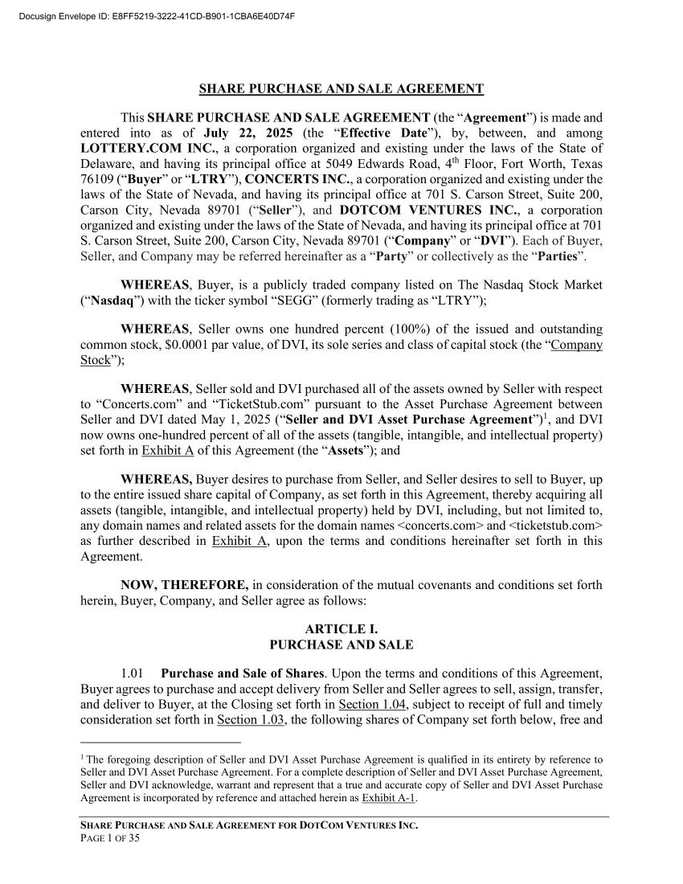

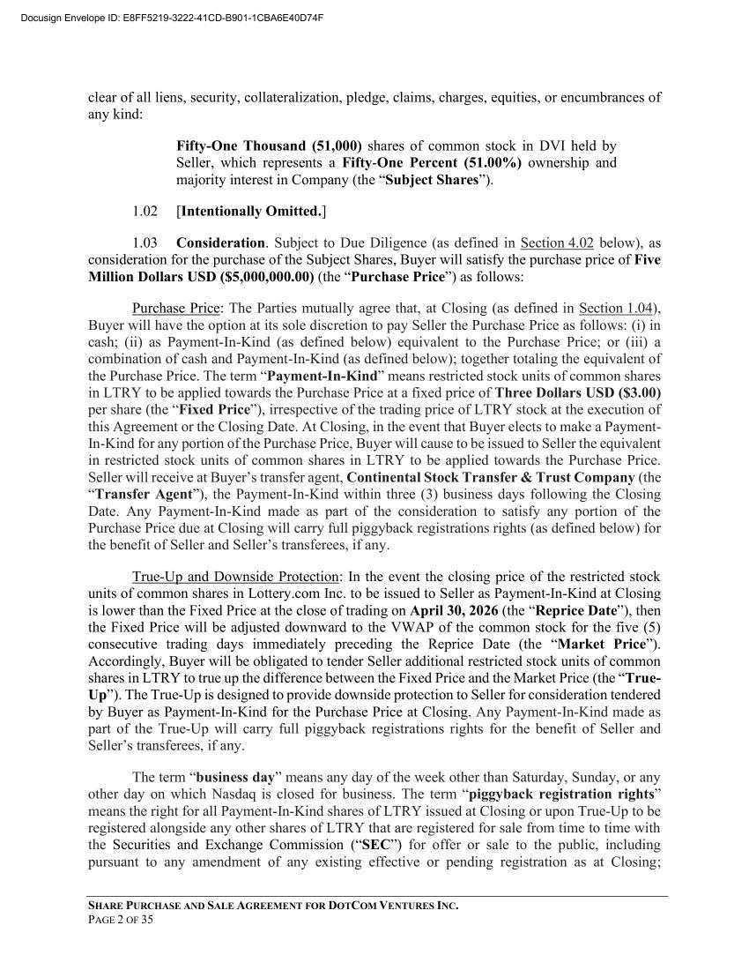

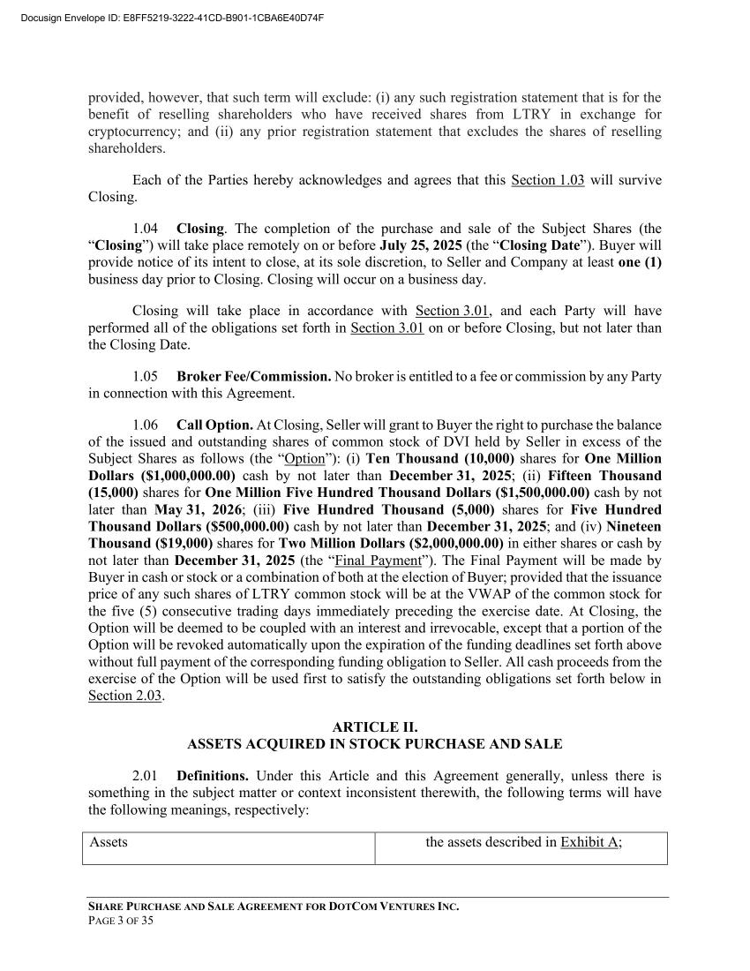

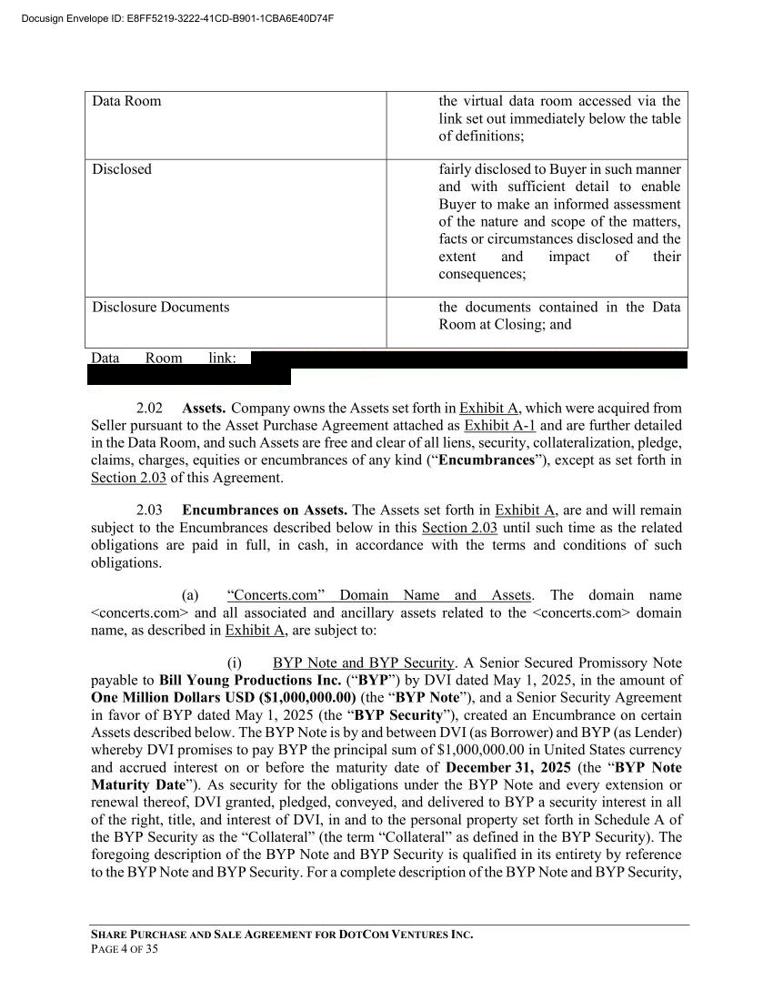

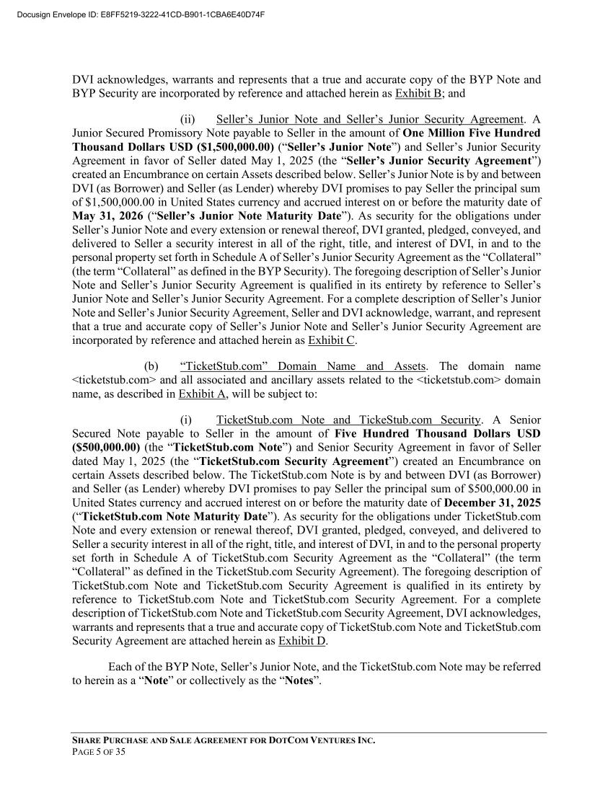

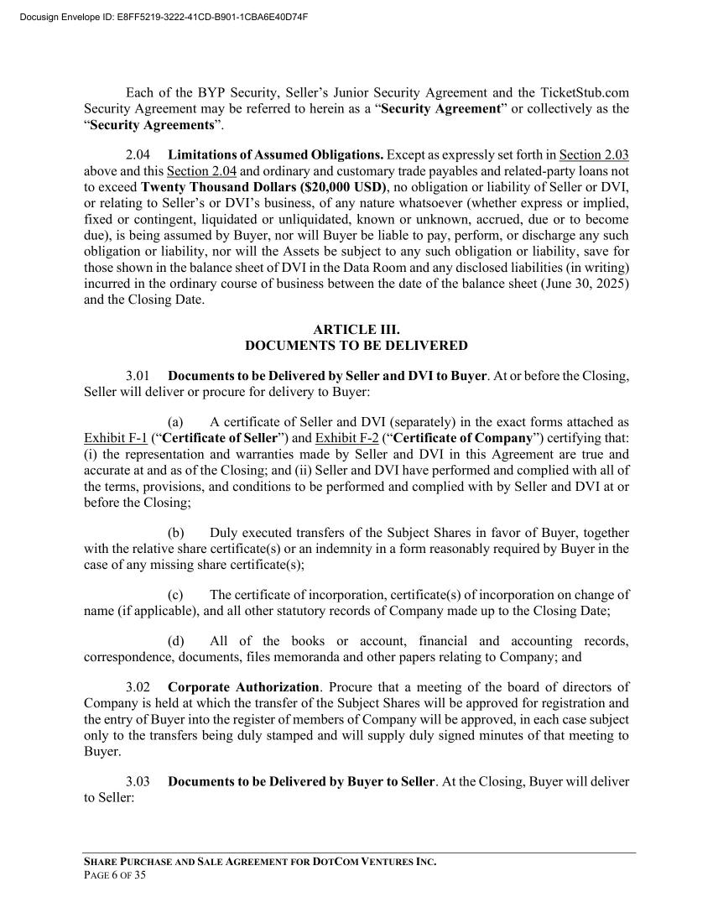

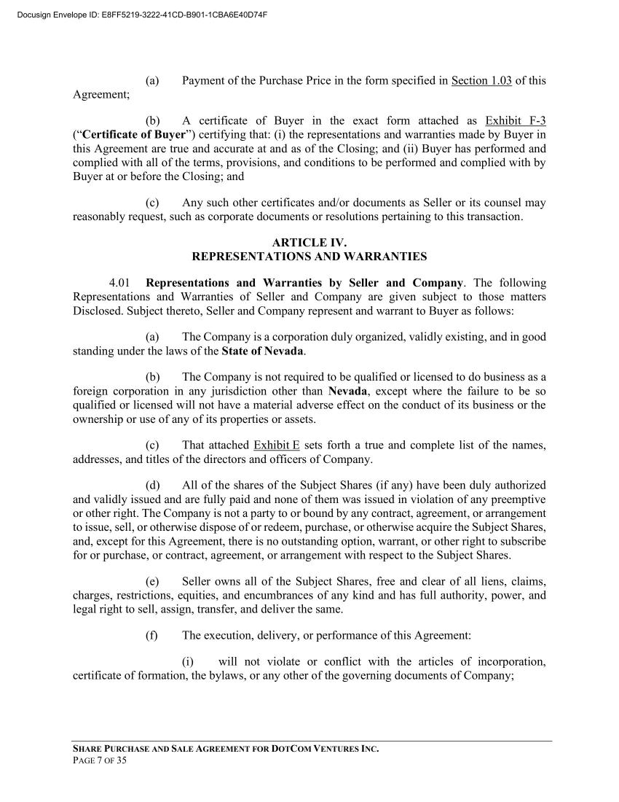

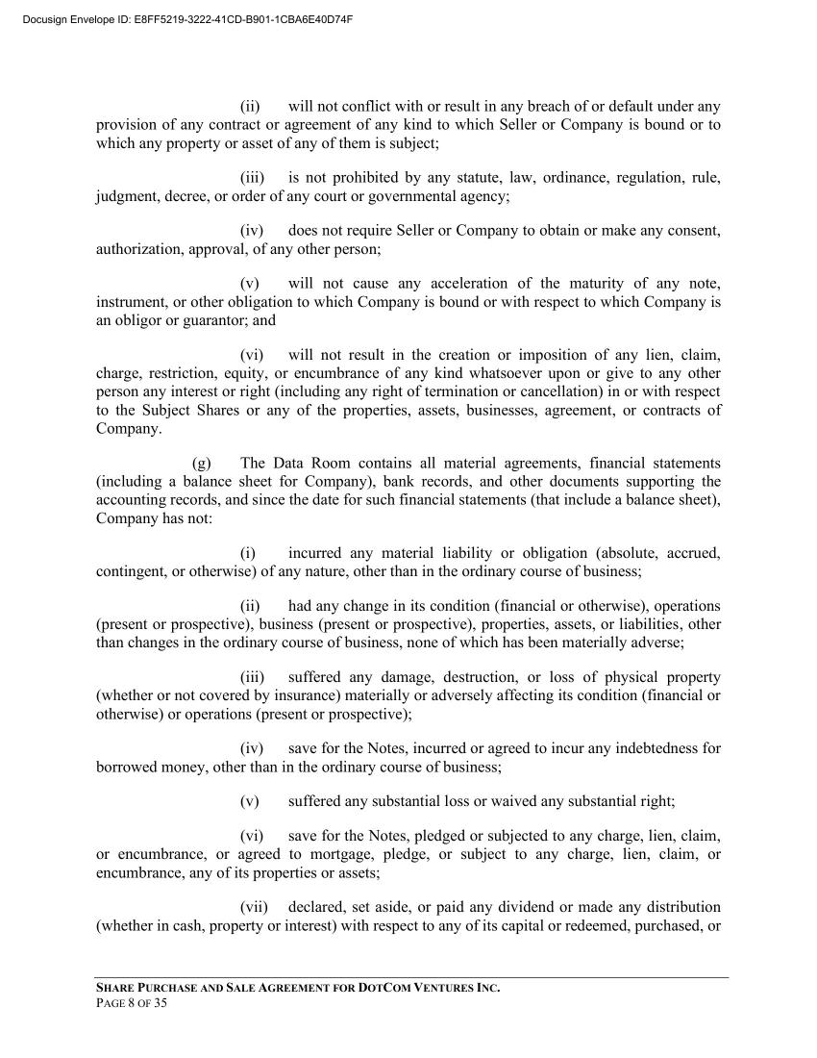

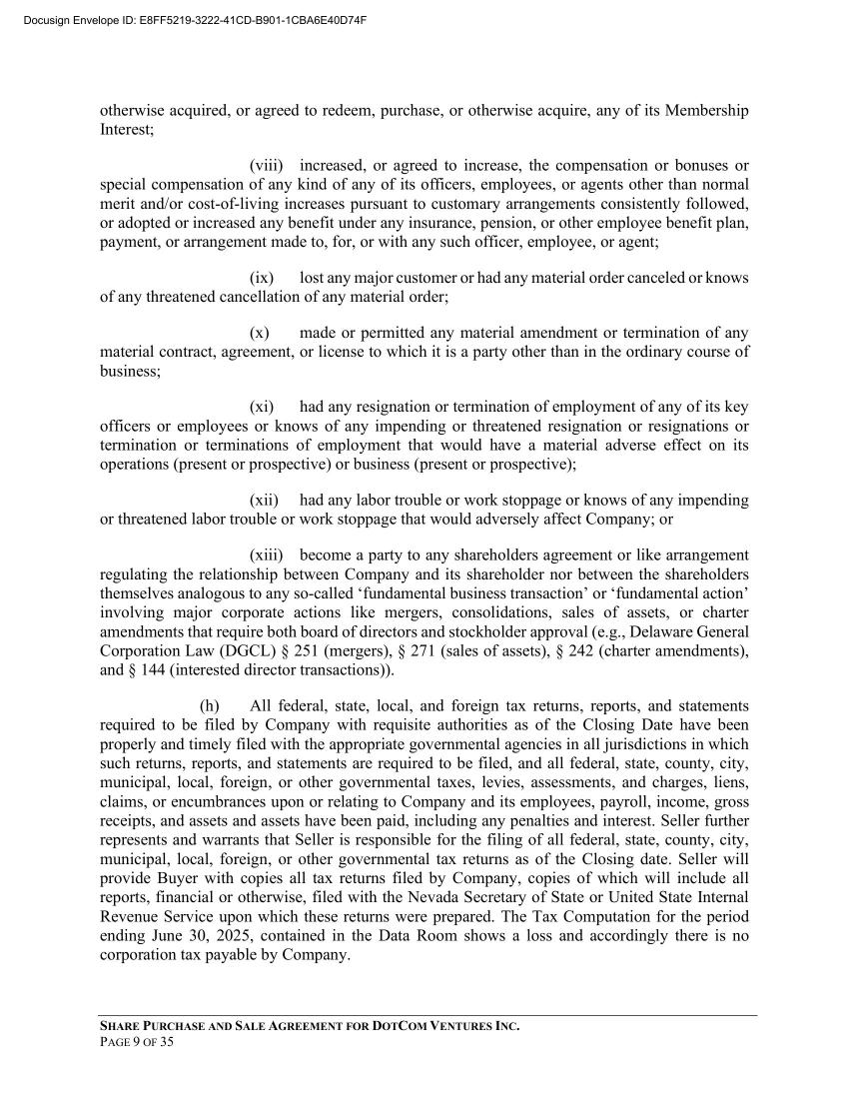

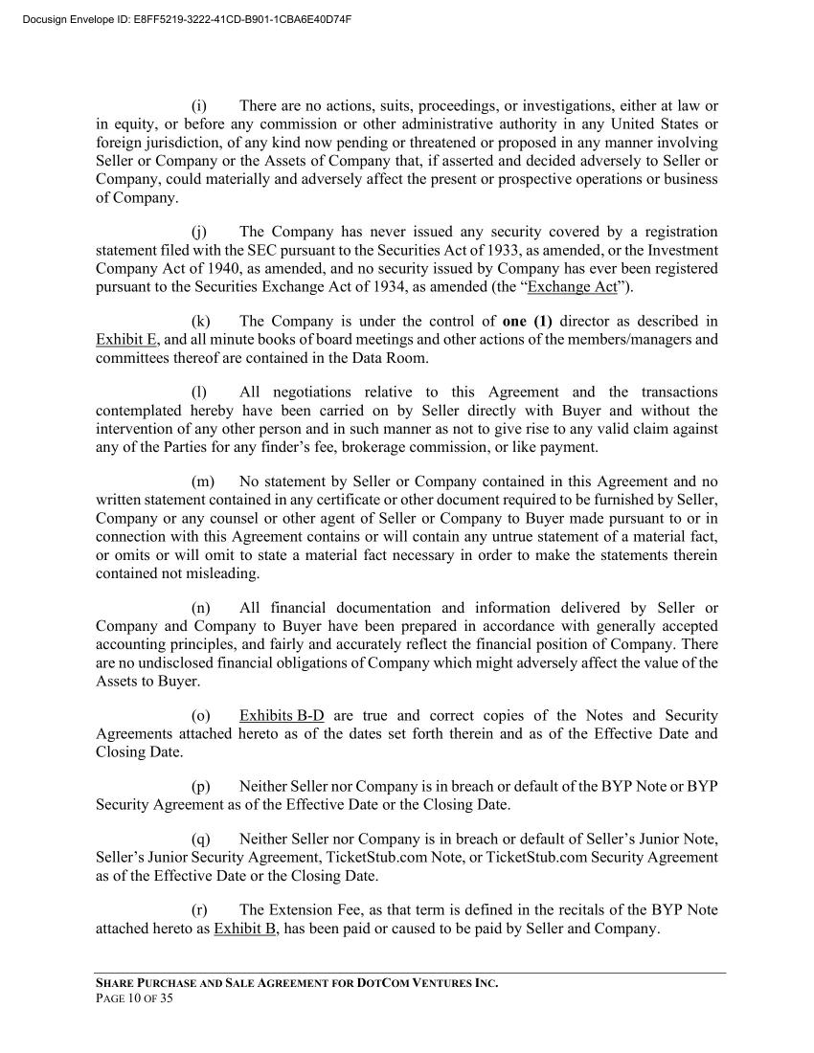

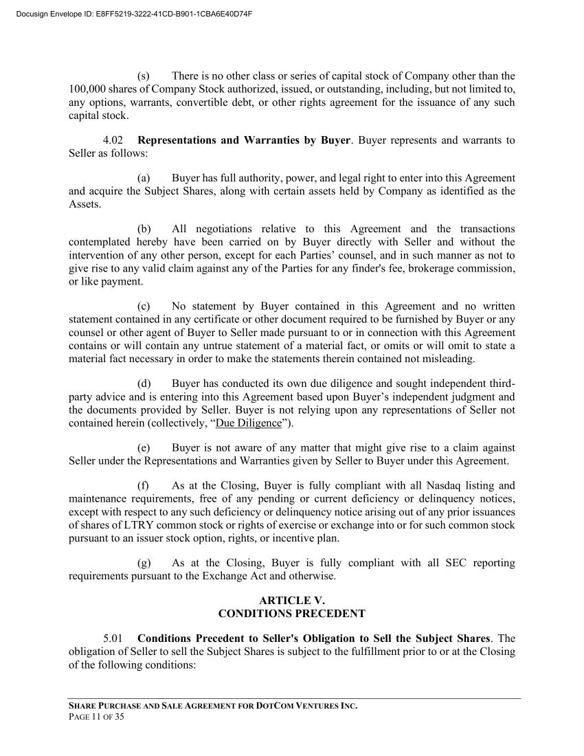

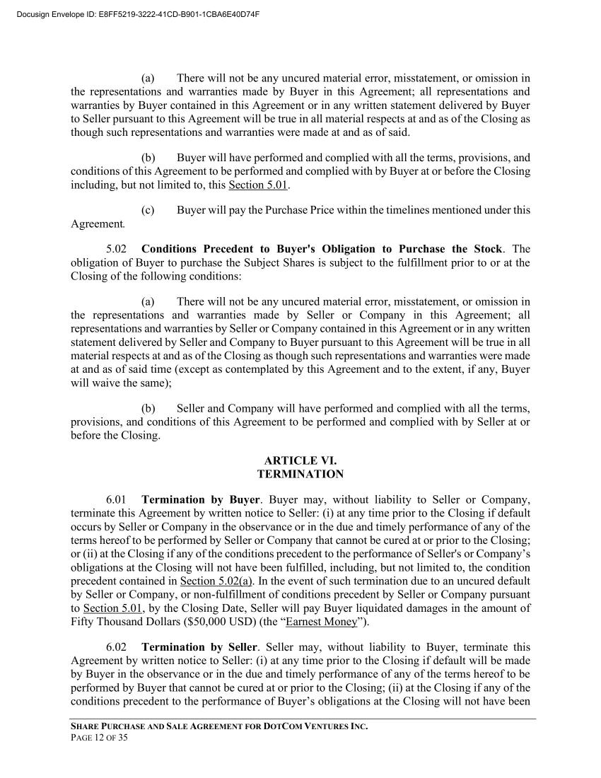

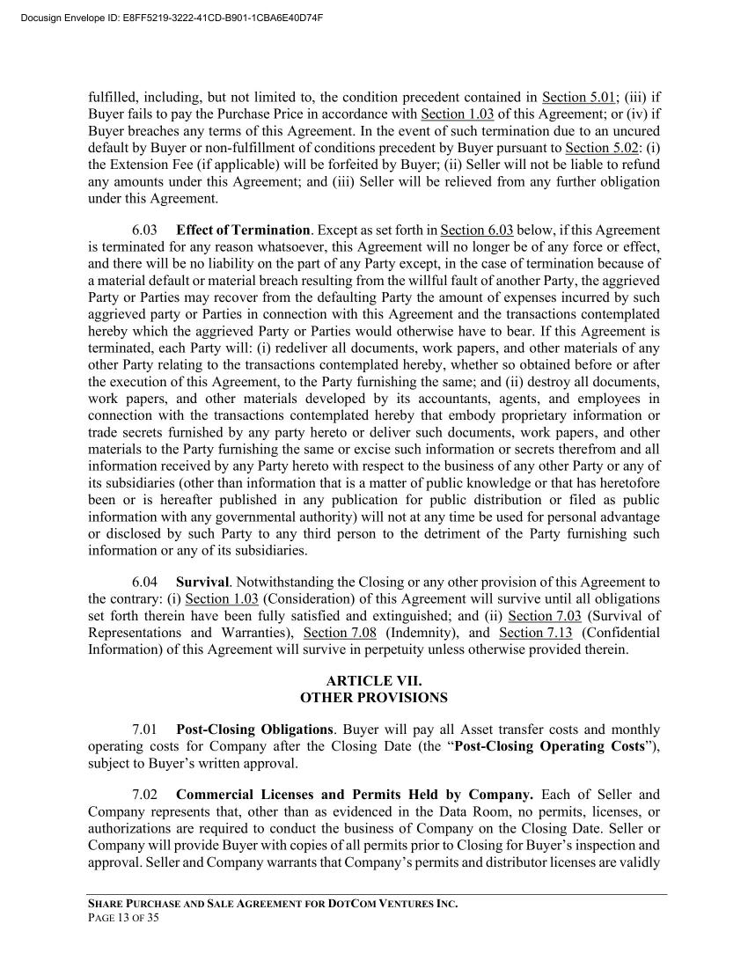

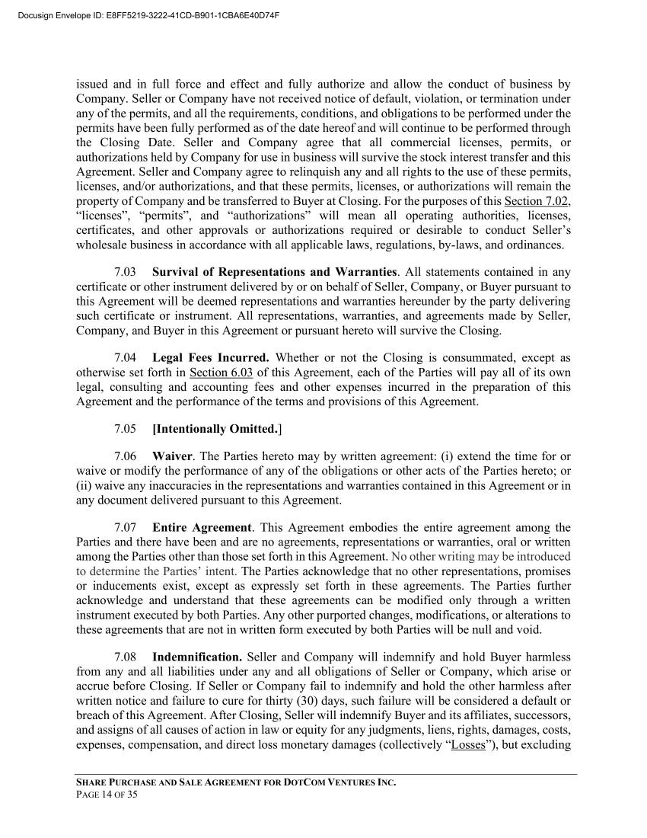

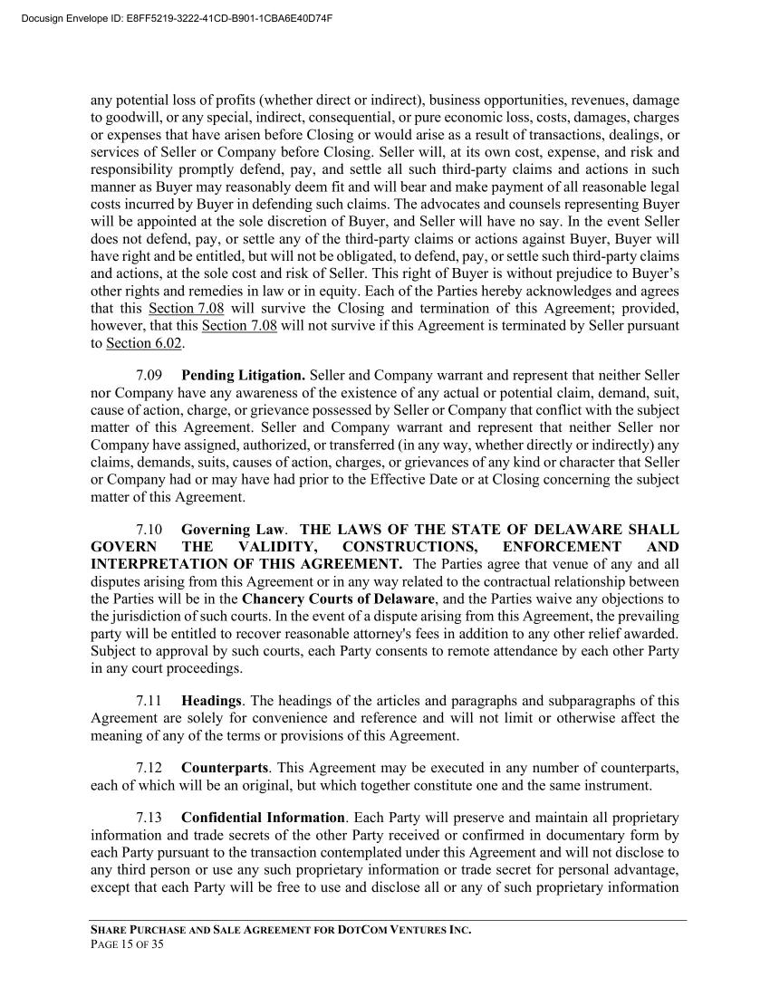

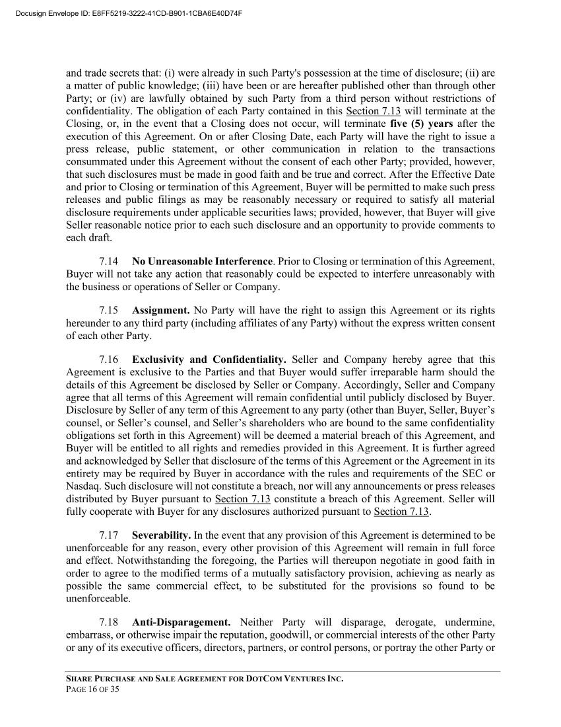

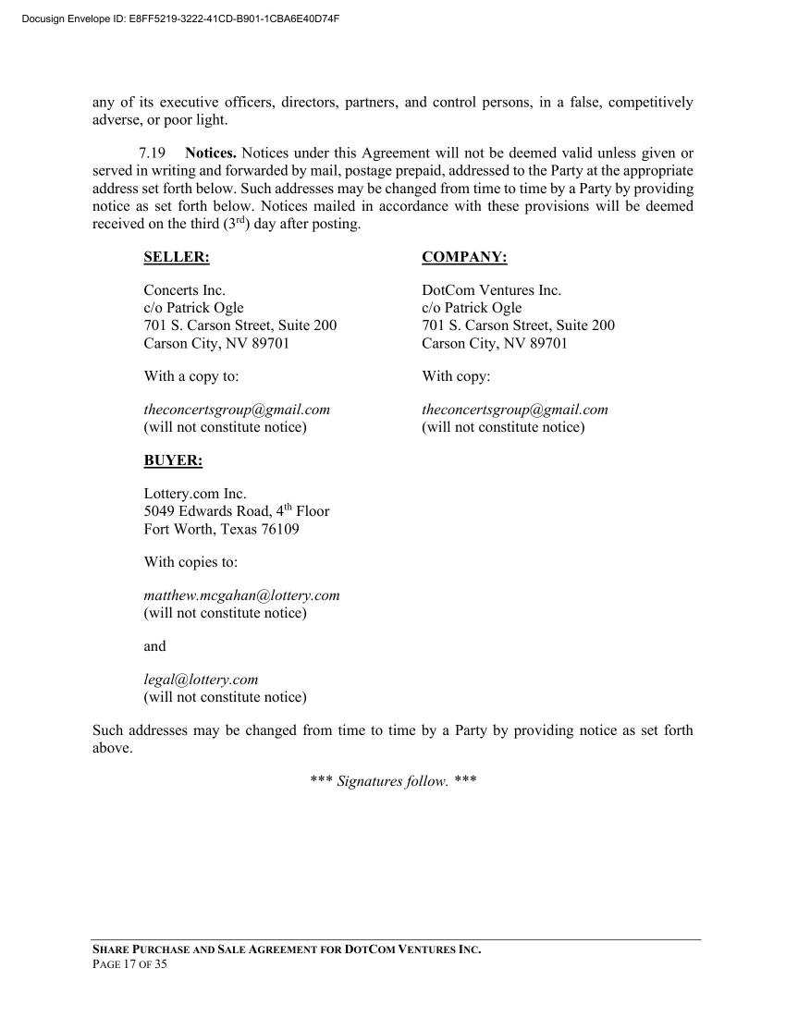

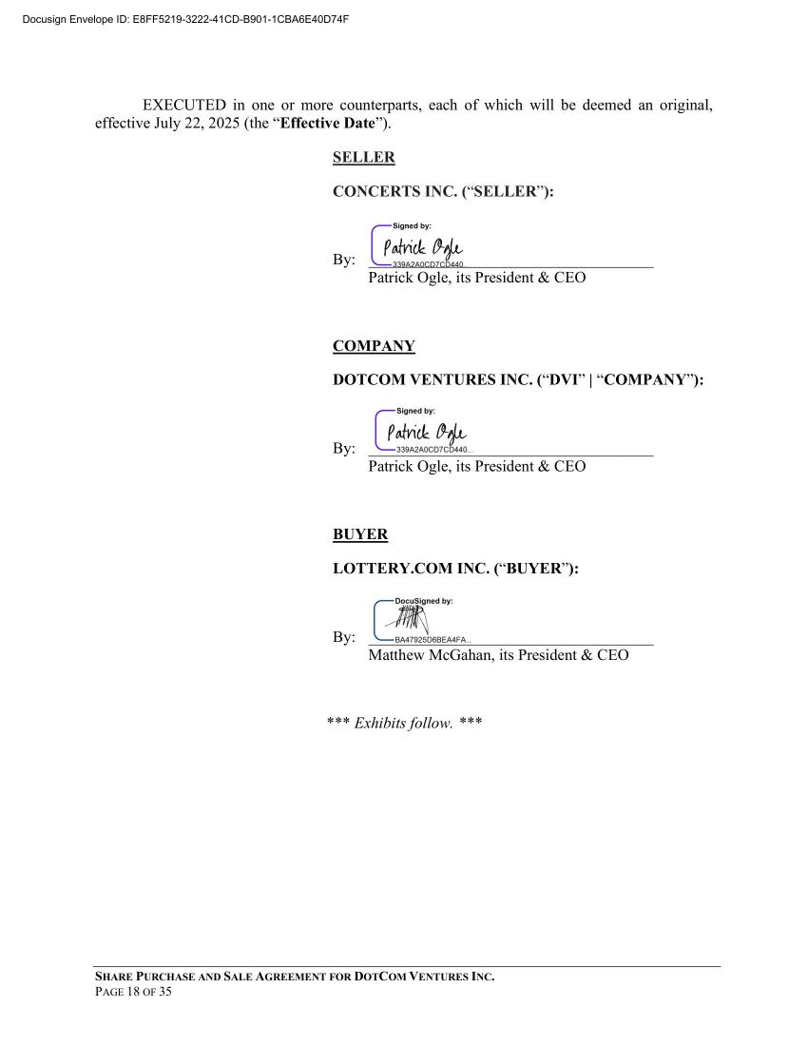

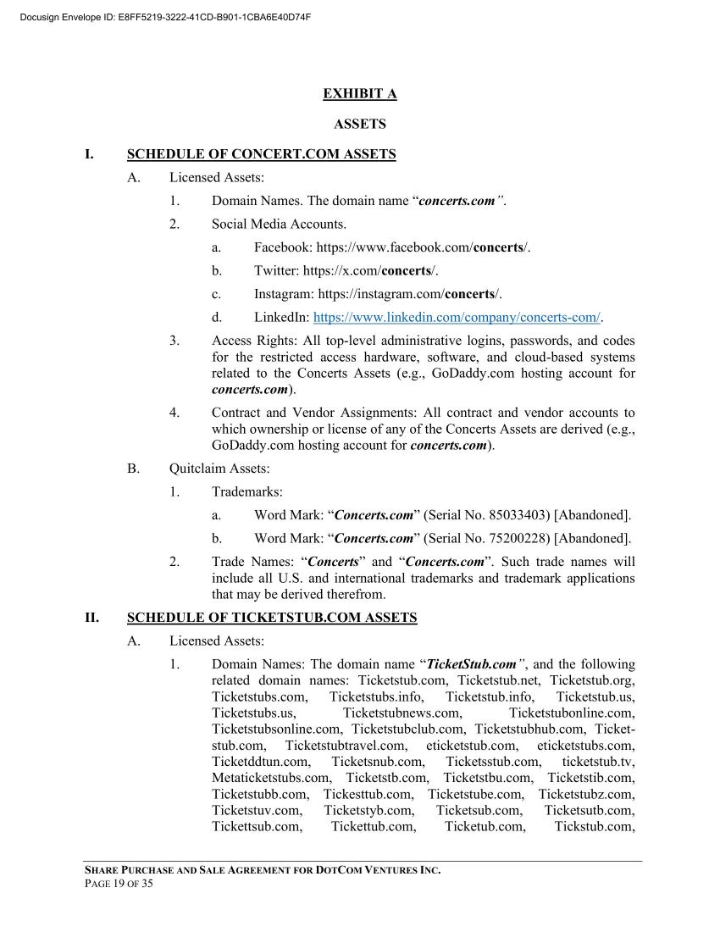

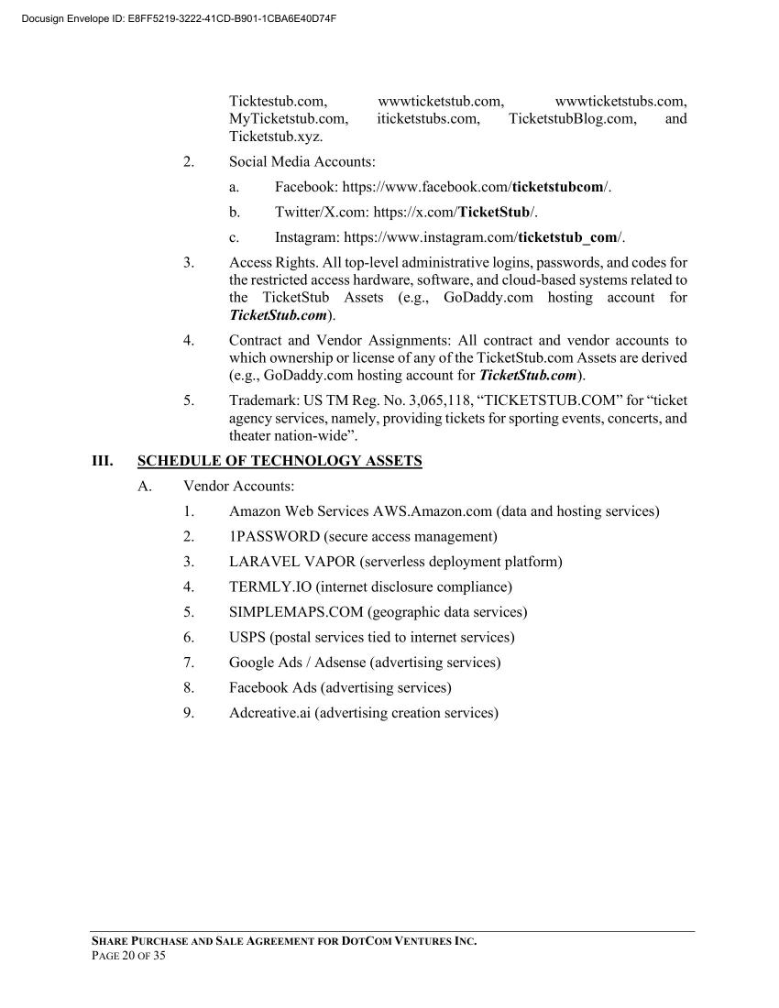



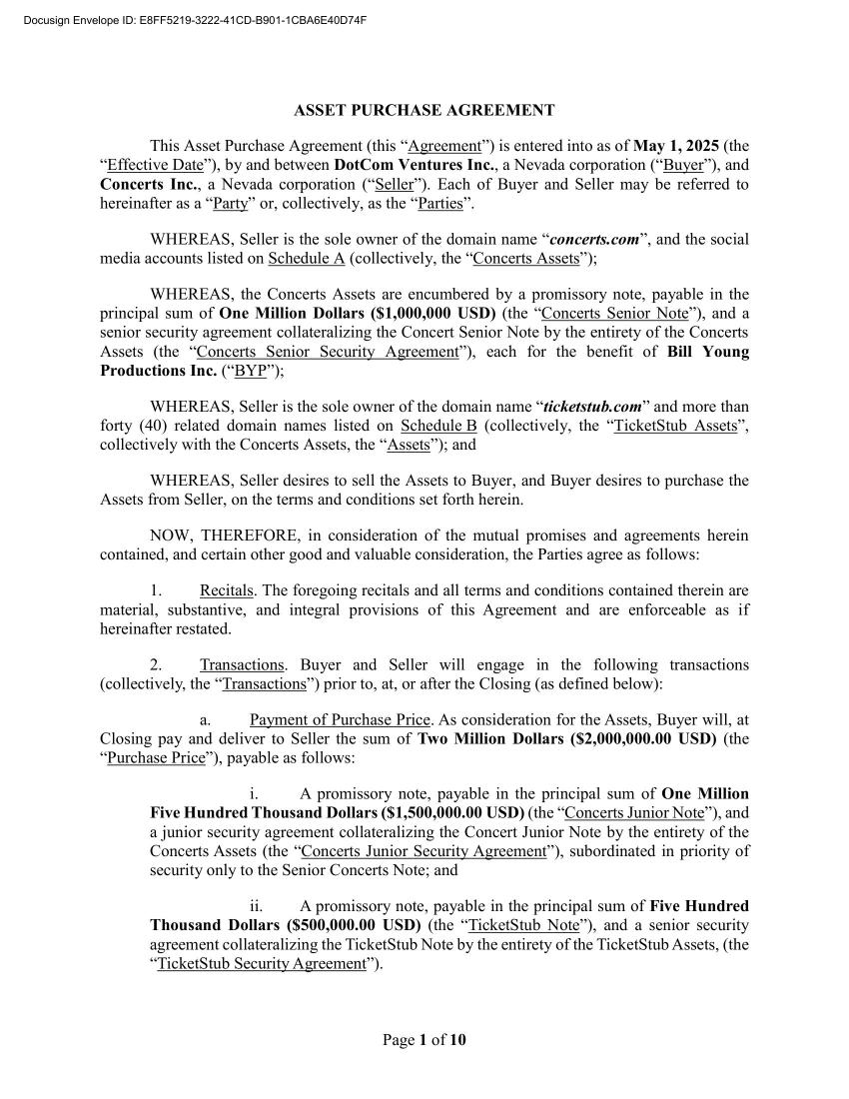

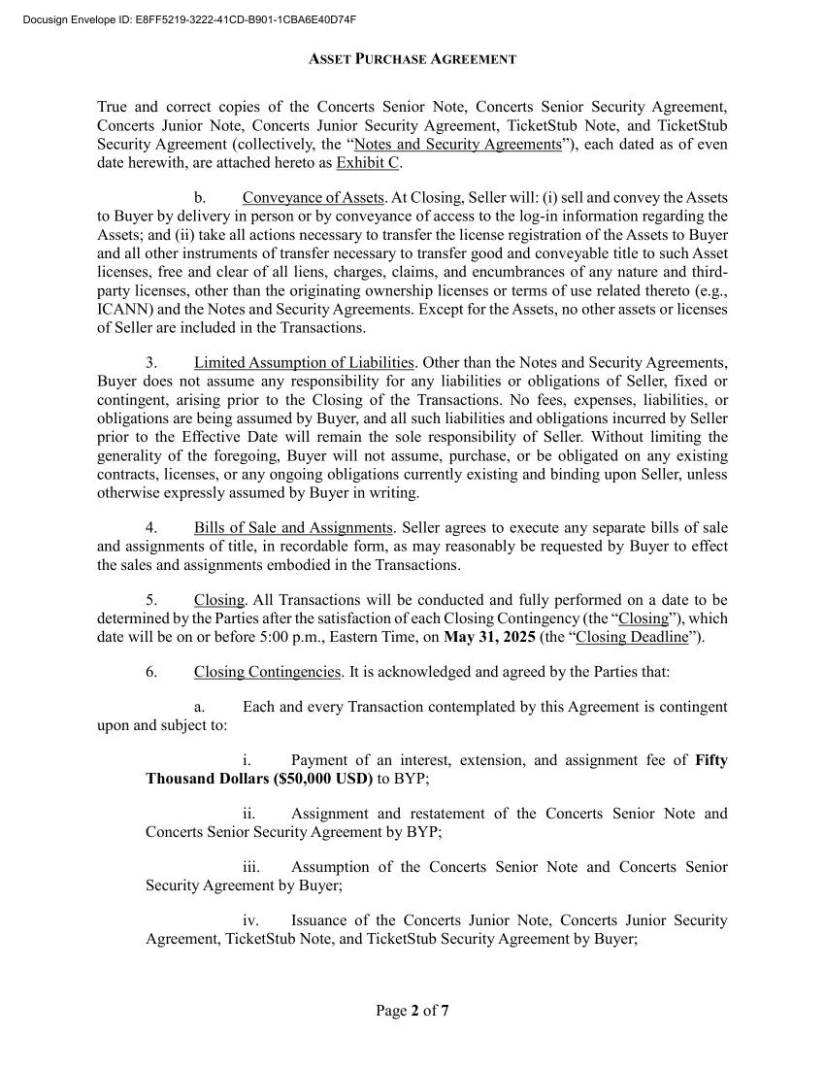

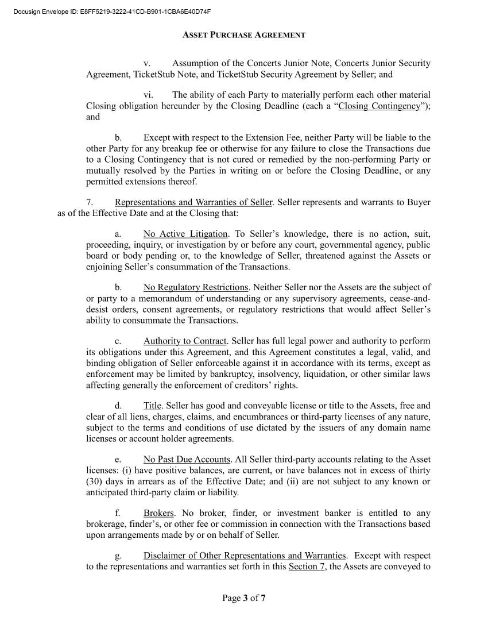

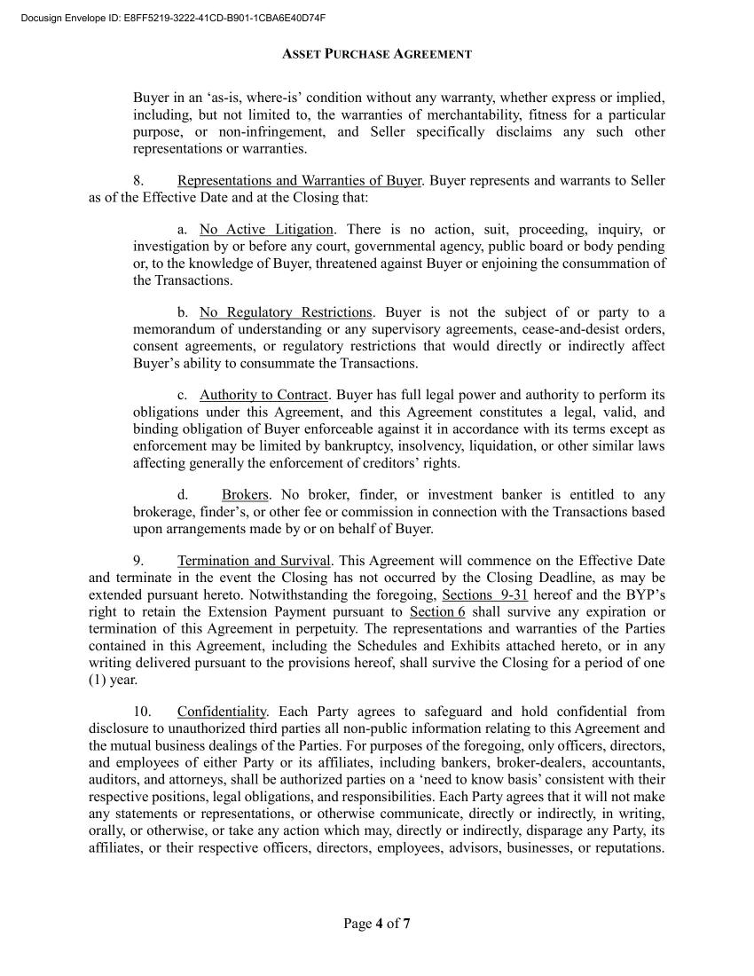

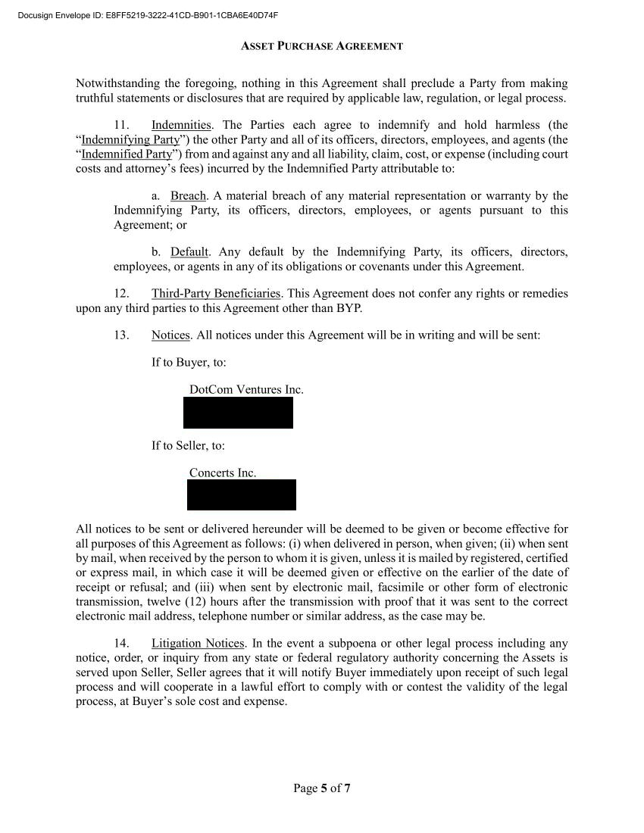

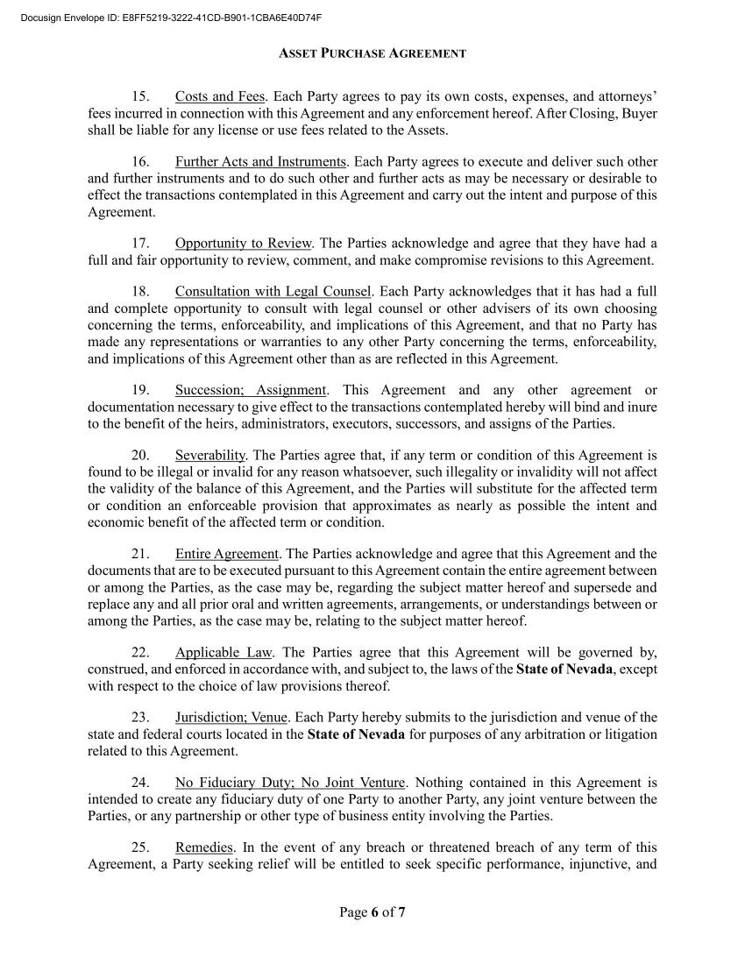

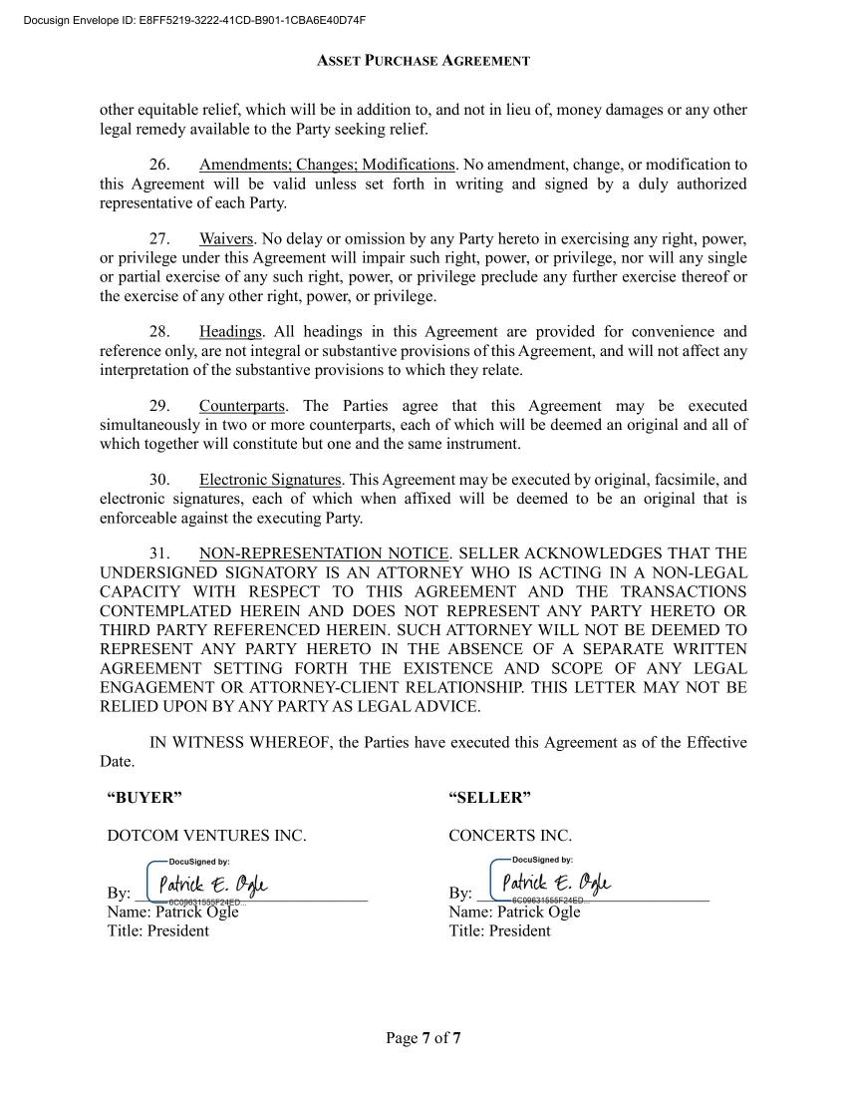

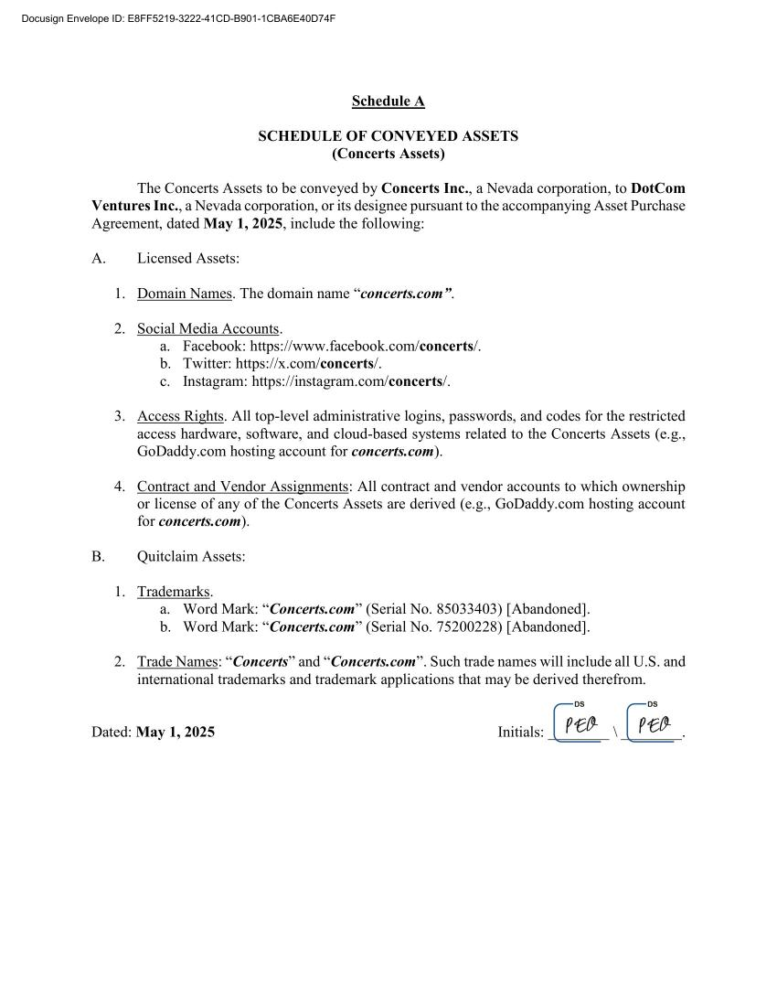

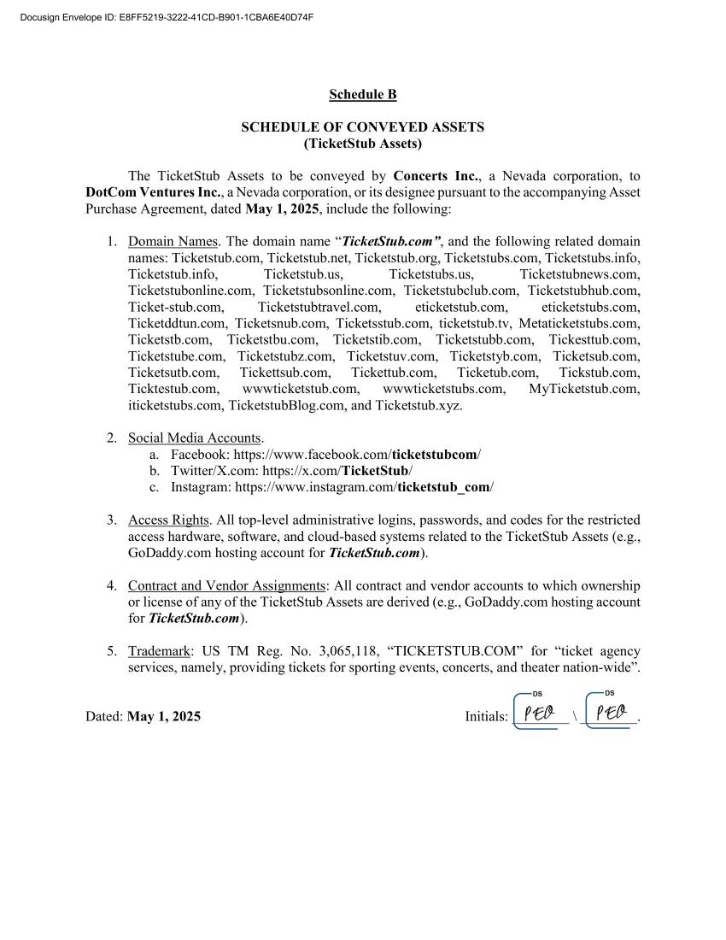

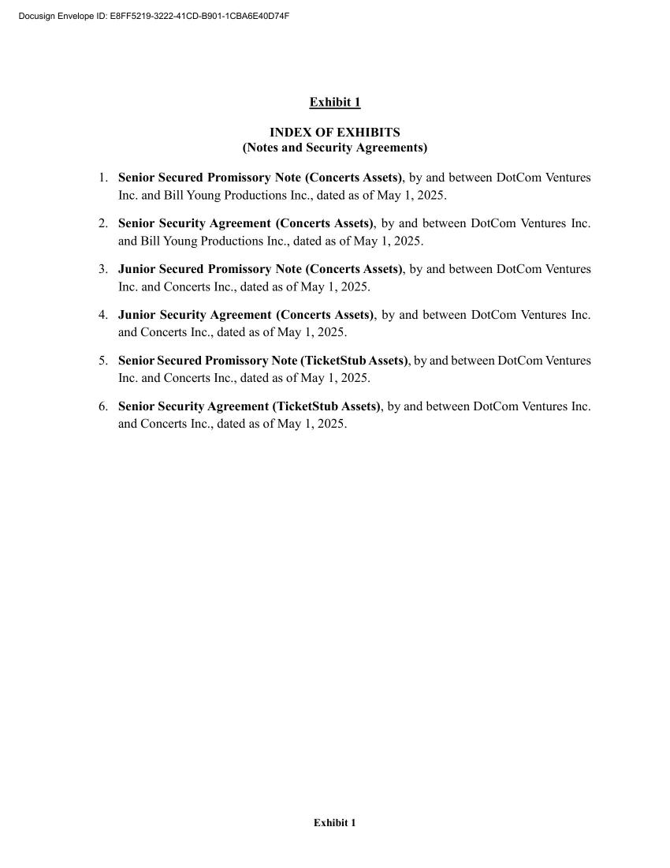



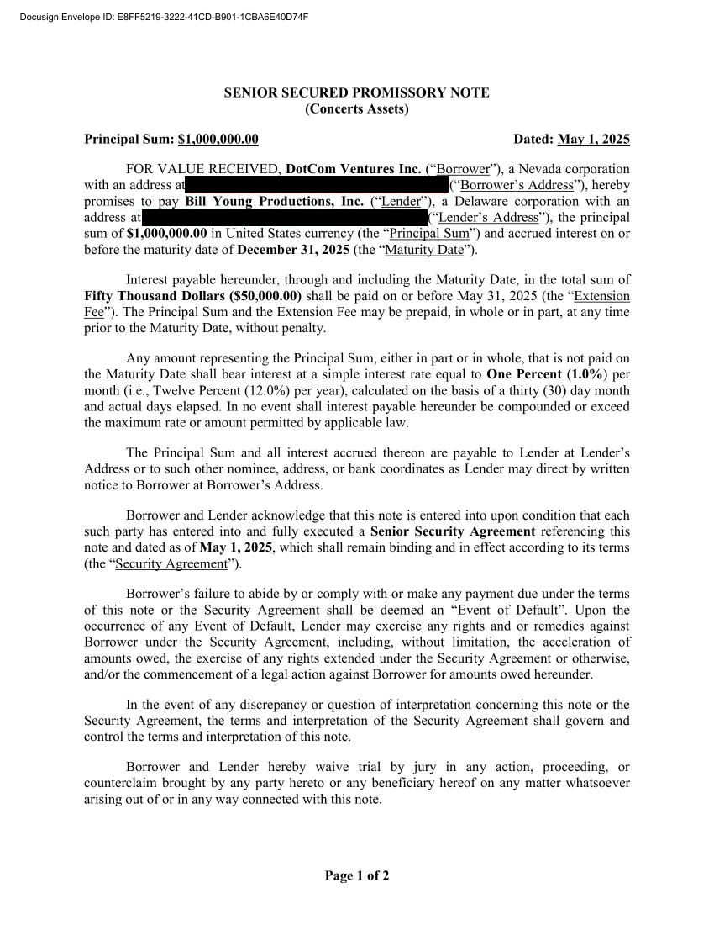

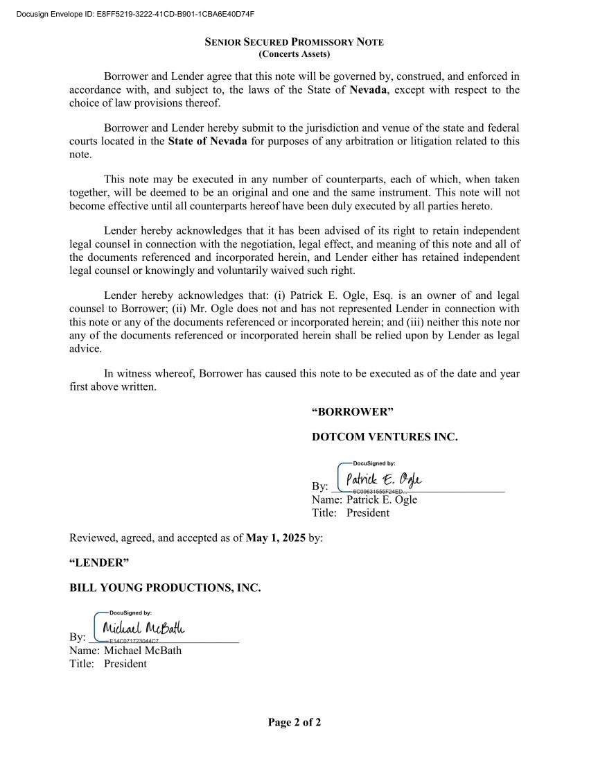



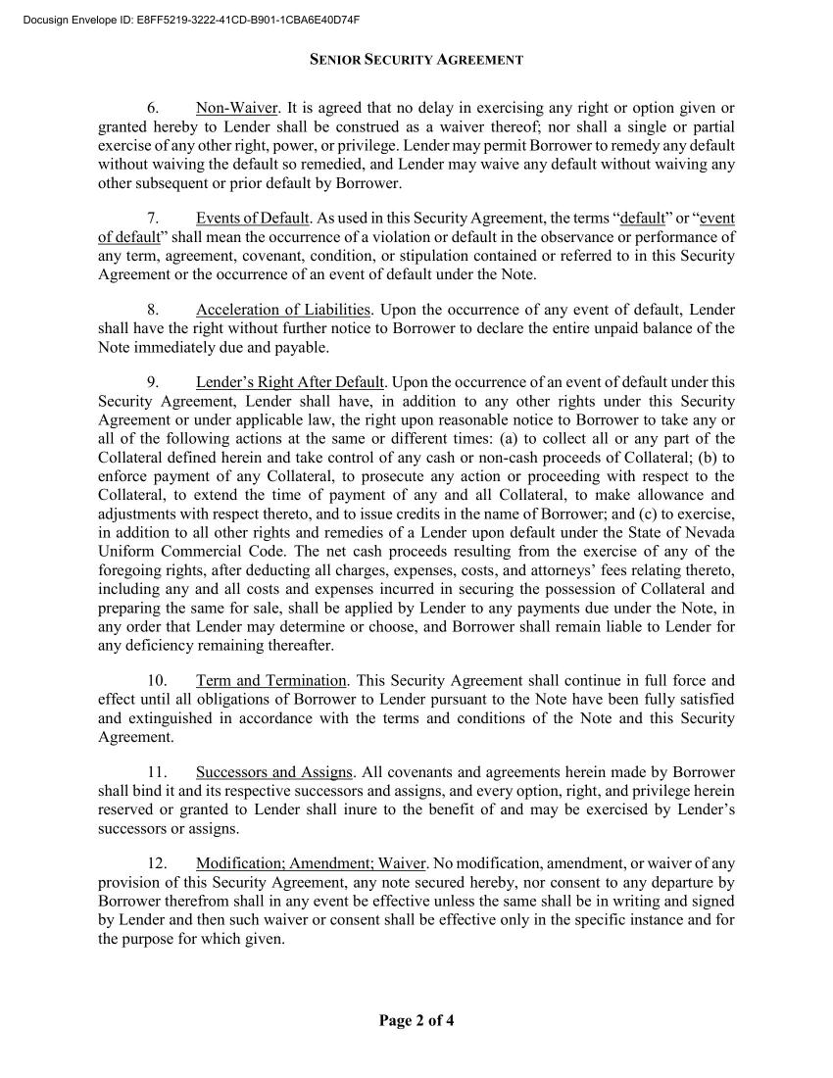

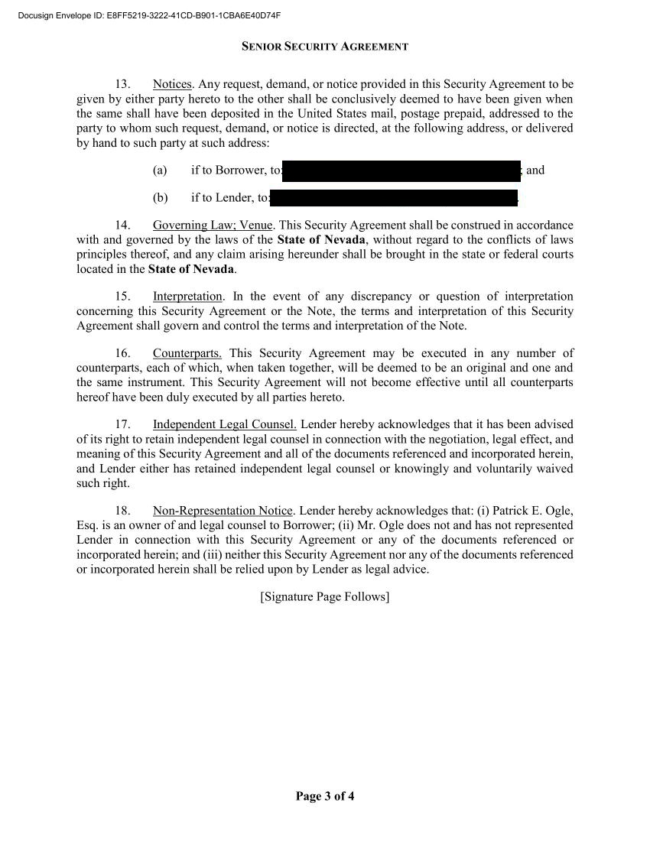

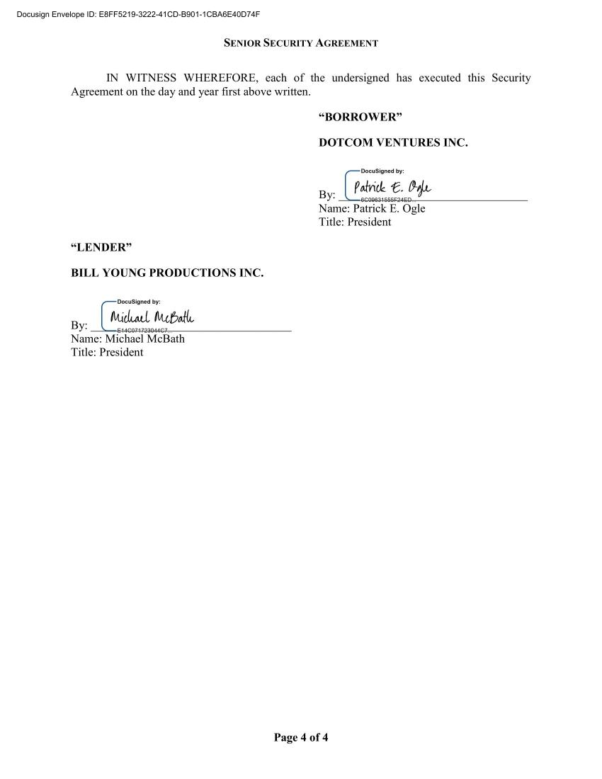

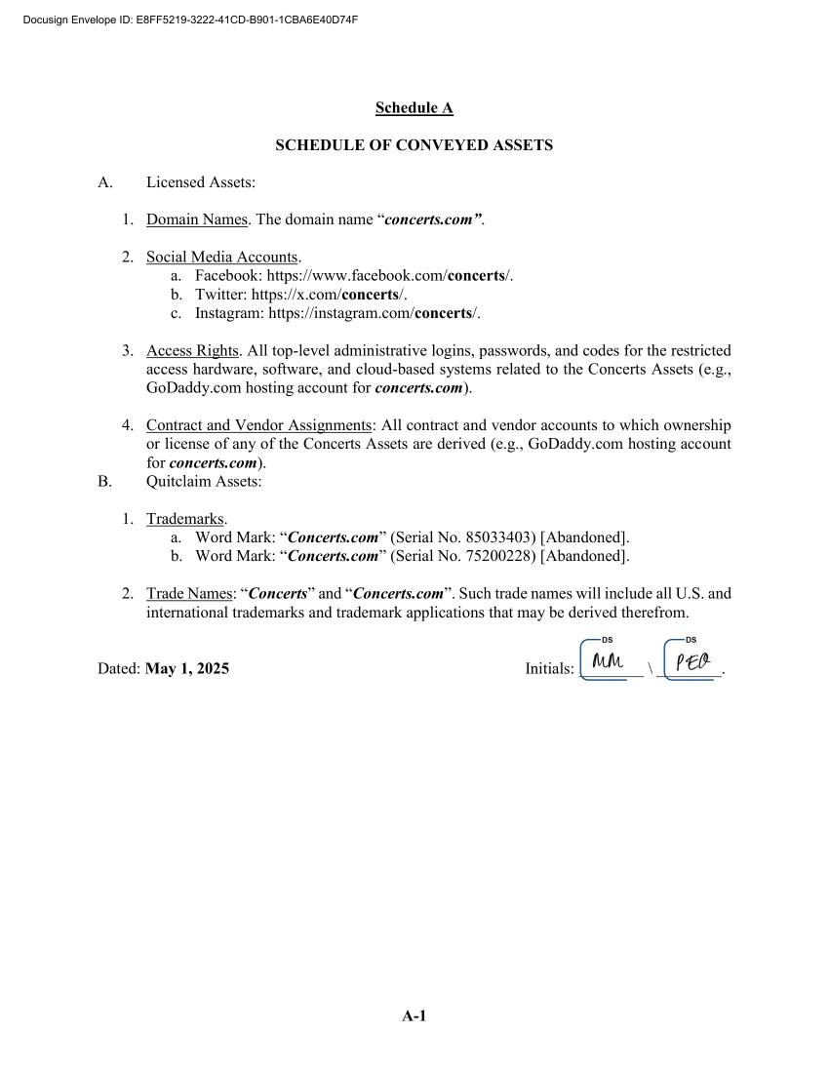





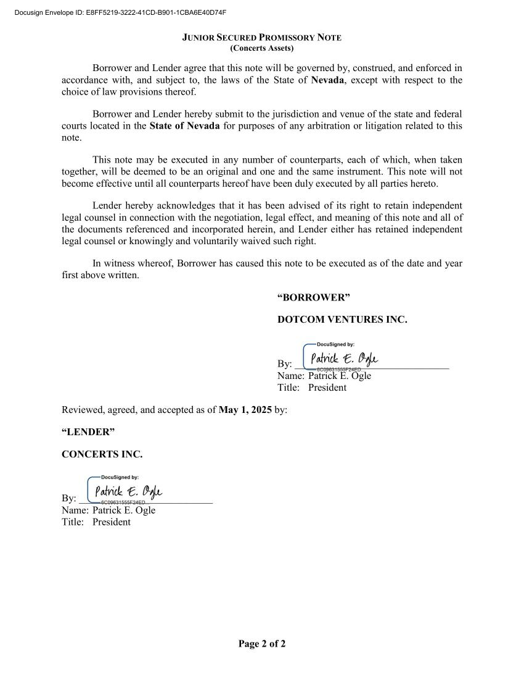

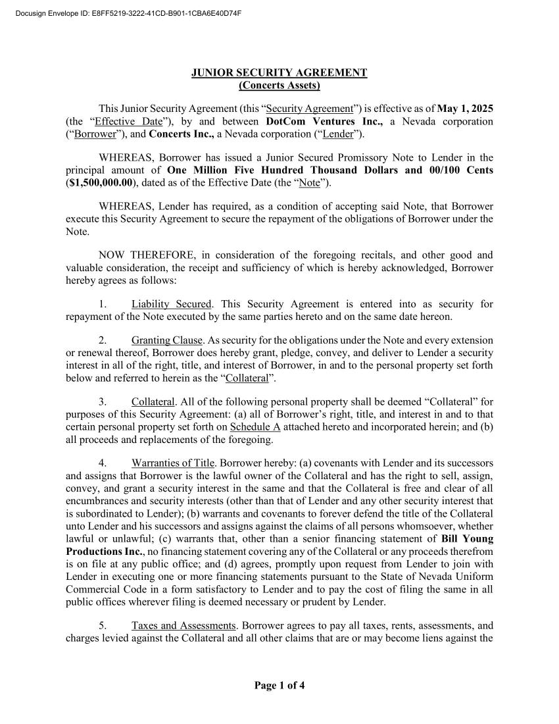

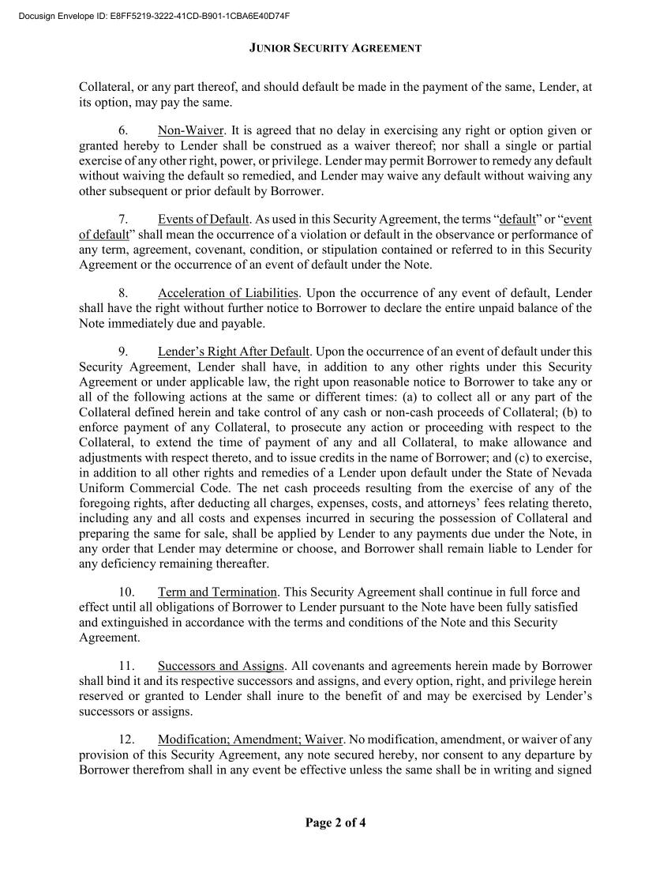

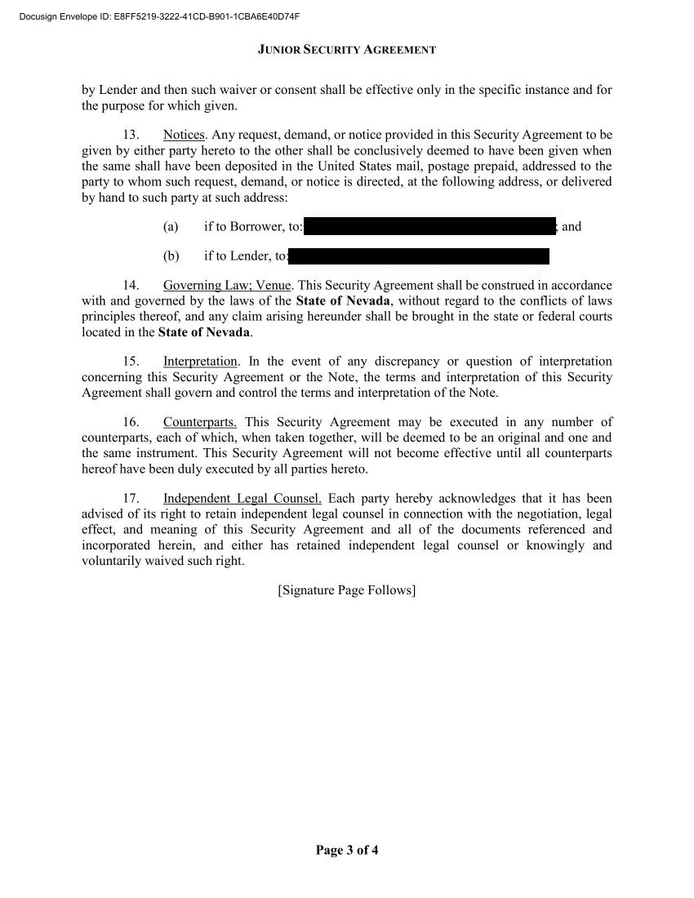

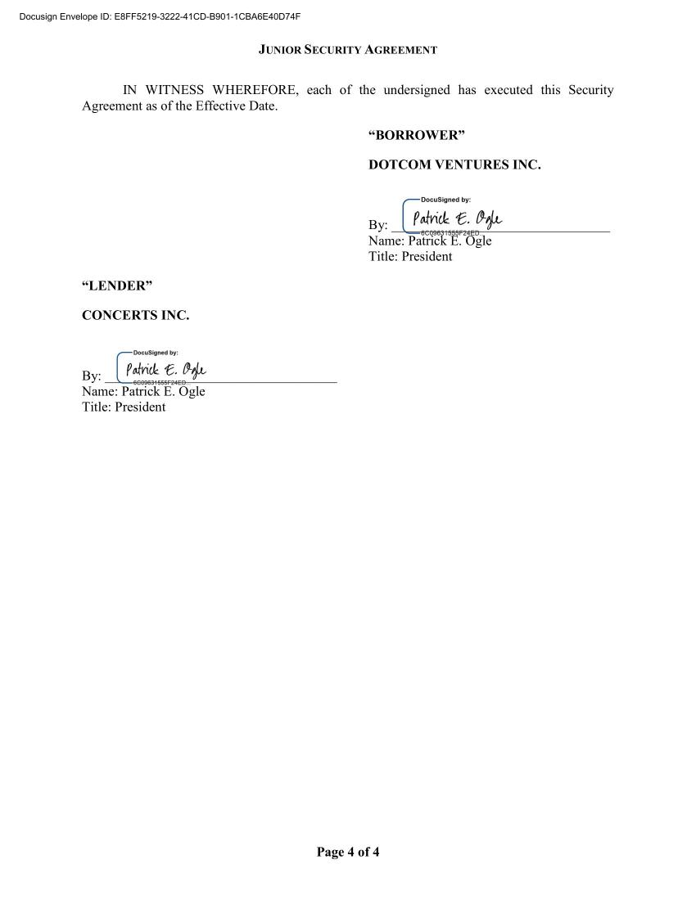

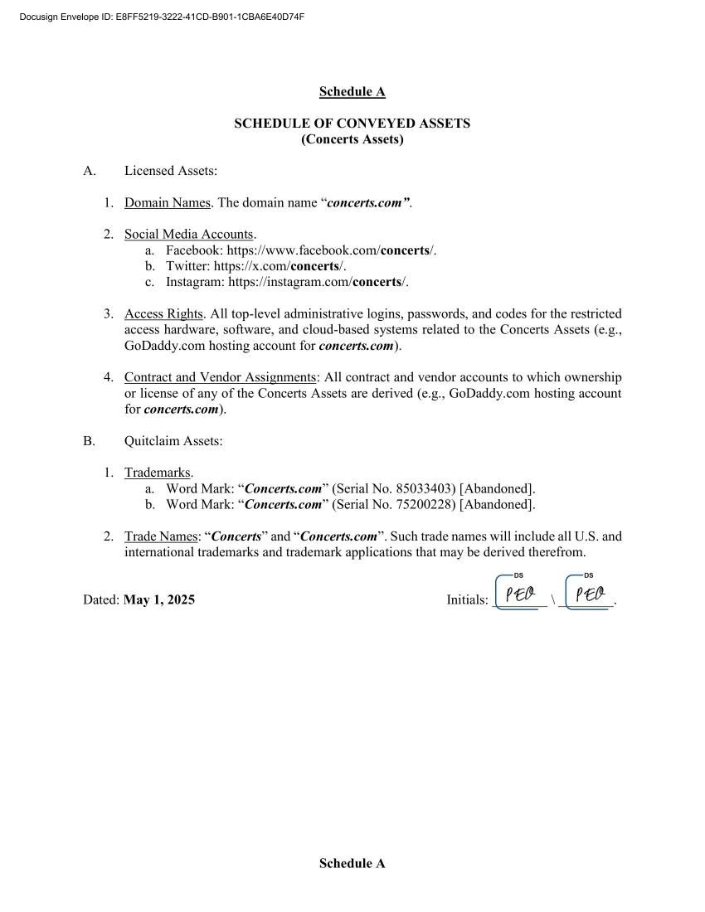





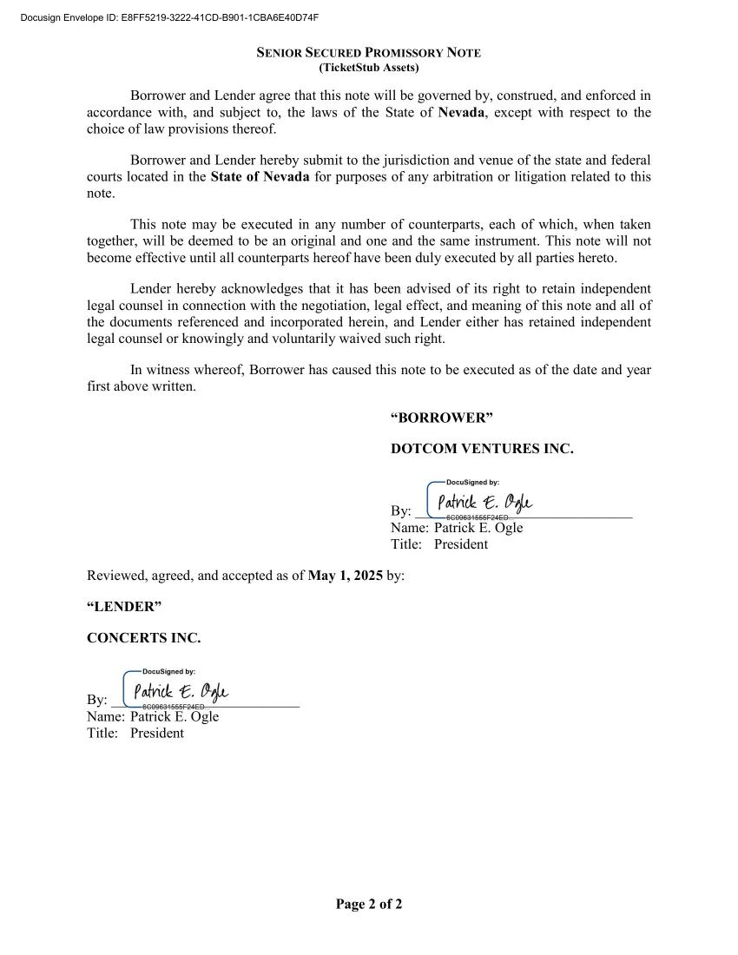



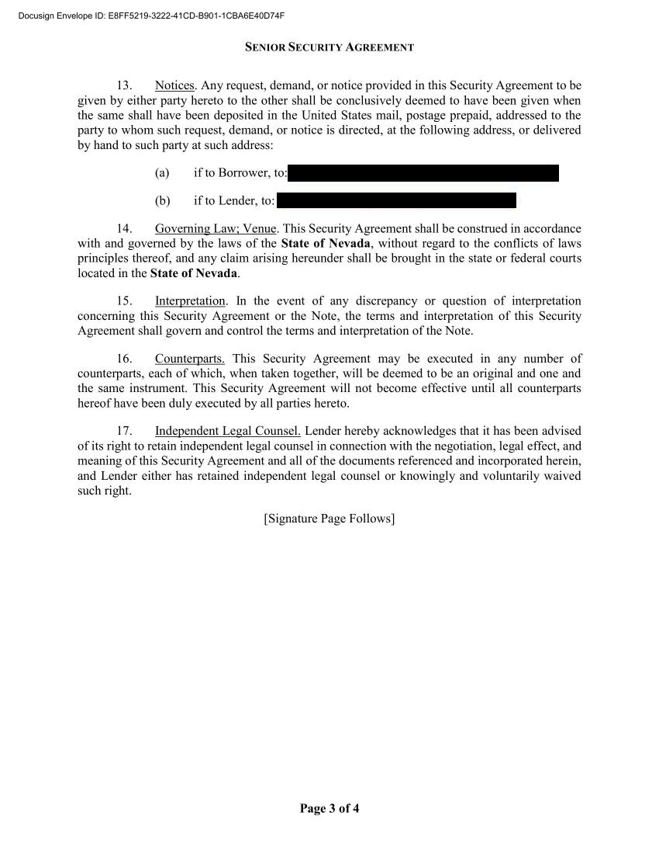

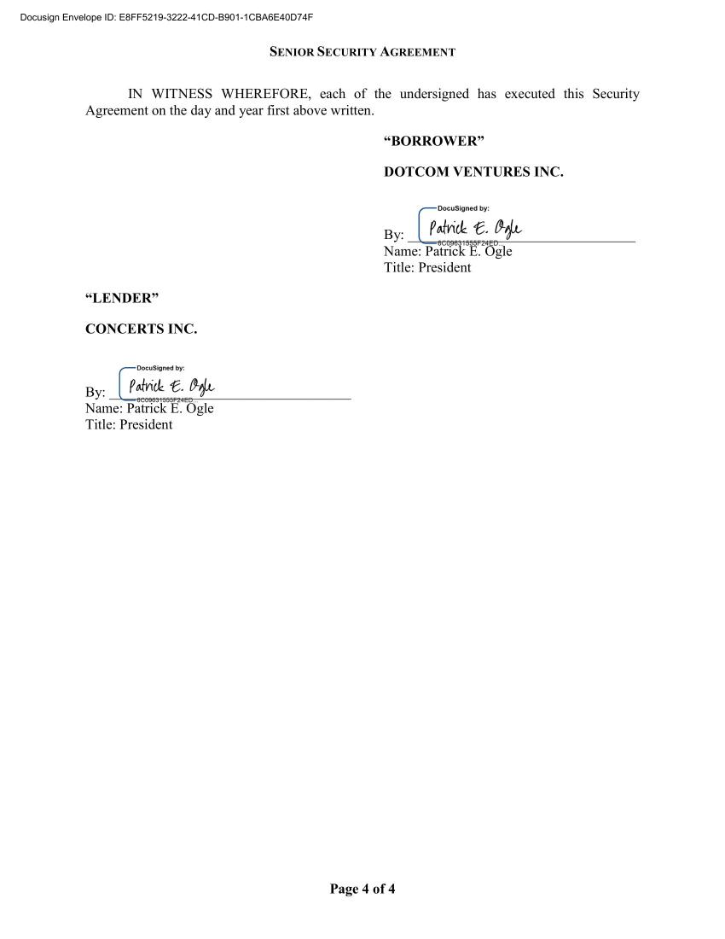

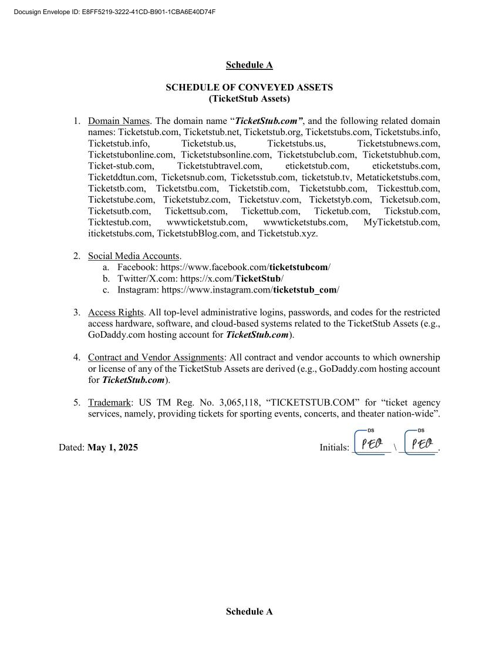

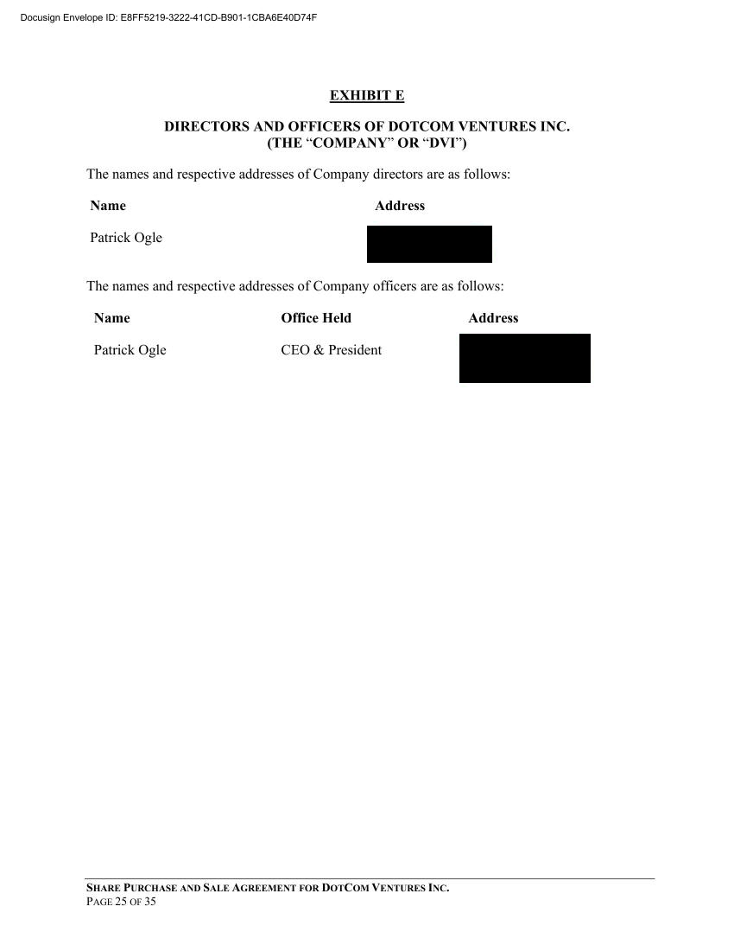

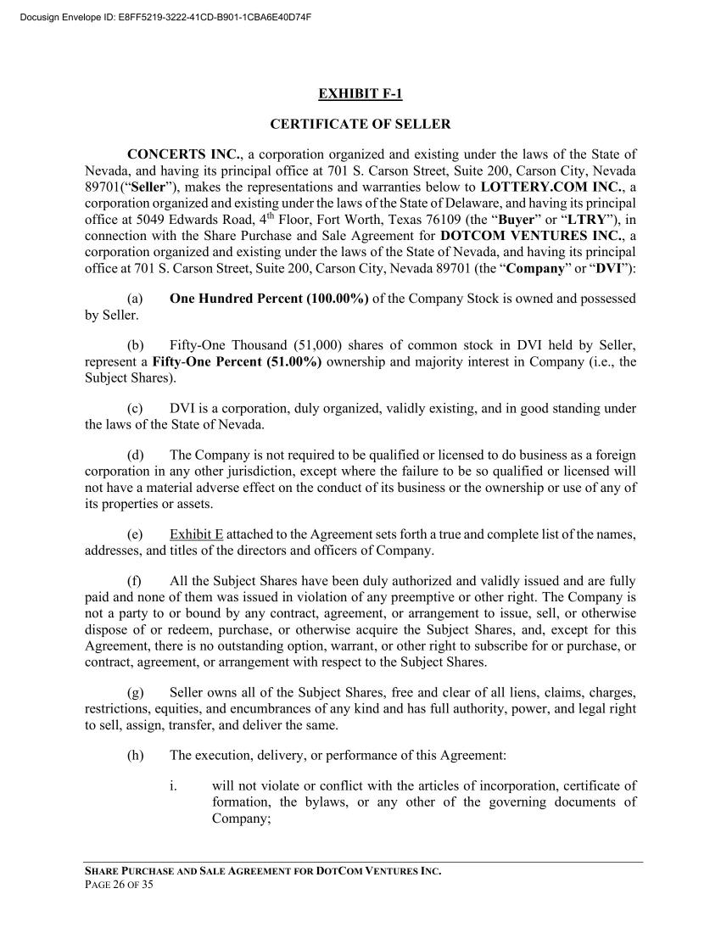

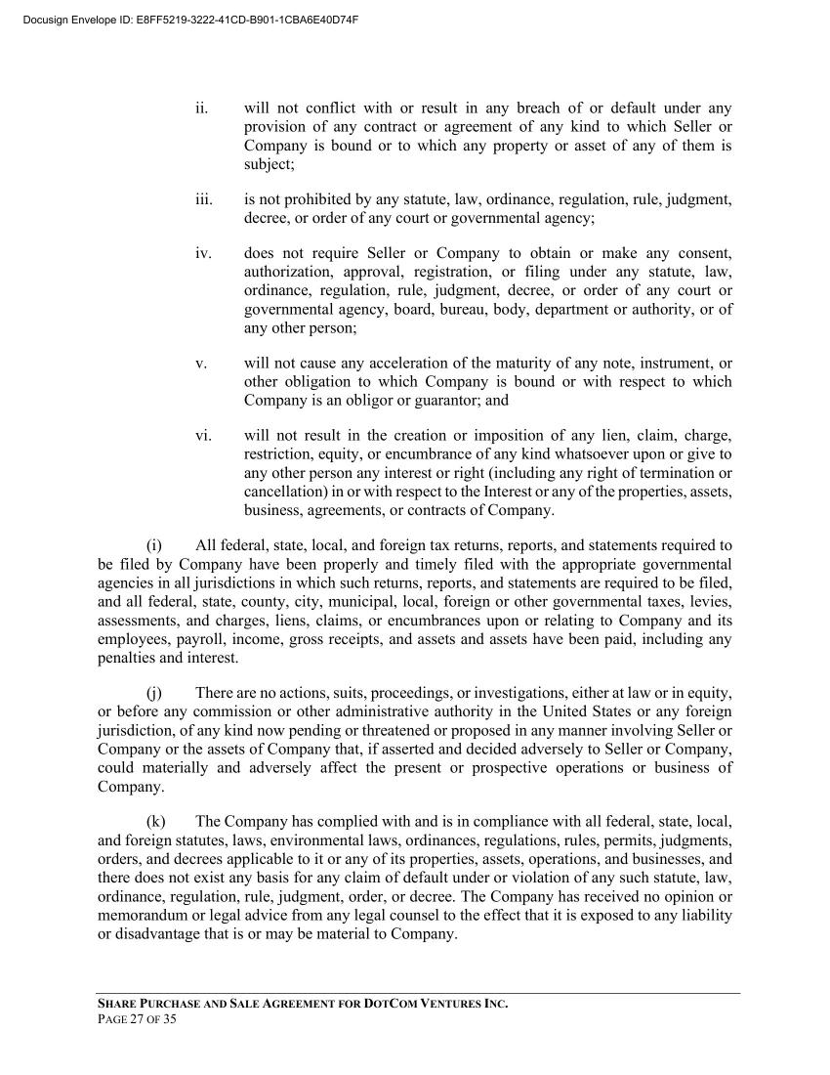

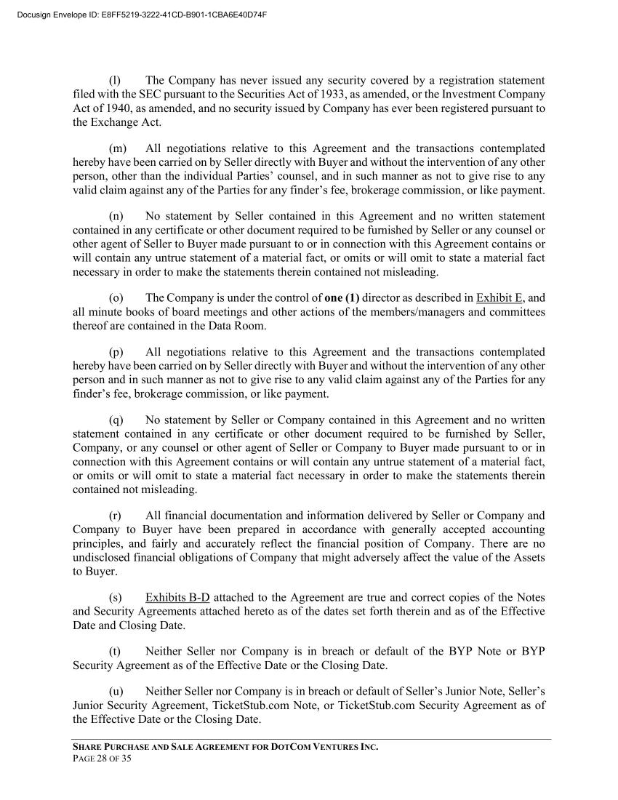

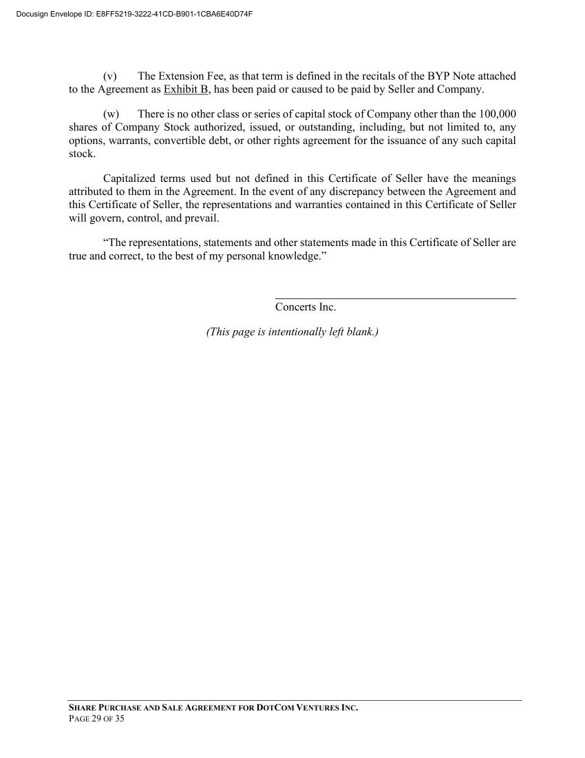

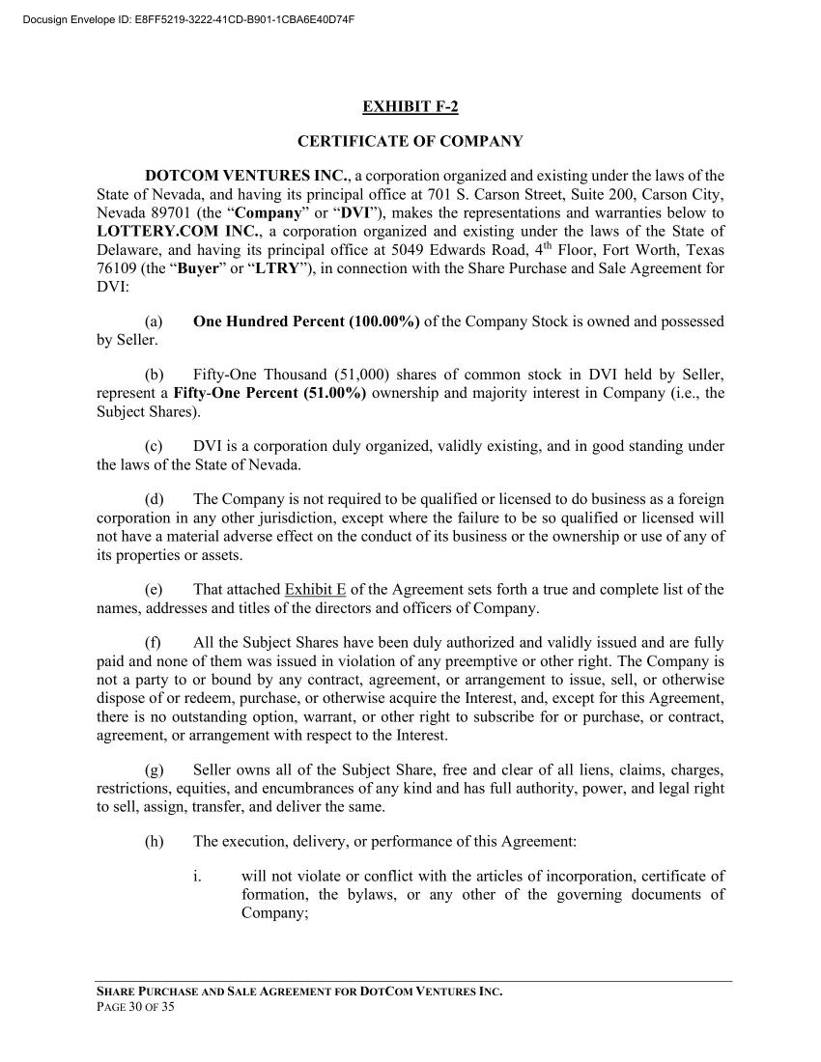

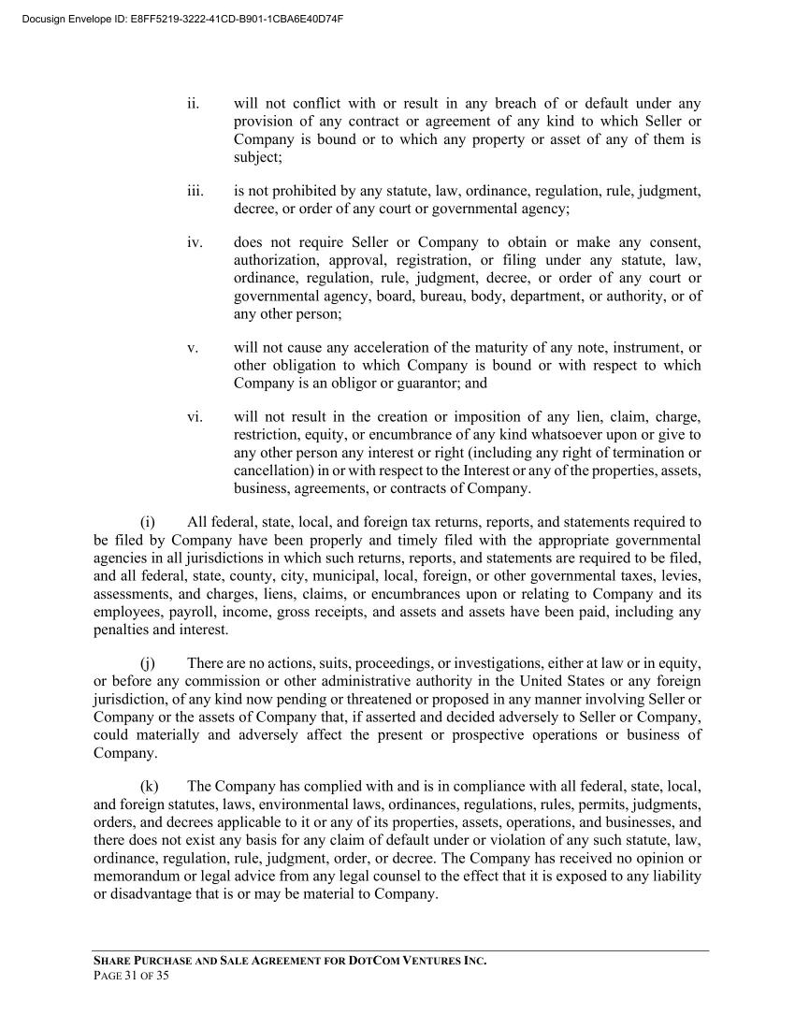

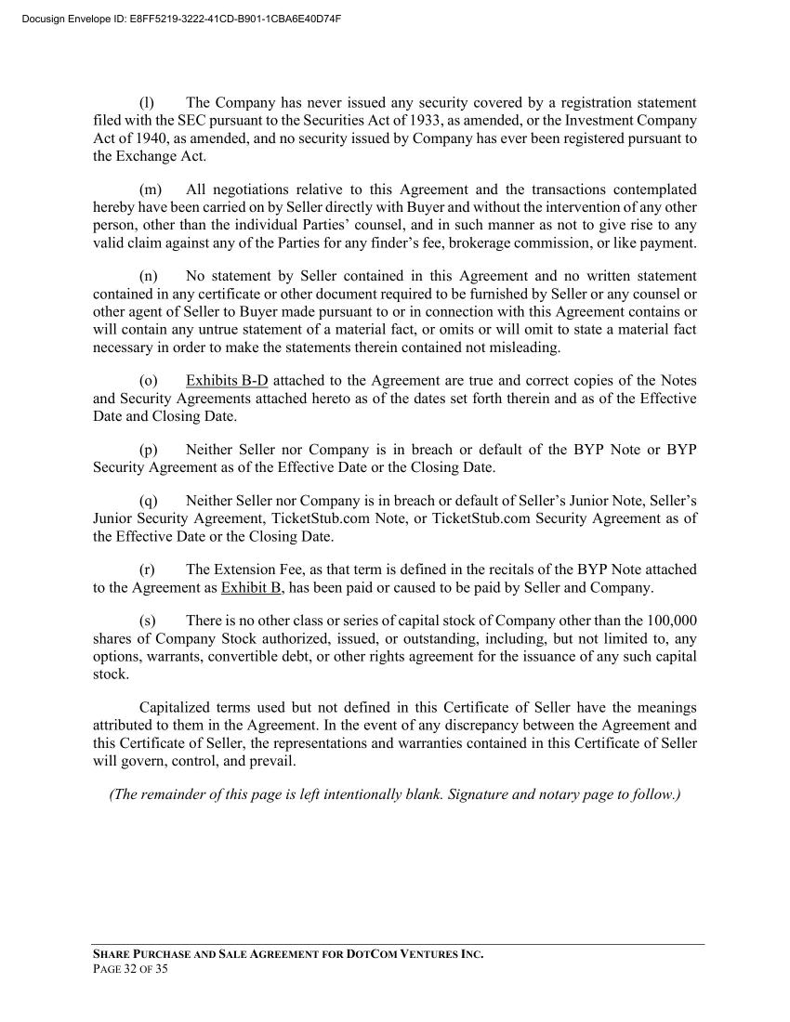



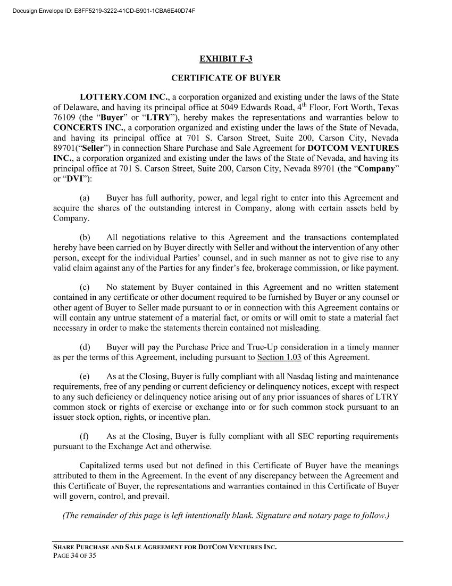



Exhibit 10.53
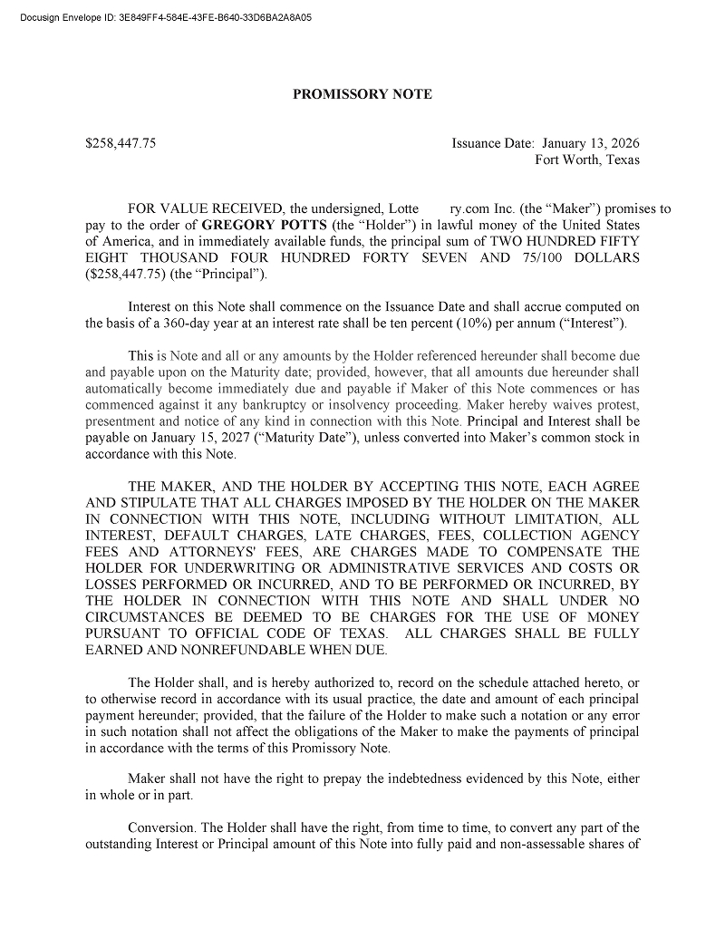

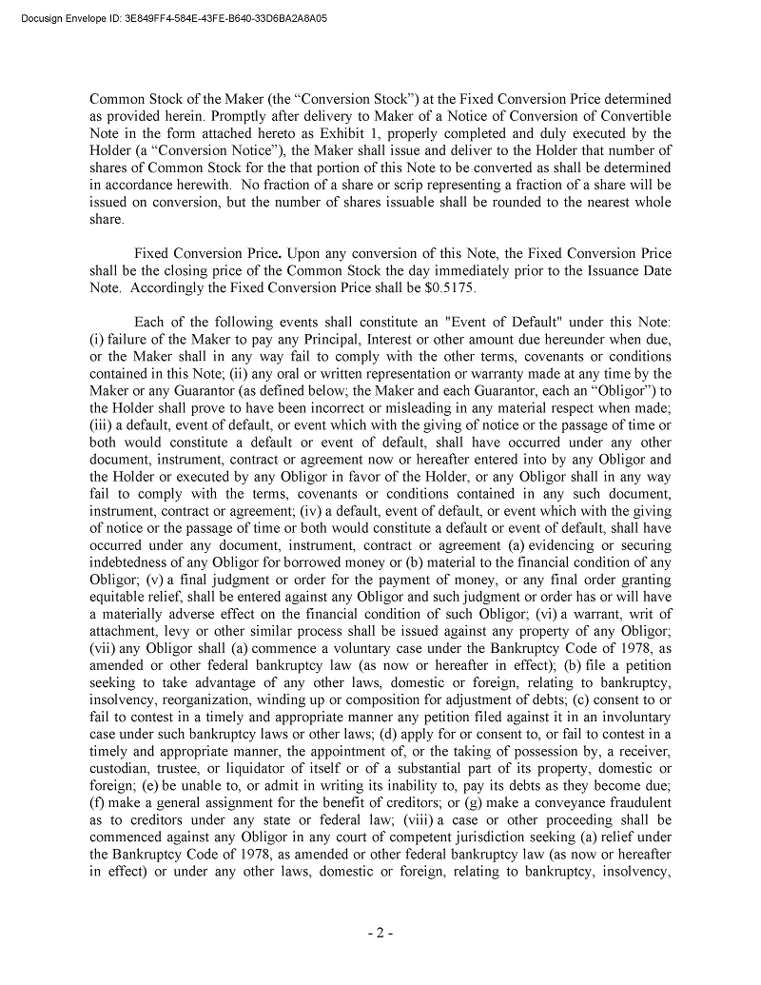



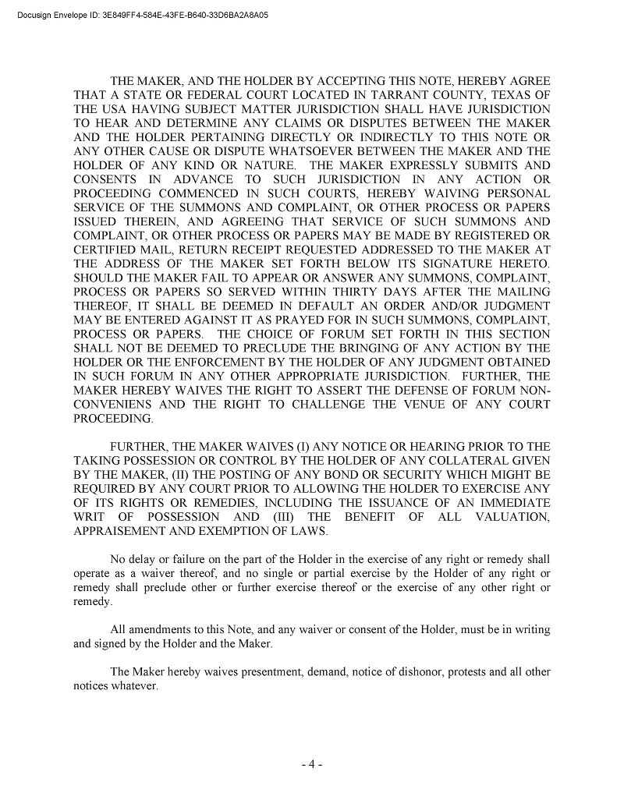

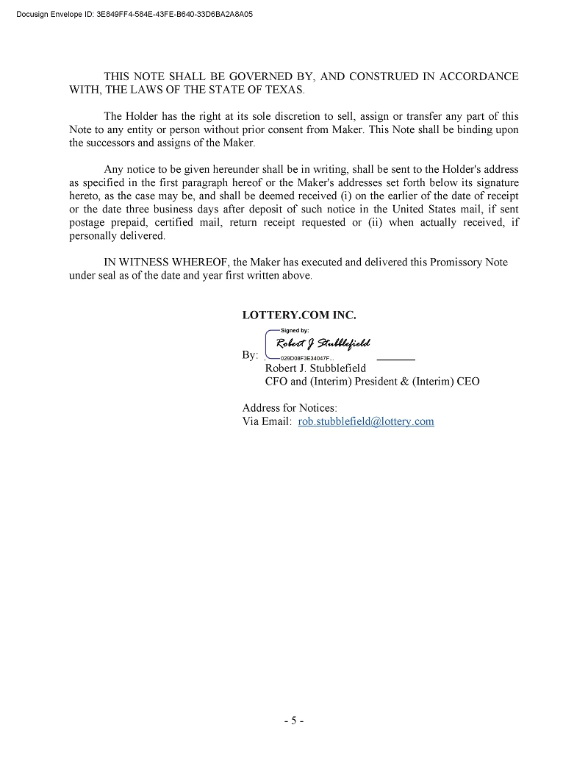



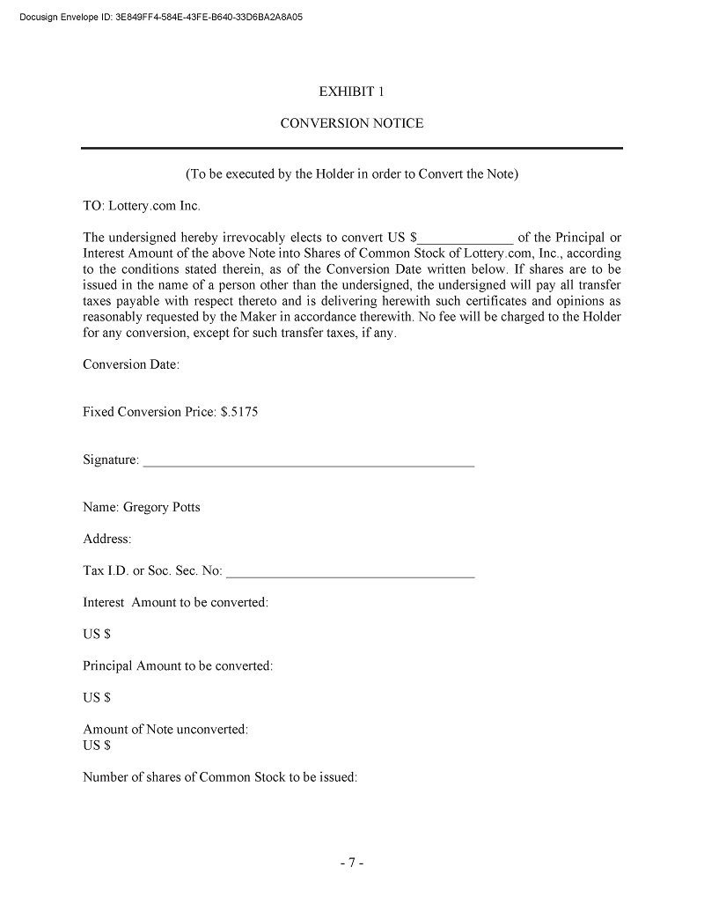

Exhibit 10.54
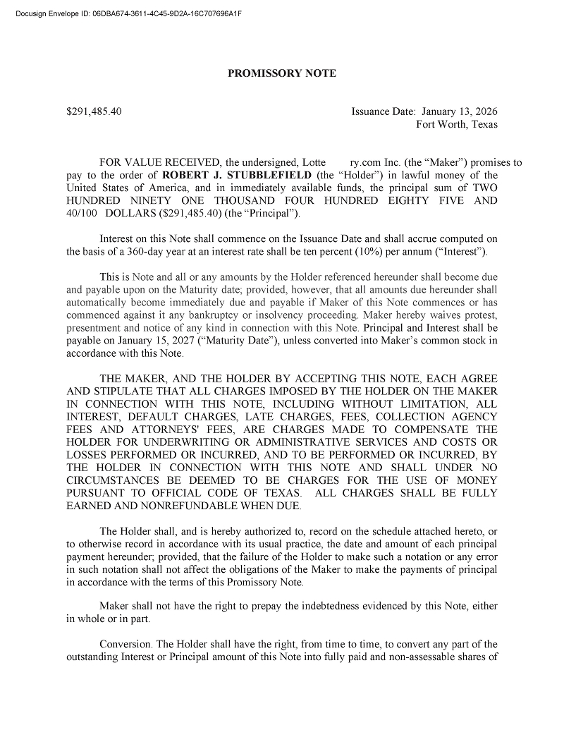

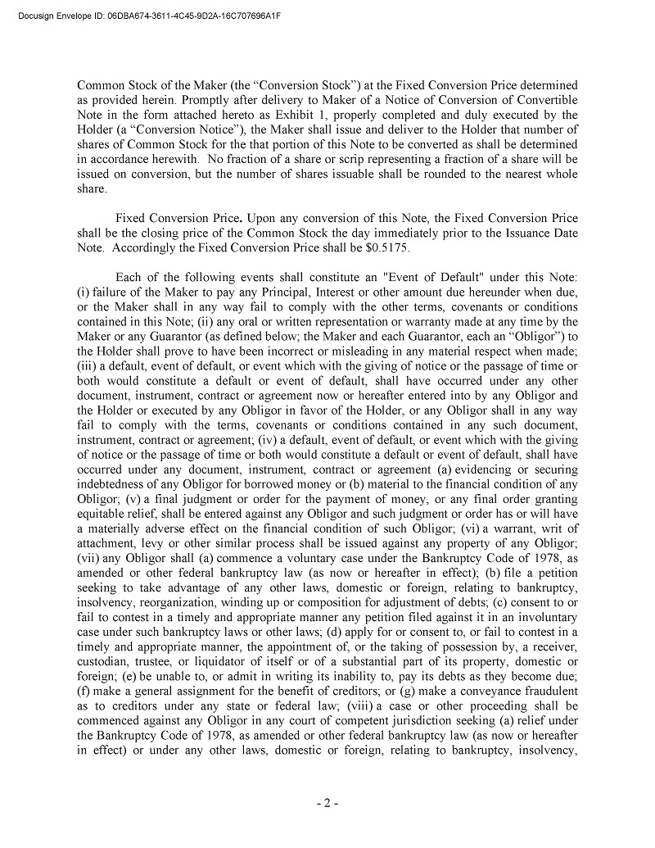



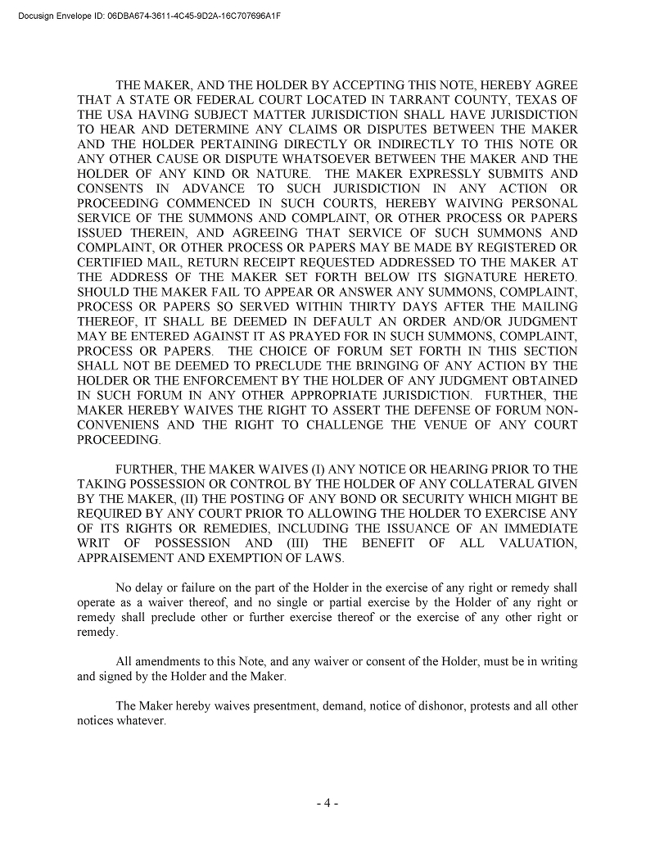

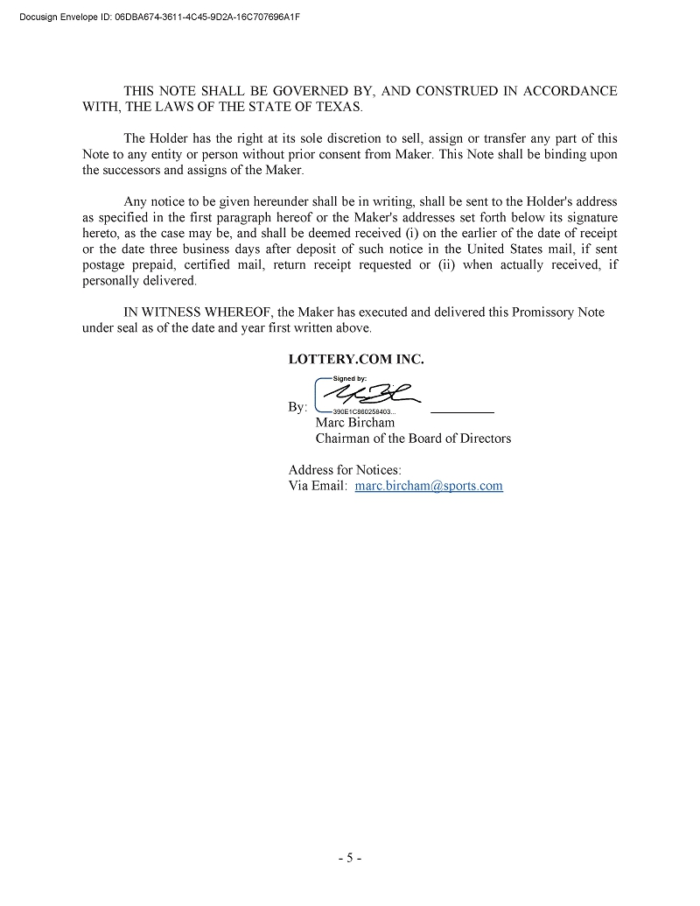



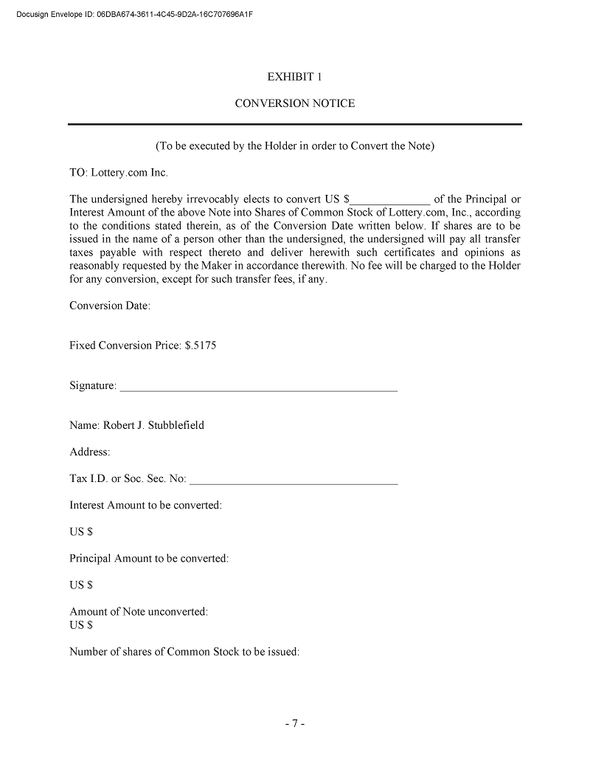

Exhibit 31.1

CERTIFICATION PURSUANT TO
RULES 13a-14(a) AND 15d-14(a) UNDER THE SECURITIES EXCHANGE ACT OF 1934,
AS ADOPTED PURSUANT TO SECTION 302 OF THE SARBANES-OXLEY ACT OF 2002

I, Robert J. Stubblefield, certify that:

 | 1. | I have reviewed this Report on Form 10-Q of Sports Entertainment Gaming Global Corporation.;

 | 2. | Based on my knowledge, this report does not contain any untrue statement of a material fact or omit to state a material fact necessary to make the statements made, in light of the circumstances under which such statements were made, not misleading with respect to the period covered by this report;

 | 3. | Based on my knowledge, the financial statements, and other financial information included in this report, fairly present in all material respects the financial condition, results of operations and cash flows of the registrant as of, and for, the periods presented in this report;

 | 4. | The registrant’s other certifying officer(s) and I are responsible for establishing and maintaining disclosure controls and procedures (as defined in Exchange Act Rules 13a-15(e) and 15d-15(e)) and internal control over financial reporting (as defined in Exchange Act Rules 13a-15(f) and 15d-15 (f)) for the registrant and have:

 | (a) | Designed such disclosure controls and procedures, or caused such disclosure controls and procedures to be designed under our supervision, to ensure that material information relating to the registrant, including its consolidated subsidiaries, is made known to us by others within those entities, particularly during the period in which this report is being prepared;

 | (b) | Designed such internal control over financial reporting, or caused such internal control over financial reporting to be designed under our supervision, to provide reasonable assurance regarding the reliability of financial reporting and the preparation of financial statements for external purposes in accordance with generally accepted accounting principles;

 | (c) | Evaluated the effectiveness of the registrant’s disclosure controls and procedures and presented in this report our conclusions about the effectiveness of the disclosure controls and procedures, as of the end of the period covered by this report based on such evaluation; and

 | (d) | Disclosed in this report any change in the registrant’s internal control over financial reporting that occurred during the registrant’s most recent fiscal quarter (the registrant’s fourth fiscal quarter in the case of an annual report) that has materially affected, or is reasonably likely to materially affect, the registrant’s internal control over financial reporting; and

 | 5. | The registrant’s other certifying officer(s) and I have disclosed, based on my most recent evaluation of internal control over financial reporting, to the registrant’s auditors and the audit committee of the registrant’s board of directors (or persons performing the equivalent functions):

 | (a) | All significant deficiencies and material weaknesses in the design or operation of internal control over financial reporting which are reasonably likely to adversely affect the registrant’s ability to record, process, summarize and report financial information; and

 | (b) | Any fraud, whether or not material, that involves management or other employees who have a significant role in the registrant’s internal control over financial reporting.

Date: October 8, 2026 | By: | /s/ Robert J. Stubblefield
 |  | Robert J. Stubblefield
 |  | Interim Chief Executive Officer
 |  | (Principal Executive Officer)

Exhibit 31.2

CERTIFICATION PURSUANT TO
RULES 13a-14(a) AND 15d-14(a) UNDER THE SECURITIES EXCHANGE ACT OF 1934,
AS ADOPTED PURSUANT TO SECTION 302 OF THE SARBANES-OXLEY ACT OF 2002

I, Robert J. Stubblefield, certify that:

 | 1. | I have reviewed this Report on Form 10-Q of Sports Entertainment Gaming Global Corporation.;

 | 2. | Based on my knowledge, this report does not contain any untrue statement of a material fact or omit to state a material fact necessary to make the statements made, in light of the circumstances under which such statements were made, not misleading with respect to the period covered by this report;

 | 3. | Based on my knowledge, the financial statements, and other financial information included in this report, fairly present in all material respects the financial condition, results of operations and cash flows of the registrant as of, and for, the periods presented in this report;

 | 4. | The registrant’s other certifying officer(s) and I are responsible for establishing and maintaining disclosure controls and procedures (as defined in Exchange Act Rules 13a-15(e) and 15d-15(e)) and internal control over financial reporting (as defined in Exchange Act Rules 13a-15(f) and 15d-15 (f)) for the registrant and have:

 | (a) | Designed such disclosure controls and procedures, or caused such disclosure controls and procedures to be designed under our supervision, to ensure that material information relating to the registrant, including its consolidated subsidiaries, is made known to us by others within those entities, particularly during the period in which this report is being prepared;

 | (b) | Designed such internal control over financial reporting, or caused such internal control over financial reporting to be designed under our supervision, to provide reasonable assurance regarding the reliability of financial reporting and the preparation of financial statements for external purposes in accordance with generally accepted accounting principles;

 | (c) | Evaluated the effectiveness of the registrant’s disclosure controls and procedures and presented in this report our conclusions about the effectiveness of the disclosure controls and procedures, as of the end of the period covered by this report based on such evaluation; and

 | (d) | Disclosed in this report any change in the registrant’s internal control over financial reporting that occurred during the registrant’s most recent fiscal quarter (the registrant’s fourth fiscal quarter in the case of an annual report) that has materially affected, or is reasonably likely to materially affect, the registrant’s internal control over financial reporting; and

 | 5. | The registrant’s other certifying officer(s) and I have disclosed, based on my most recent evaluation of internal control over financial reporting, to the registrant’s auditors and the audit committee of the registrant’s board of directors (or persons performing the equivalent functions):

 | (a) | All significant deficiencies and material weaknesses in the design or operation of internal control over financial reporting which are reasonably likely to adversely affect the registrant’s ability to record, process, summarize and report financial information; and

 | (b) | Any fraud, whether or not material, that involves management or other employees who have a significant role in the registrant’s internal control over financial reporting.

Date: October 8, 2026 | By: | /s/ Robert J. Stubblefield
 |  | Robert J. Stubblefield
 |  | Chief Financial Officer
 |  | (Principal Financial/Accounting Officer)

Exhibit 32.1

CERTIFICATION PURSUANT TO 18 U.S.C. SS. 1350 AS ADOPTED PURSUANT TO
SECTION 906 OF THE SARBANES-OXLEY ACT OF 2002

In connection with the Quarterly Report of Sports Entertainment Gaming Global Corporation (the “Company”) on Form 10-Q for the quarter ended March 31, 2026, as filed with the Securities and Exchange Commission (the “Report”), I, Robert J. Stubblefield, Principal Executive Officer of the Company, certify, pursuant to 18 U.S.C. Section 1350, as adopted pursuant to Section 906 of the Sarbanes-Oxley Act of 2002, that:

 | (1) | The Report fully complies with the requirements of Section 13(a) or 15(d) of the Securities Exchange Act of 1934; and

 | (2) | The information contained in the Report fairly presents, in all material respects, the financial condition and results of operations of the Company at the dates and for the periods indicated.

Date: October 8, 2026 | By: | /s/ Robert J. Stubblefield
 |  | Robert J. Stubblefield
 |  | Interim Chief Executive Officer
 |  | (Principal Executive Officer)

Exhibit 32.2

CERTIFICATION PURSUANT TO 18 U.S.C. SS. 1350 AS ADOPTED PURSUANT TO
SECTION 906 OF THE SARBANES-OXLEY ACT OF 2002

In connection with the Quarterly Report of Sports Entertainment Gaming Global Corporation (the “Company”) on Form 10-Q for the quarter ended March 31, 2026, as filed with the Securities and Exchange Commission (the “Report”), I, Robert J. Stubblefield, Principal Financial Officer of the Company, certify, pursuant to 18 U.S.C. Section 1350, as adopted pursuant to Section 906 of the Sarbanes-Oxley Act of 2002, that:

 | (1) | The Report fully complies with the requirements of Section 13(a) or 15(d) of the Securities Exchange Act of 1934; and

 | (2) | The information contained in the Report fairly presents, in all material respects, the financial condition and results of operations of the Company at the dates and for the periods indicated.

Date: October 8, 2026 | By: | /s/ Robert J. Stubblefield
 |  | Robert J. Stubblefield
 |  | Chief Financial Officer
 |  | (Principal Financial/Accounting Officer)

